Change the wording of an Offision email
Swap the subject line and the body text of any Offision notification for your own words, in each language you send, and watch the preview before you save.
2026-08-20 · https://offision.com/help/en/system/change-the-wording-of-an-offision-email/
Before you start:
You need an account that can open System config. The page only appears while you
are viewing the root organization — switch back from a sub-organization first.

1. Open Email Template
Go to System config › Settings › Email › Email Template.
Where in Offision: admin app → system-account/email-template (Email Template)
The screen is three columns and you work across them left to right: the list of
emails on the left, a live preview in the middle, and Edit settings — the
part you type into — on the right.

2. Pick the email you want to change
The list is grouped by what the email is about: Bookings, Reminders,
Review, Users, Visitors, Services, Attendance, Events
and Others. Selecting a row loads it into the preview and the edit panel;
one is already selected when the page opens.
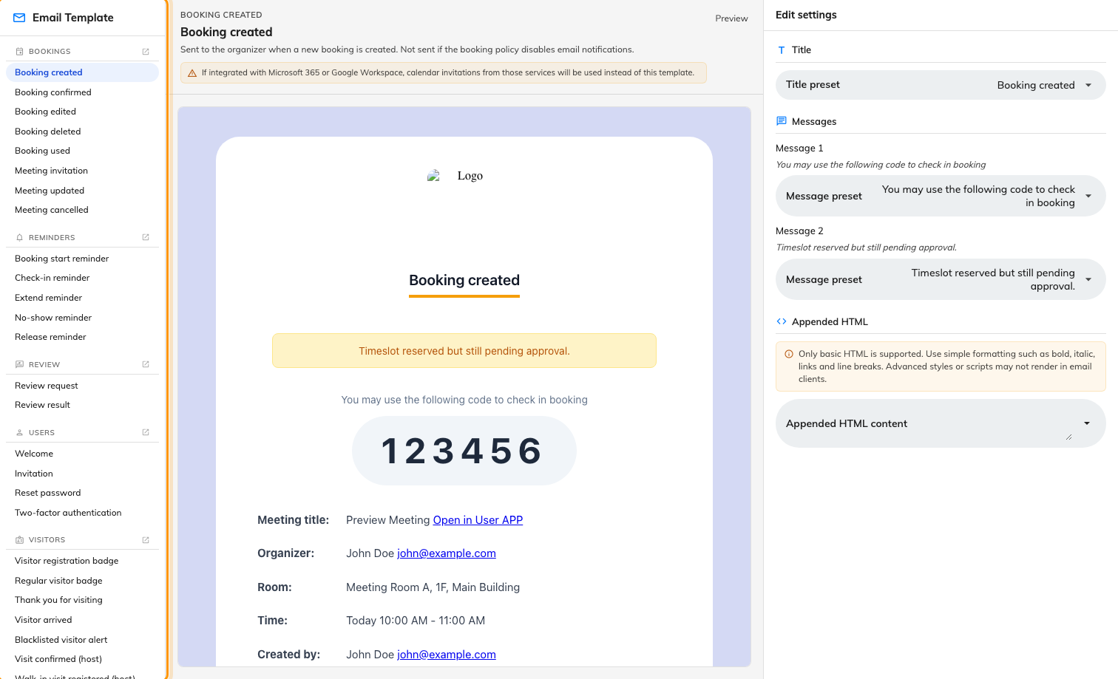
Emails grouped by subject, with the preview and edit panel beside them.
A dot beside a name means that one has already been changed — hover it and it
says so. Not every message Offision sends is listed here; if you cannot find one,
its wording is fixed.
The arrow on a category header leaves this screen entirely. It opens the page
that decides who gets that kind of email and when — Reminders opens the
email reminder settings, Visitors opens visitor management. This screen only
decides what the message says.

3. Change the subject
The middle column shows the subject as its heading, so you can read the line
you are editing without sending anything.
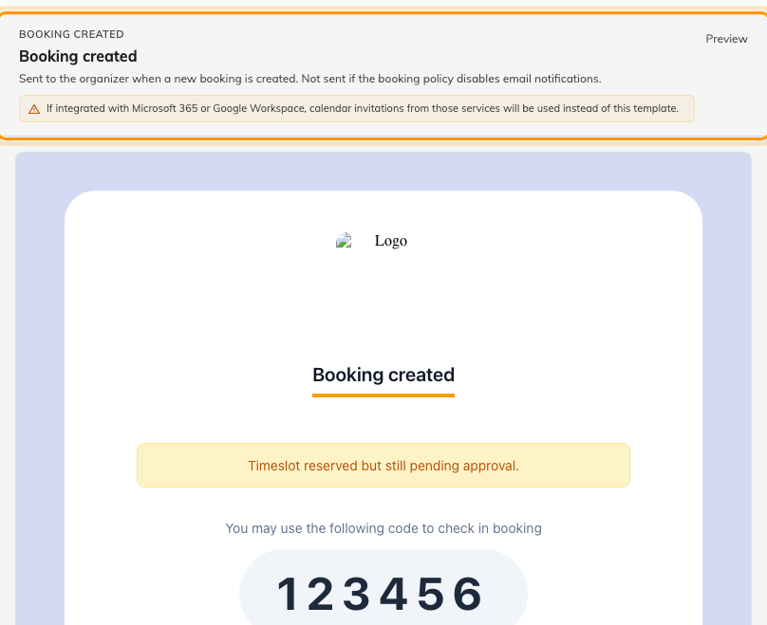
The subject, a note on when the email is sent, and the live preview under it.
Title preset offers the alternative wordings that ship with Offision — the
same message said a shorter or a warmer way. Pick one and you are done.
To write your own instead, choose Customization at the foot of that list. A
Custom title field appears, holding the wording that is currently in use so
you have something to edit rather than an empty box.
The field shows one language at a time. The arrow at its right — Show all
languages — opens the rest, one box per language your company has enabled.
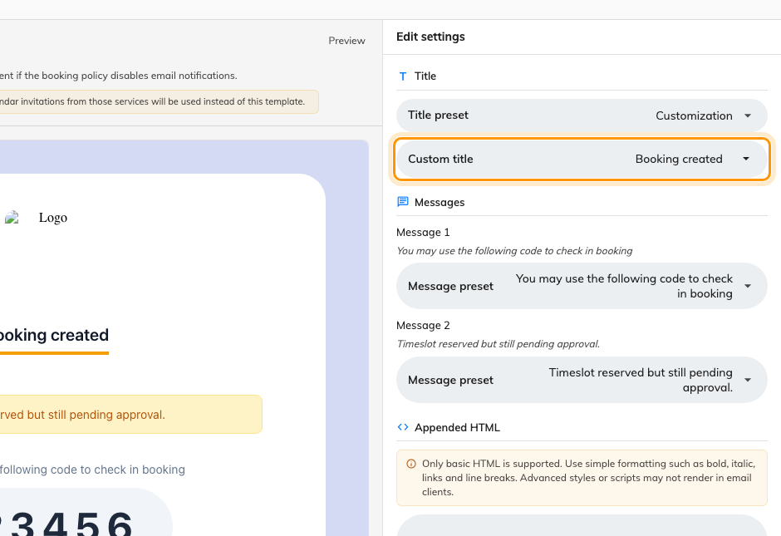
Custom title, in place of the preset.

4. Change the body text
Messages lists the lines of the email you are allowed to rewrite, as
Message 1, Message 2 and so on, with the current wording printed under
each label so you can tell which line is which. How many there are depends on
the email — some have one, some have several, some have none.
Each works the same way as the title: Message preset for a ready-made
alternative, or Customization for a Custom message you write yourself.
Word it however you like — there is nothing you have to keep, and no length
limit.
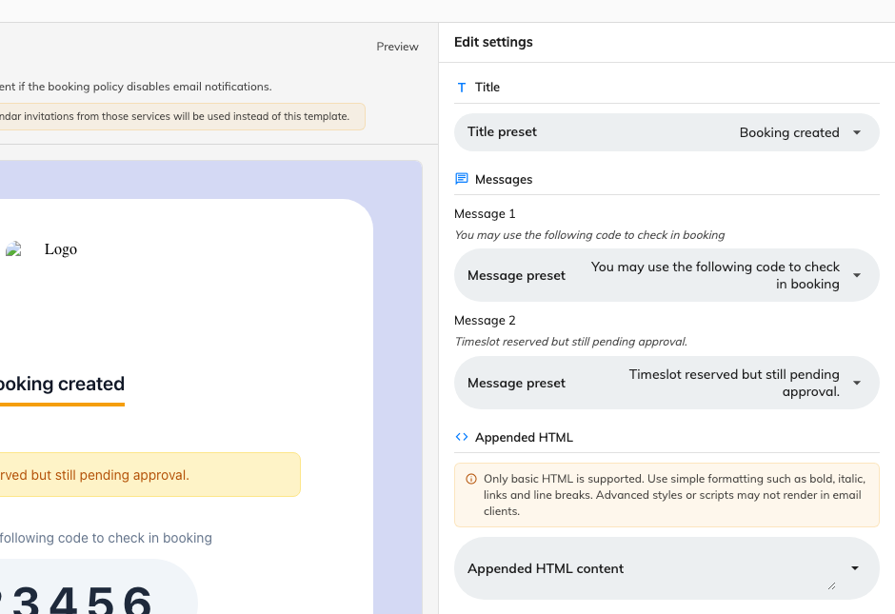
Title, Messages and Appended HTML, the three things you can edit.
Behind Show all languages, leaving one empty is a real choice rather than an
oversight: that language is then left out of the email rather than falling back
to the original wording. Fill in every language you actually send in.

5. Add something of your own at the end
Appended HTML is free text added under the message, and its note is exact:
Only basic HTML is supported. Use simple formatting such as bold, italic, links
and line breaks. Advanced styles or scripts may not render in email clients.
It is per email type, which makes it the right place for something that belongs
to one message — a booking policy link on booking confirmations, say. Anything
that belongs on every email is the footer instead, on
Email setting.

6. Watch the preview, then save
The preview redraws a moment after you stop typing, so you can read the whole
email as you go. Discard throws away what you have changed since you last
saved; Save commits it. Both appear only once something has changed.
Going back to the original wording:
There is no reset button. Select the first entry in a preset list — the one
above the alternatives — and that line goes back to the wording Offision ships
with. Discard will not do it: it only drops edits you have not saved yet.

7. Check it worked
Trigger the real thing — book a room, invite a visitor — and read what arrives.
Which language the email goes out in:
Emails are sent in the language your company has set, not the one the
recipient uses. If a second email language is set as well, both appear in the
same message, one under the other. That is why an unfilled language quietly
disappears from the mail. See
Choose the languages your company offers.

What this screen does not control
- How the email looks — the logo, the background colour and the footer are
on Email setting, and they reach every
email at once.
- Who it comes from — see
Send email from your own address.
- Who receives it, and when — that is the arrow on the category header, on
the feature's own settings page.
- Booking and meeting invitations, where Microsoft 365 or Google Workspace is
connected. Those services send their own calendar invitations and your
wording is not used. The screen warns you on the templates this affects.

