The YouTube widget
A reel of up to ten YouTube videos, streamed straight from their links and played in order — plus one audio setting for the whole reel.
2026-08-19 · https://offision.com/help/en/signage/youtube/
YouTube videos, straight from their links — nothing to upload. Paste the links
and the screen plays them in order, round and round, which makes it the
quickest way to put existing published video on a wall.
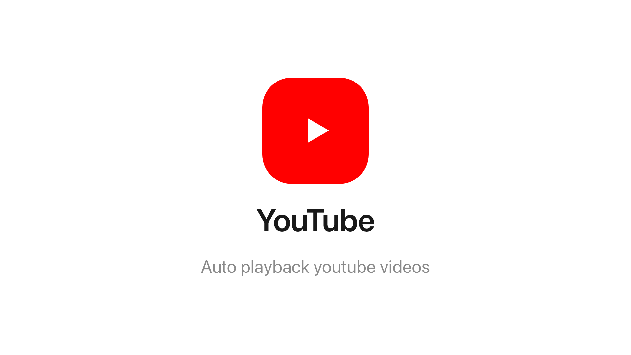
The YouTube widget on the main stage.
Can go on: Main stage · Info cards

Settings
Setting | What it does | When to change it
YouTube URL | One row per video — Add video adds the next, up to 10. Row order is play order, and rows drag to reorder | A link that is not a YouTube link says so on its row — fix it there
Mute | Silences the whole reel — on by default | Only where the screen's speakers should actually be heard
Volume | 0–100, once Mute is off | —

Audio is asked once: the one Mute and Volume cover every video in the
reel.

What this does not control
- The videos themselves. They stream live from YouTube — the screen needs
a route to the internet, and a video removed there disappears here.
- Its size and colour. The design-wide settings apply as everywhere —
media widgets ignore the font size — see
Widgets and the places they go.

