The World clocks widget
Several cities' local time at once — rows beside a globe on the stage, compact rows in the side column, dials or numeral columns on a card. The cities, the paging, and the card style.
2026-08-19 · https://offision.com/help/en/signage/world-clocks/
The local time in the cities you name — for the lobby of a company whose
mornings happen in three of them. Each row carries the offset from the
screen's own time, so nobody does the arithmetic.
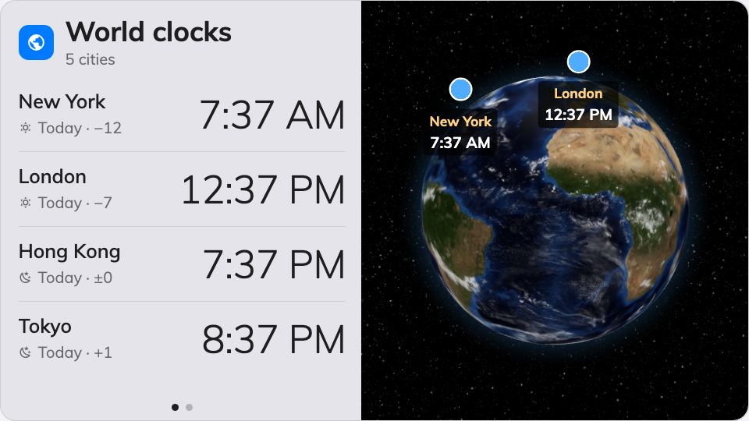
World clocks on the main stage — the rows beside the globe.
Can go on: Main stage · Side widgets · Info cards

Settings
Setting | What it does | When to change it
Cities | Which cities appear, in the order you add them | Put the office people actually call first
Seconds per city | How long each page of cities holds before the next | More cities than fit at once — give the far pages time to be read
Card style | How the 16:9 card draws them: Day/night dials or Digital times | Dials say day-or-night at a glance; digital times are for reading the exact hour. Only the info-card placement uses this

The widget redraws itself for each place: rows beside a globe on the stage,
compact stacked rows in the side column, and the card style above on an info
card.

What this does not control
- The screen's own clock. One place's time, without the globe, is the
Clock widget.
- Its size and colour. The design's font size, appearance and widget
background apply here like everywhere else — see
Widgets and the places they go.

