Widgets and the places they go
The five kinds of place on a signage design, which widget can sit in each of them, and the settings that apply to the whole design at once.
2026-08-19 · https://offision.com/help/en/signage/widgets-and-places/
Everything on the content is opened by clicking it in the preview. There is no
list of widgets to work through and no properties panel to hunt in: click the
thing you want to change, and the rail on the right becomes its settings.
Where in Offision: admin app → signage/signage-content (Signage)

The five kinds of place
What you are offered when you click depends entirely on where you clicked,
because a tall column and a small square tile cannot hold the same things.
Place | Shape | What it is for
Main stage | The large flexible area | The one thing the screen is really showing
Side widgets | A tall column beside the stage | A list that runs down the screen — bookings, visitors, announcements
Info cards | Fixed 16:9 | A glanceable readout — a clock, the weather, a summary
Action buttons | Fixed 3:4 tiles | One thing to press, or one code to scan
Text bar | A thin band on an edge | Text scrolling past, or a fixed info bar

Which of these your design actually has is a layout question, not a content
one — see Change a layout.

What can go where
Every widget has an article of its own — what it shows, and its settings, field
by field. The tables below say which places each one fits.

Bookings & events
Widget | Can go on
Booking list | Main stage · Side widgets · Info cards
Resource calendar | Main stage
Booking status - Map | Main stage
Resource list - for booking | Main stage · Side widgets
Event list | Main stage · Side widgets
Event information | Main stage
Booking status - Summary | Info cards
Booking buttons | Action buttons

Workplace data
Widget | Can go on
Support ticket list | Main stage · Side widgets · Action buttons
Service request list | Main stage · Side widgets · Action buttons
Occupancy sensor data - Map | Main stage
Wayfinding QR code | Action buttons

Ambient & info
Widget | Can go on
Announcements | Main stage · Side widgets · Info cards · Text bar
World clocks | Main stage · Side widgets · Info cards
Clock | Info cards · Action buttons
Weather | Info cards · Action buttons
Hong Kong weather | Info cards · Action buttons
Lunar calendar | Info cards
QR Code | Action buttons
RSS Text | Text bar
Info bar | Text bar

Visitor
Widget | Can go on
Visitor welcome | Main stage
Visitor list | Main stage · Side widgets
Visitor self service buttons | Main stage · Action buttons
Visitor registration QR code | Action buttons
Wi-Fi QR Code | Action buttons

Intercom
Widget | Can go on
Offision call people list | Main stage · Side widgets · Info cards · Action buttons
Teams phone call people list | Main stage · Side widgets · Info cards · Action buttons

Controls
Widget | Can go on
Room control QR code | Action buttons
Open door button | Action buttons
Language selection | Action buttons

Media
Widget | Can go on
Image | Main stage · Info cards · Action buttons
Video | Main stage · Info cards
YouTube | Main stage · Info cards
Playlist | Main stage · Info cards
HLS (HTTP live streaming) | Main stage · Info cards
Website - iFrame | Main stage · Info cards
PDF Playback | Main stage

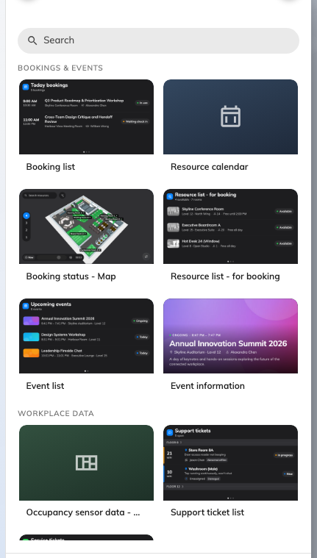
The picker, grouped exactly as the tables above — and showing only what fits where you clicked.
A non-touch screen shows fewer of them:
Where the screen was described as having no touch, the widgets that exist to be
pressed are hidden rather than shown and dead: Open door button,
Language selection, Booking buttons and the two call lists. Visitor
self service buttons is the exception — it is silently replaced by Visitor
registration QR code, so the guest does the same thing on their own phone.
Change the answer on the editor's Screen page and they come back.

Settings that apply to everything at once
The rail's first page — the one it opens on, and the one the ← arrow always
returns to — is the content itself rather than anything on it.
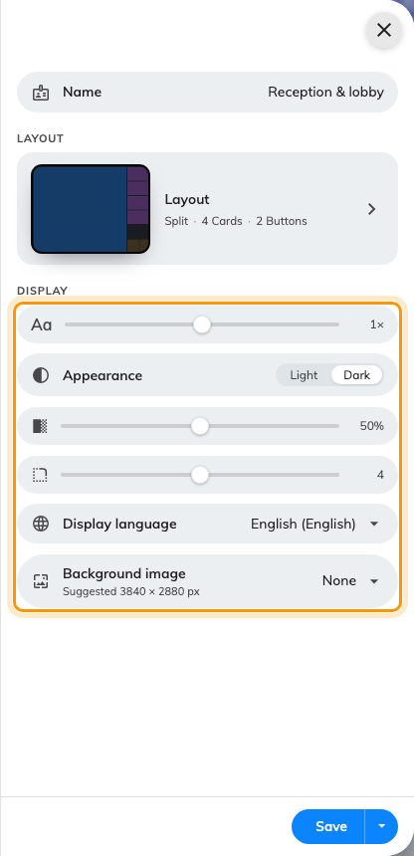
Everything here applies to every widget at once.
Setting | What it does | When to change it
Name | What the content is called in the list and in the device wizard | Immediately — new content is named after the purpose it was created from, which stops being distinctive by the third one
Font size | Scales all the text at once, from half size to two and a half times | The screen is further away, or closer, than its size class assumes. Media widgets ignore it — nothing in a video responds to a type ramp
Appearance | Light or dark | A bright lobby, or a screen that has to match the wall it is on
Widget background | How solid the panels behind widgets are, from fully transparent to solid | A background image is showing through too strongly, or not enough. The two map widgets ignore it
Corner radius | How rounded the panels are, square through to fully rounded | Matching the hardware's own bezel
Display language | The language the screen renders in | The screen serves a different audience from the console's own language
Background image | An image behind everything | Branding a lobby screen. Use the suggested pixel size, or it will be scaled

Two of those rows carry only an icon and their value — the fill slider directly
under Appearance is the widget background, and the one below it is the corner
radius. Everything else on the page is named.
Any single widget can override the font size on top of this, on its own settings
page — useful where one card holds a long list and everything else is a headline.

What this does not control
- Which places exist at all. How many cards, whether there is a side column,
which edge it sits on — all of that is the layout, in
Change a layout.
- Playing several things in turn on the main stage — scenes, playlists and
the weekly schedule are in Scenes, and the screens that
interrupt themselves are in Takeovers.
- What a widget actually shows. A booking list shows the bookings that
exist; a visitor list shows the visits that were invited. The screen reports,
it never decides.
- Where the screen thinks it is. Widgets that need a place read the
device's location, not the content's — see
Build signage content and put it on a screen.

