The Website - iFrame widget
A live web page inside the design, loaded from a URL — a dashboard, a status page, anything with an address. One setting, and what stays the page's own.
2026-08-19 · https://offision.com/help/en/signage/website-iframe/
A web page, live inside the design. Whatever already exists at a URL — a
metrics dashboard, a departures screen, an intranet page — shows here as the
browser would show it, so anything the web can display, the screen can too.
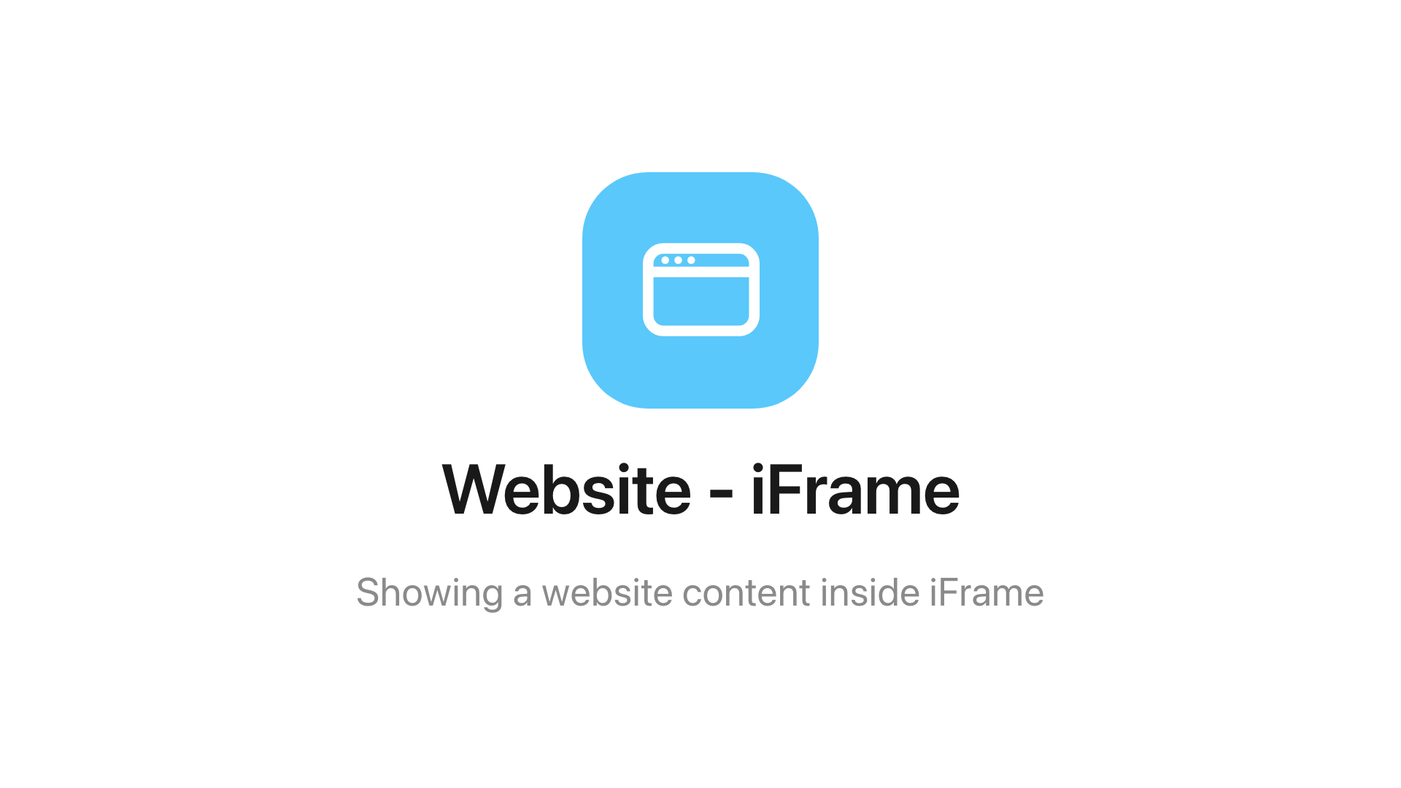
The Website - iFrame widget on the main stage.
Can go on: Main stage · Info cards

Settings
Setting | What it does | When to change it
Website URL | The address the widget loads | Pointing the screen at a different page — everything past that is the page's own

What this does not control
- What the page shows. Content, refresh and sign-in are the website's own
business — the screen must be able to reach the address, and a page that
refuses to be embedded stays blank.
- Its size and colour. The design-wide settings stop at the frame — the
font size does not reach inside the page — see
Widgets and the places they go.

