Takeovers: when the screen interrupts itself
A takeover replaces whatever the main stage is playing when a visitor arrives or a booking or event is about to start, then hands back — which three exist, and the two settings that decide how a reception screen greets.
2026-09-02 · https://offision.com/help/en/signage/takeovers/
A takeover is not another scene. It replaces whatever the stage is playing for
as long as it has something to say, and then hands back. The section lives at
the foot of the stage's settings — click the stage in the preview to reach it.
Where in Offision: admin app → signage/signage-content (Signage)
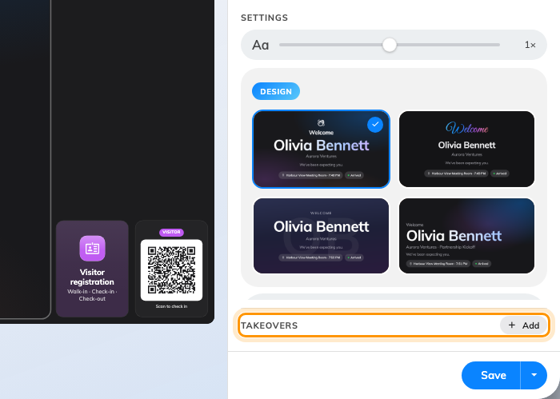
The takeover section: only what is already on is listed, and Add turns another one on.

The three takeovers
Where two are due at once, the one higher in this list wins:
Takeover | Fires when | Default
Visitor welcome | Somebody checks in, or is expected | —
Event starting soon | An event is about to begin | 15 minutes before
Booking starting soon | A booking is about to begin | 5 minutes before

The middle two are named the other way round from what most people expect:
Event is an event from the Activity module, Booking is a room booking.

Being listed is being enabled
The list shows only the takeovers that are on. The Add pill on the
heading turns another one on and opens it; Remove at the foot of a
takeover's page turns it off and keeps its settings for later. There is no
on/off switch beyond that.

How a reception screen greets
Two settings on Visitor welcome decide almost everything about how a
reception screen behaves. Show chooses between guests who have checked in
and guests who are expected around their appointment time — a screen behind
the desk usually wants the first, a screen at the door the second. Greet
chooses between every check-in across the buildings this screen belongs to, and
only the guests who scanned this screen's own QR code.
A takeover outranks whatever mode the stage is in: it interrupts a single
widget, a scene rotation and a weekly schedule alike,
and hands back to whatever is due next rather than to what it interrupted.
A takeover belongs to one stage:
Where the layout splits the content into two stages, each keeps its own
takeovers, and a takeover replaces only the stage that owns it. The other stage
carries on. Side widgets, cards and buttons are never covered.

What this does not control
- What the welcome screen looks like — that is the
Visitor welcome widget, whether it arrives as a
takeover or is placed on the stage directly.
- Who counts as expected. Invitations, check-in and the visitor flow are
Visiting's job — the screen only reports them.
- The whole lobby setup, end to end — see
Set up a lobby screen for visitors.

