Set up a lobby screen for visitors
Build reception content, connect the screen that shows it, and give that screen a location — which is what decides whose visitors it greets and where a walk-in registers.
2026-09-07 · https://offision.com/help/en/signage/set-up-a-lobby-screen-for-visitors/
A screen in a reception area does two jobs at once: it greets the people who
have arrived, and it registers the ones who turned up unannounced. Both come
from the same content, and both depend on one field that is easy to walk past.
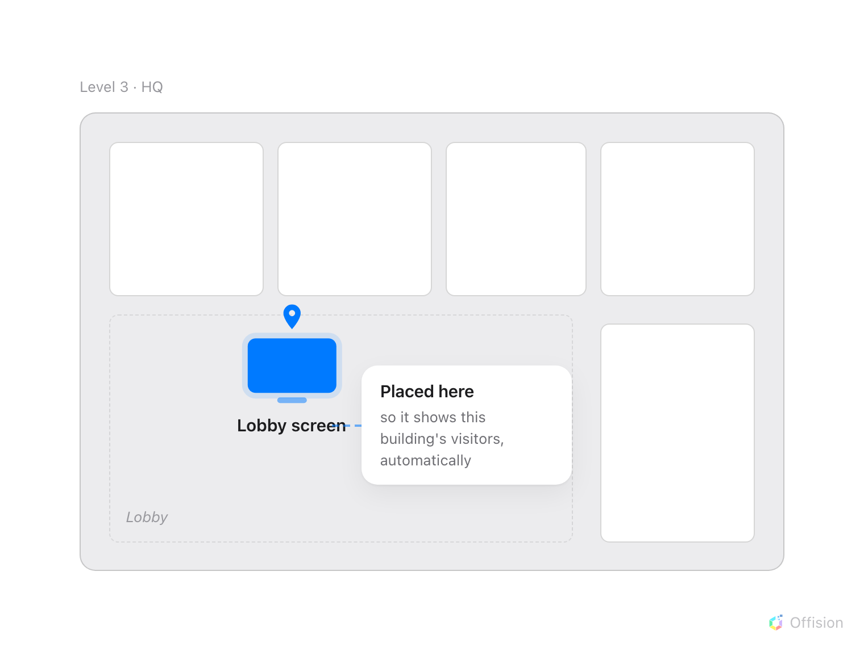
Putting the device on a floor plan is what tells it where it is — and everything on the screen that depends on a place works itself out from that spot.
This is what the four steps below add up to.
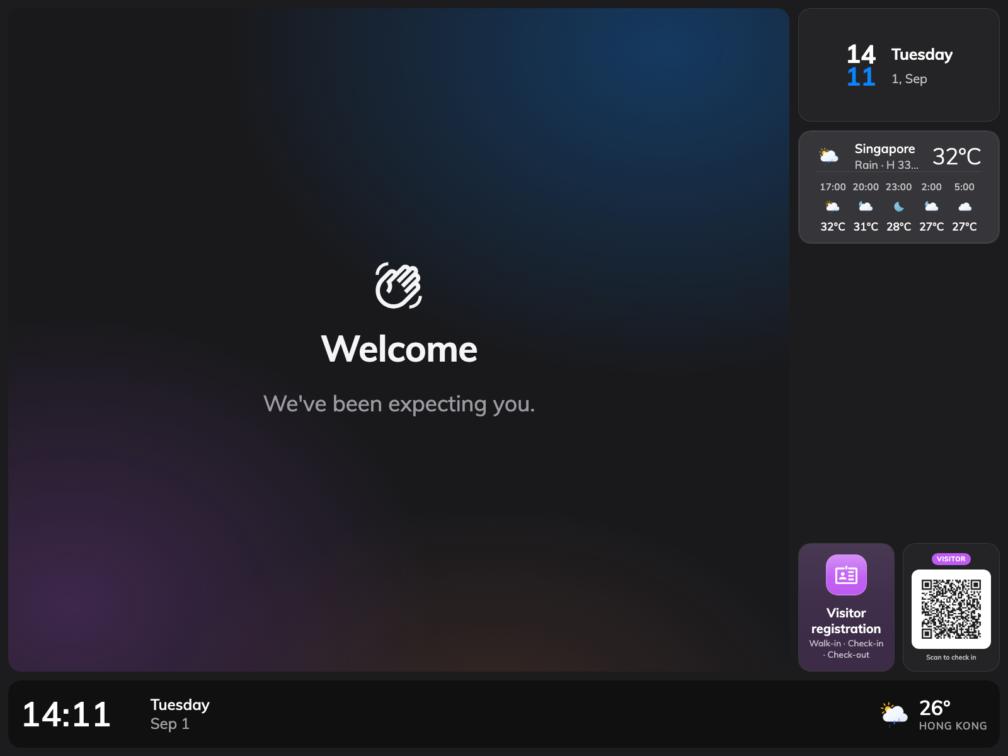
The finished screen between guests: the company welcome, with the walk-in code beside it.
The content is the design: the welcome screen, the visitor list, the
walk-in QR code. It belongs to no building and no floor. A device is the
hardware in the lobby, and it is the device that holds the Location. Every
location-aware part of the content is set to Follow device location out of
the box, so a device with no location falls back to all buildings — the
screen greets everyone's visitors, and a walk-in registers into nothing in
particular. Nothing errors. It just quietly gets the wrong answer.
That is why step 4 below is a step and not a footnote.
Before you start:
You need an account that can manage devices. Visitor management should already
be set up — visiting types and a location policy for the building this screen
serves — because the screen only displays what those produce. The building needs
a floor with a floor plan, so the device has somewhere to be placed. Have the
screen powered on, on the network, and running the Offision player app.

1. Create the content
Go to Signage › Content, choose Add, and pick Reception & lobby.
Where in Offision: admin app → signage/signage-content (Signage)
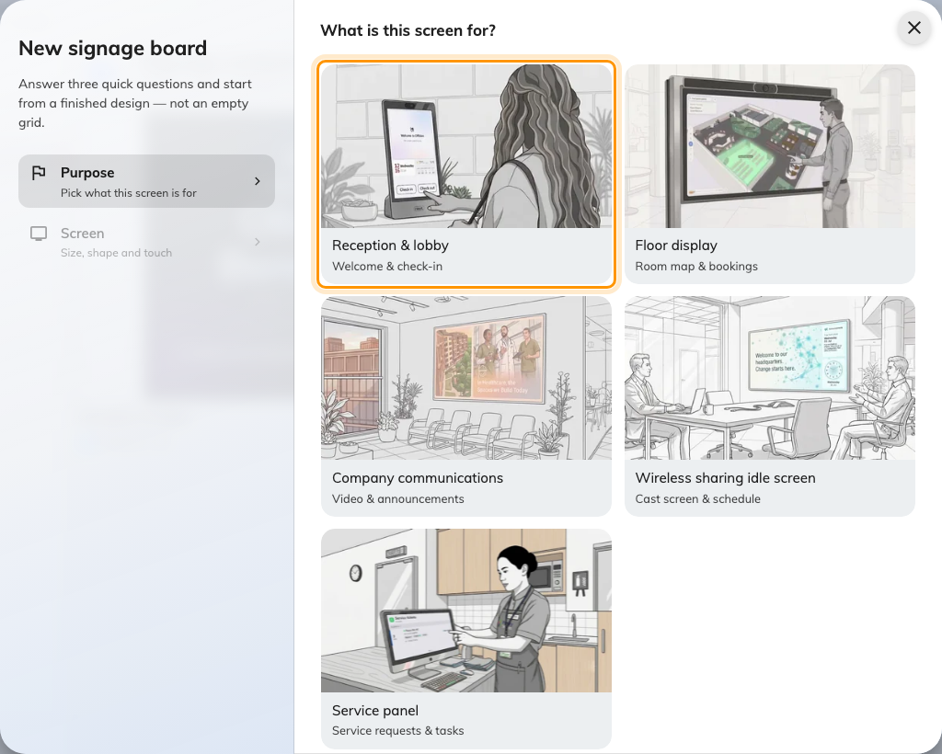
Reception & lobby seeds the welcome screen, the self-service buttons and the walk-in code in one click.
That purpose seeds the design with a visitor welcome screen, self-service
buttons and a walk-in QR code already in place, which is most of this article
done in one click. Answer the screen questions that follow — size, shape,
orientation and Touch screen — and choose Create.
Be honest about Touch screen. On a screen nobody can touch, the self-service
buttons are replaced by the walk-in QR code, because there is no point offering a
button nobody can press.
The rest of the wizard, and everything about the editor it opens, is in
Build signage content and put it on a screen.

2. Set up what visitors see
The editor shows a live preview on the left and its settings on the right, and
everything is reached by clicking the thing you want to change in the preview.
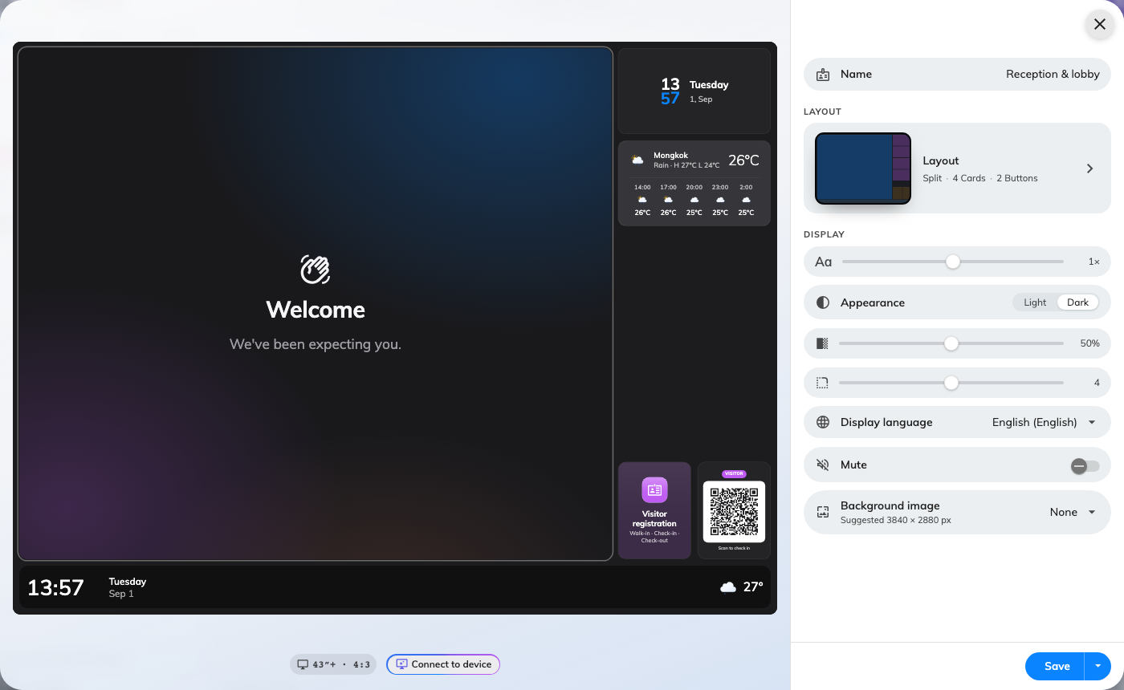
The editor: the live preview on the left, and the settings of whatever you click in it on the right.
Start with the page it opens on: give the content a Name, set its
Appearance to light or dark, and choose the Display language.
The welcome screen. Click the large area of the preview to open the
Visitor welcome settings. The one to think about is Show — checked-in
visitors, or upcoming ones. A screen behind the reception desk usually shows
who has arrived; a screen at the door usually shows who is expected. Below it,
Greet decides whether the screen welcomes every arrival in its buildings or
only the people who checked in at this screen. Both are on the widget's
Visitors page — Greet only when it runs as the takeover — with
Location under them.
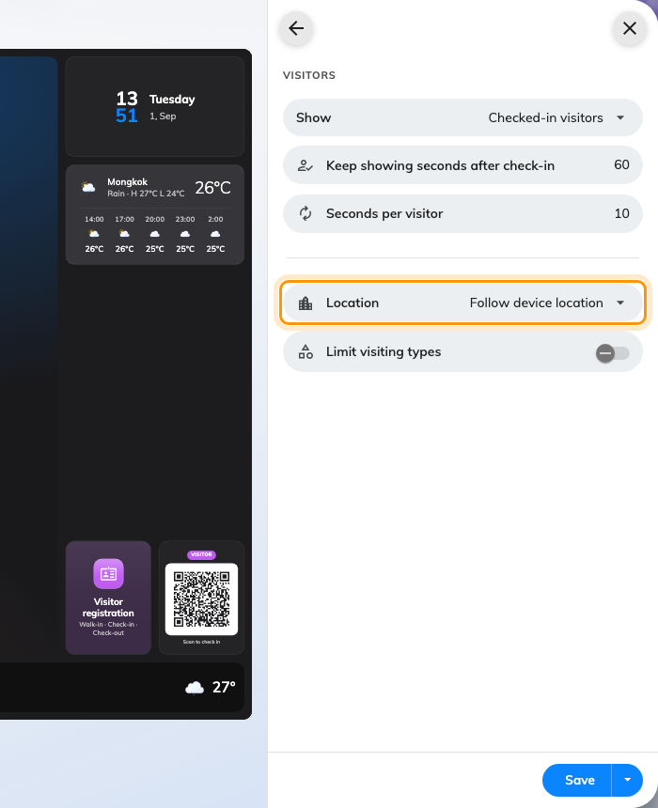
The Visitors page of the welcome screen: who gets greeted, and whose visitors count.
The walk-in code. This purpose already put it on a tile, so click that tile
in the preview rather than adding one. Four settings matter here:
- QR action — whether scanning registers the visitor only, or registers and
checks them in.
- Check in directly — skips the confirmation the visitor would otherwise
tap through. This one is refused unless the code carries a valid access key,
so it is not independent of the next setting.
- Access key type — how often the code behind the QR is replaced: daily,
hourly, or every three minutes. A code on a public wall should rotate fast; a
code behind a reception desk need not.
- Location — leave it on Follow device location. This is the setting the
diagram is about.
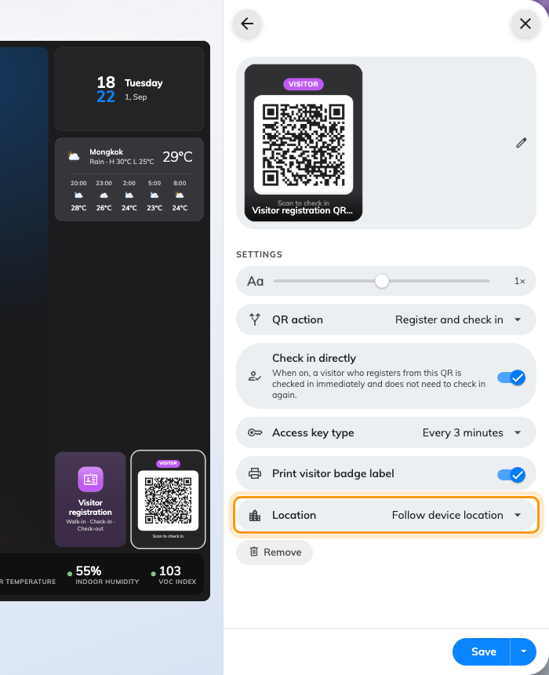
The walk-in code's settings. Location is the one to leave following the device.
Add Visitor self-service buttons and Guest Wi-Fi in the same way if the
screen is touchable. Then Save.
That widget carries a QR code of its own, under Show QR code, with its own
route — so a touchable screen does not need the separate QR widget above unless
you want the code given a slot of its own. See
Action widgets.

3. Connect the screen to the device
The content still shows nowhere. Nothing you did in step 2 touched hardware —
content and device are joined in the Devices section, and only there.
Go to Devices › Signage › Devices › Add, choose this design as
the Content, choose the Brand of hardware you are installing, type
the six-character code the screen is showing into the Connect step, and go
on to Location. The full walkthrough is in
Connect a signage screen.
Where in Offision: admin app → device/signage/signage-device (Signage devices)
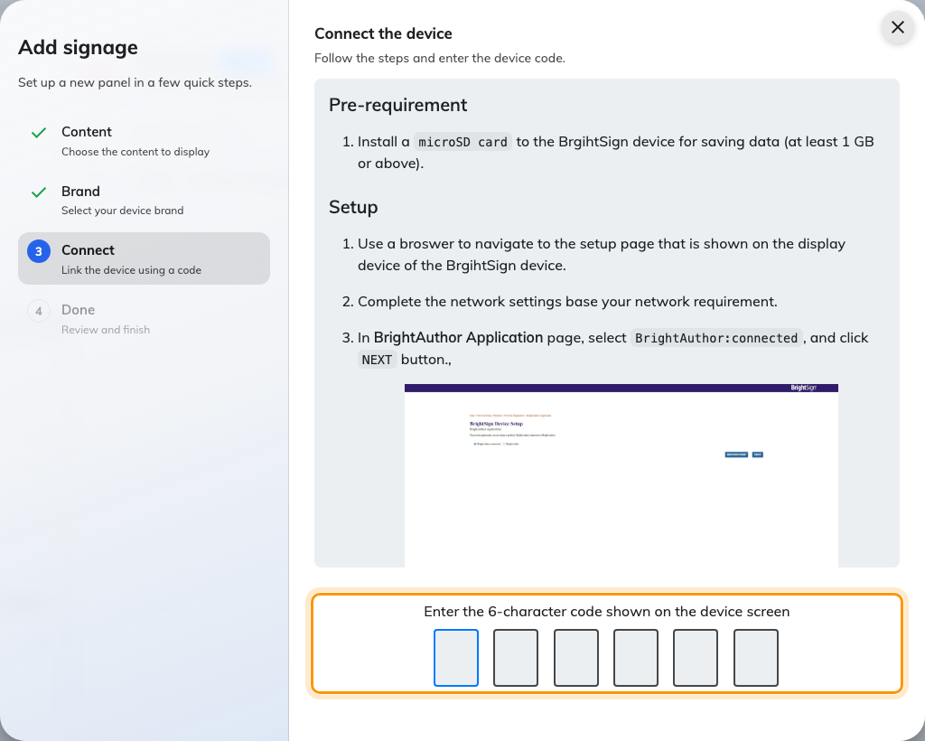
The Connect step: the six characters the screen is showing go here.
The moment the code is accepted the screen stops showing it and starts showing
the content. A device carries exactly one design.

4. Set the device's location
The wizard asks for this before it finishes, which is what keeps the screen you
just lit out of the fall-through state from the diagram. Answer it while you are
still standing next to the hardware.
Location comes straight after Connect and asks Where is this
signage? over the floor plan itself. Pick the floor, then click on the plan;
Next stays disabled until you have. Set later skips the step and asks
once before it does. If you did skip it, open the device from Devices ›
Signage › Devices — the panel on the right has a Location row you
can edit straight from there, and Edit › Basic has the same field. All
of them open the same picker.
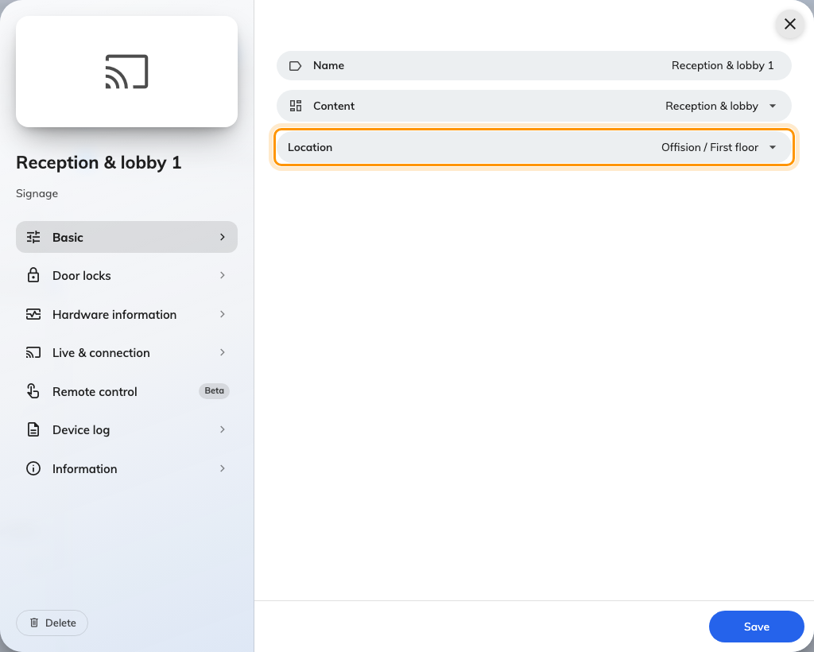
Location on a signage device, in the field that decides whose visitors it shows.
For a lobby, drop a point on the floor plan rather than tapping a room: the
screen belongs to the entrance, not to any one space. What the two picks differ
on is in Connect a signage screen.
Either way the device now resolves to a building, and every widget set to
Follow device location narrows to it. In the device list, the Location
column should read the floor and building. If it reads No location in
amber, the picker did not save — the product flags it that way because an
unlocated screen is a screen showing the wrong thing.

5. Check it worked
Go to Devices › Screen monitoring for a live picture of what the screen
is actually displaying. It is the fastest way to confirm the content landed,
without walking back to the lobby — see
see what every screen is showing.
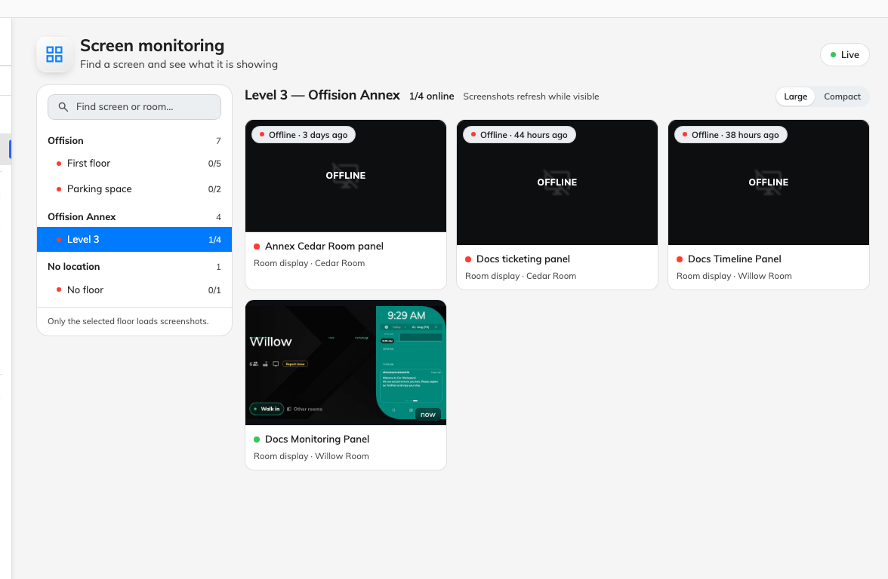
Screen monitoring: what the lobby screen is actually displaying, without walking to it.
Then test the path a real visitor takes: scan the QR code on the screen,
register, and check that the visitor appears on the welcome screen — and, in
the visitor list in the console, against the building you placed the device in
rather than some other one. That last detail is the whole point of step 4, and
it is the only check that proves it.

What this does not cover
The screen built here shows one thing all the time. Playing several in turn and
scheduling by time of day are Scenes; the way the welcome
screen interrupts whatever is playing is Takeovers. Which
widget can sit where is
Widgets and the places they go, and changing the
shape, rather than what is in it, is Change a layout.
The badge a visitor is given when they check in is designed elsewhere and is
company-wide — see Change the visitor badge design.
The printer that prints it is connected on the screen itself — see
Connect a label printer to a signage screen.
Still need help:
Note the device's brand and model, what the Location column reads for it,
whether the walk-in QR's Location is following the device or naming
buildings itself, and which building the test visitor actually landed in. Those
four separate a content problem from a location one.

