The RSS Text widget
An outside feed's headlines on the text bar — one item at a time, or one scrolling line. The feed URL, the two display modes, and the marquee controls.
2026-08-19 · https://offision.com/help/en/signage/rss-text/
Headlines from a feed somebody else publishes — news, a status page, a blog —
running along the text bar. Point it at any RSS feed's address and the screen
keeps itself current; the text bar is the one place this widget goes.
Can go on: Text bar
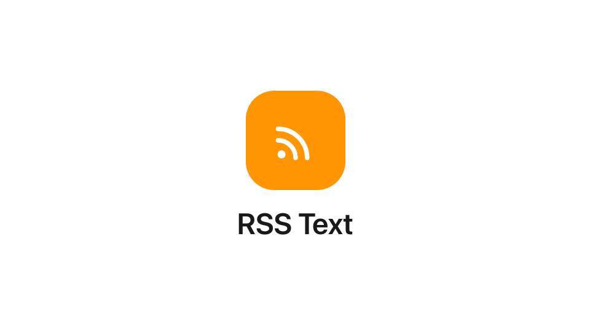
The RSS text widget on an info card.

Settings
Setting | What it does | When to change it
Feed URL | The address of the RSS feed to read | This is the widget — without it the bar is empty
Display | Full content shows one item at a time; Rolling text joins the items into one scrolling marquee line | Full content for few, long items; rolling text for many short headlines
Rolling speed | With Rolling text: how fast the line travels | Slower for a bar read from across the room
Rolling direction | With Rolling text: Right to left or Left to right — a bar on a side edge offers Bottom to top and Top to bottom instead | Match the reading direction of the display language

What this does not control
- What the headlines say. The feed's publisher writes them; the widget
only repeats the feed.
- Your own words. A message of your own on a screen is an announcement —
post it in Broadcast and use the
Announcements widget.
- Its size and colour. The design's font size, appearance and widget
background apply here like everywhere else — see
Widgets and the places they go.

