The QR code tiles
The five built-in codes a screen can put on the wall — a link of your own, guest Wi-Fi, visitor registration, wayfinding and room control — with each one's settings and where it may sit.
2026-09-01 · https://offision.com/help/en/signage/qr-code-widgets/
A code on the wall is the touchless path: nobody presses anything, and whatever
the tile is for happens on the visitor's own phone instead. Five of these are
built in, each wired to one thing. The tiles you press are in
Buttons on a screen, and the places themselves are in
Widgets and the places they go.
These survive a screen without touch:
Where a screen was described as having no touch, the tiles that exist to be
pressed are hidden. Every QR tile stays, and Visitor self service buttons is
silently replaced by Visitor registration QR code — which is the whole
reason these exist.
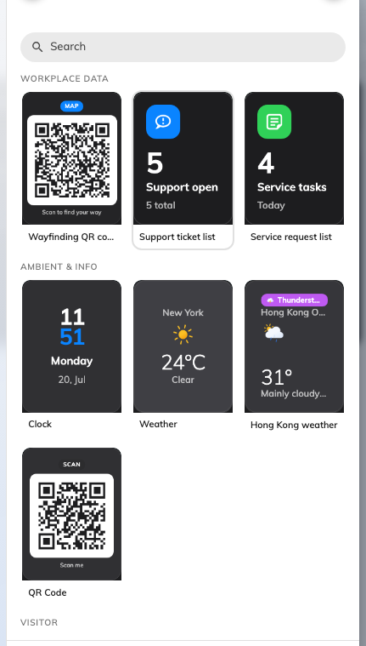
The widget picker: the five codes sit in it like any other tile.

QR Code
A code of your own — a feedback form, a menu, a survey link. The tile renders
whatever you give it as a scannable code.
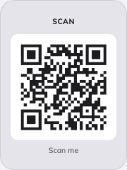
A code of your own on an action tile.
Can go on: Action buttons
Setting | What it does | When to change it
QR code content | The text or link the code encodes | The code should point somewhere new

Visitor registration QR code
The touchless walk-in: the guest scans and registers on their own phone
instead of touching the screen. It is also what Visitor self service
buttons silently becomes on a screen without touch. The full lobby build
around this widget — and why Location matters there — is
Set up a lobby screen for visitors.

The walk-in registration code on an action tile.
Can go on: Action buttons
Setting | What it does | When to change it
QR action | Whether scanning registers the visitor only (Register only) or registers and checks them in (Register and check in) | Register and check in where nobody staffs the desk
Check in directly | Skips the confirmation the visitor would otherwise tap through. Refused unless the code carries a valid access key, so it is not independent of the next setting | The shortest possible path matters more than a confirmation step
Access key type | How often the code behind the QR is replaced — Daily, Hourly or Every 3 minutes. New widgets start on Every 3 minutes; a widget already set to Daily keeps it | A code on a public wall should rotate fast; a code behind a reception desk need not
Print visitor badge label | A badge label is printed for the guest | A label printer is connected at this screen
Location | Which building the registration belongs to — Follow device location, All buildings or Choose… | Leave it on Follow device location

A guest who scanned a code moments before it rotated is not turned away: the
server keeps the previous code working for a short grace period, which is why
the faster window costs nothing.
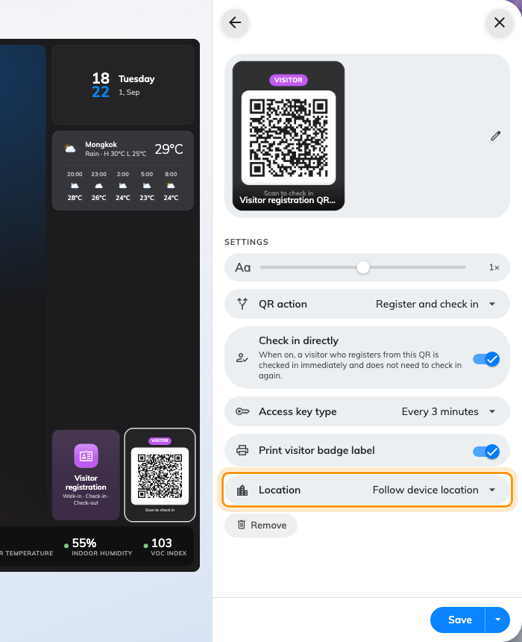
The walk-in code's settings. Location is the one to leave following the device.

Wi-Fi QR Code
The guest network as a scannable code — a phone that scans it joins the
network without typing anything.
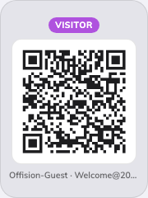
The Wi-Fi QR Code on an action tile.
Can go on: Action buttons
Setting | What it does | When to change it
Network name (SSID) | The network the code joins | The guest network changes
Password | The password the code carries | Rotating the guest password — the code updates itself
Security | The network's protection, WPA or WEP | Only if the network is not WPA
Description | The caption under the code while the credentials are hidden; empty, the tile just says to scan | Saying which network it is, or who it is for
Hidden network | Marks the network as hidden, so a phone can still find it after scanning | The SSID is not broadcast
Show SSID and password | Replaces the caption with the name and password, for typing them in by hand | Guests whose phones cannot join from a code

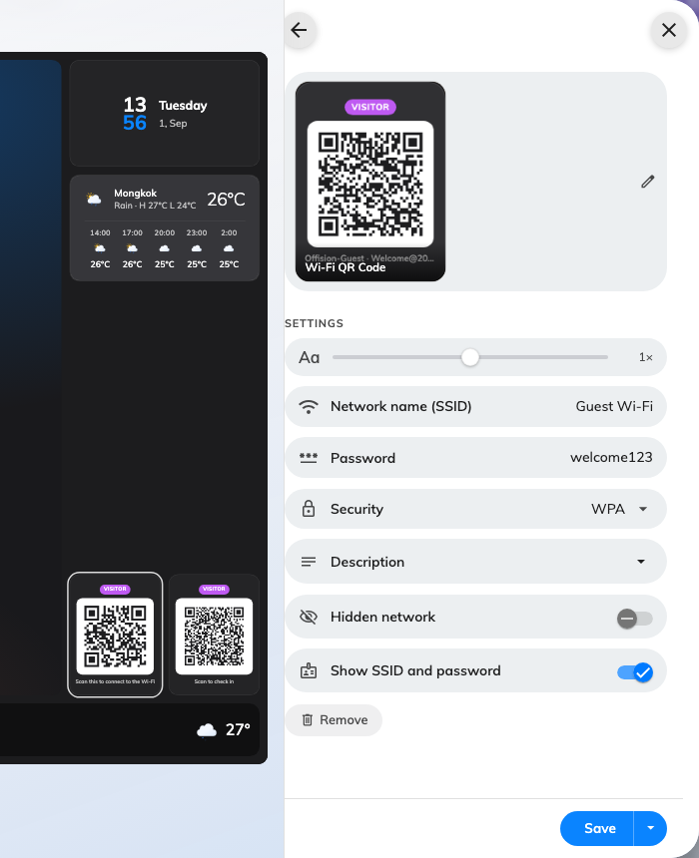
The Wi-Fi code's settings: the network the code joins, and what the tile says under it.

Wayfinding QR code
Scan it and directions open on the reader's own phone, starting from where
this screen stands — for anyone in the building, not just visitors. It has no
settings of its own beyond the shared ones.
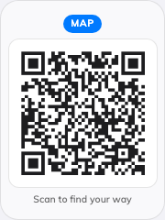
The wayfinding code on an action tile.
Can go on: Action buttons

Room control QR code
During a booking, the code lets the people in the room control its equipment
from their own phone. The code is itself the touchless path, so this tile
stays on screens without touch. It has no settings of its own beyond the
shared ones.
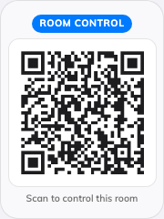
The room control code on an action tile.
Can go on: Action buttons

What these do not control
- What the code points at. Wi-Fi credentials come from the visitor Wi-Fi
settings, registration from the Visiting module, and a route from the floor
plan. The tile renders a code; it does not create the thing behind it.
- Their size and colour. The design-wide font size, appearance and widget
background apply to these like every other tile — see
Widgets and the places they go.
- A code somebody handed you. A payment code, or one issued by a bank or a
landlord, is a picture rather than a link — see
Show your own QR code on a screen.

