The Playlist widget
Plays one of your media playlists — an ordered mix of uploaded images, videos and documents — and where the playlist itself is edited.
2026-08-19 · https://offision.com/help/en/signage/playlist/
A slideshow of uploaded media — images, videos, documents — played in the
order the playlist says. The playlist is a thing of its own, built once and
reusable, so five screens can play the same rotation and a change to the
playlist reaches all of them.
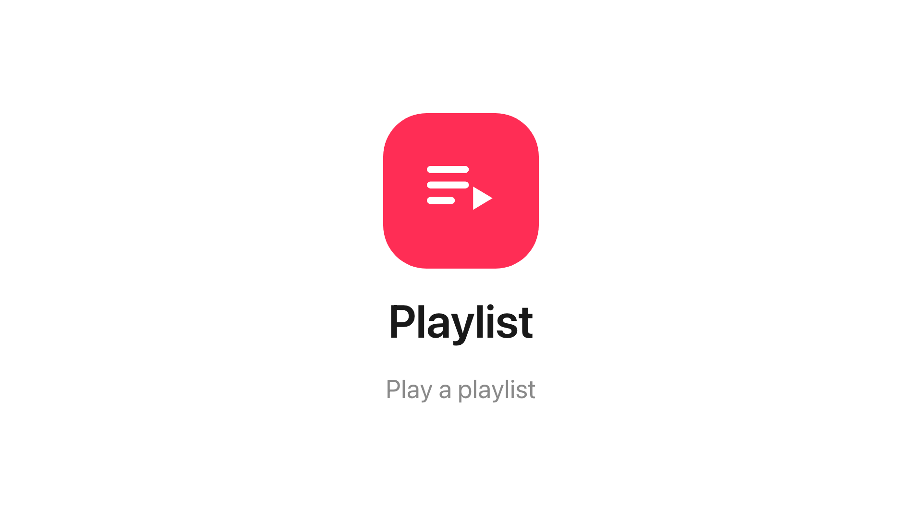
The Playlist widget on the main stage.
Can go on: Main stage · Info cards

Settings
Setting | What it does | When to change it
Playlist | Which of your playlists this widget plays | Pointing the widget at a different rotation — the playlists themselves are edited on their own page, not here

On the main stage a playlist counts as playback: a scene
rotation suspends its timer while it plays rather than
cutting media off mid-item.

What this does not control
- What is in the rotation. The items, their order and how long each stays
belong to the playlist itself — edit the playlist and every screen playing
it follows.
- Its size and colour. The design-wide settings apply as everywhere —
media widgets ignore the font size — see
Widgets and the places they go.

