The PDF Playback widget
An uploaded PDF page by page on the main stage, turning on its own timer — the document, the auto-advance and its pace, field by field.
2026-08-19 · https://offision.com/help/en/signage/pdf-playback/
A document, page after page — a menu, a programme, a slide deck exported to
PDF. Upload the file once and the screen leafs through it on a timer, which
turns any document into signage without rebuilding it as pictures.
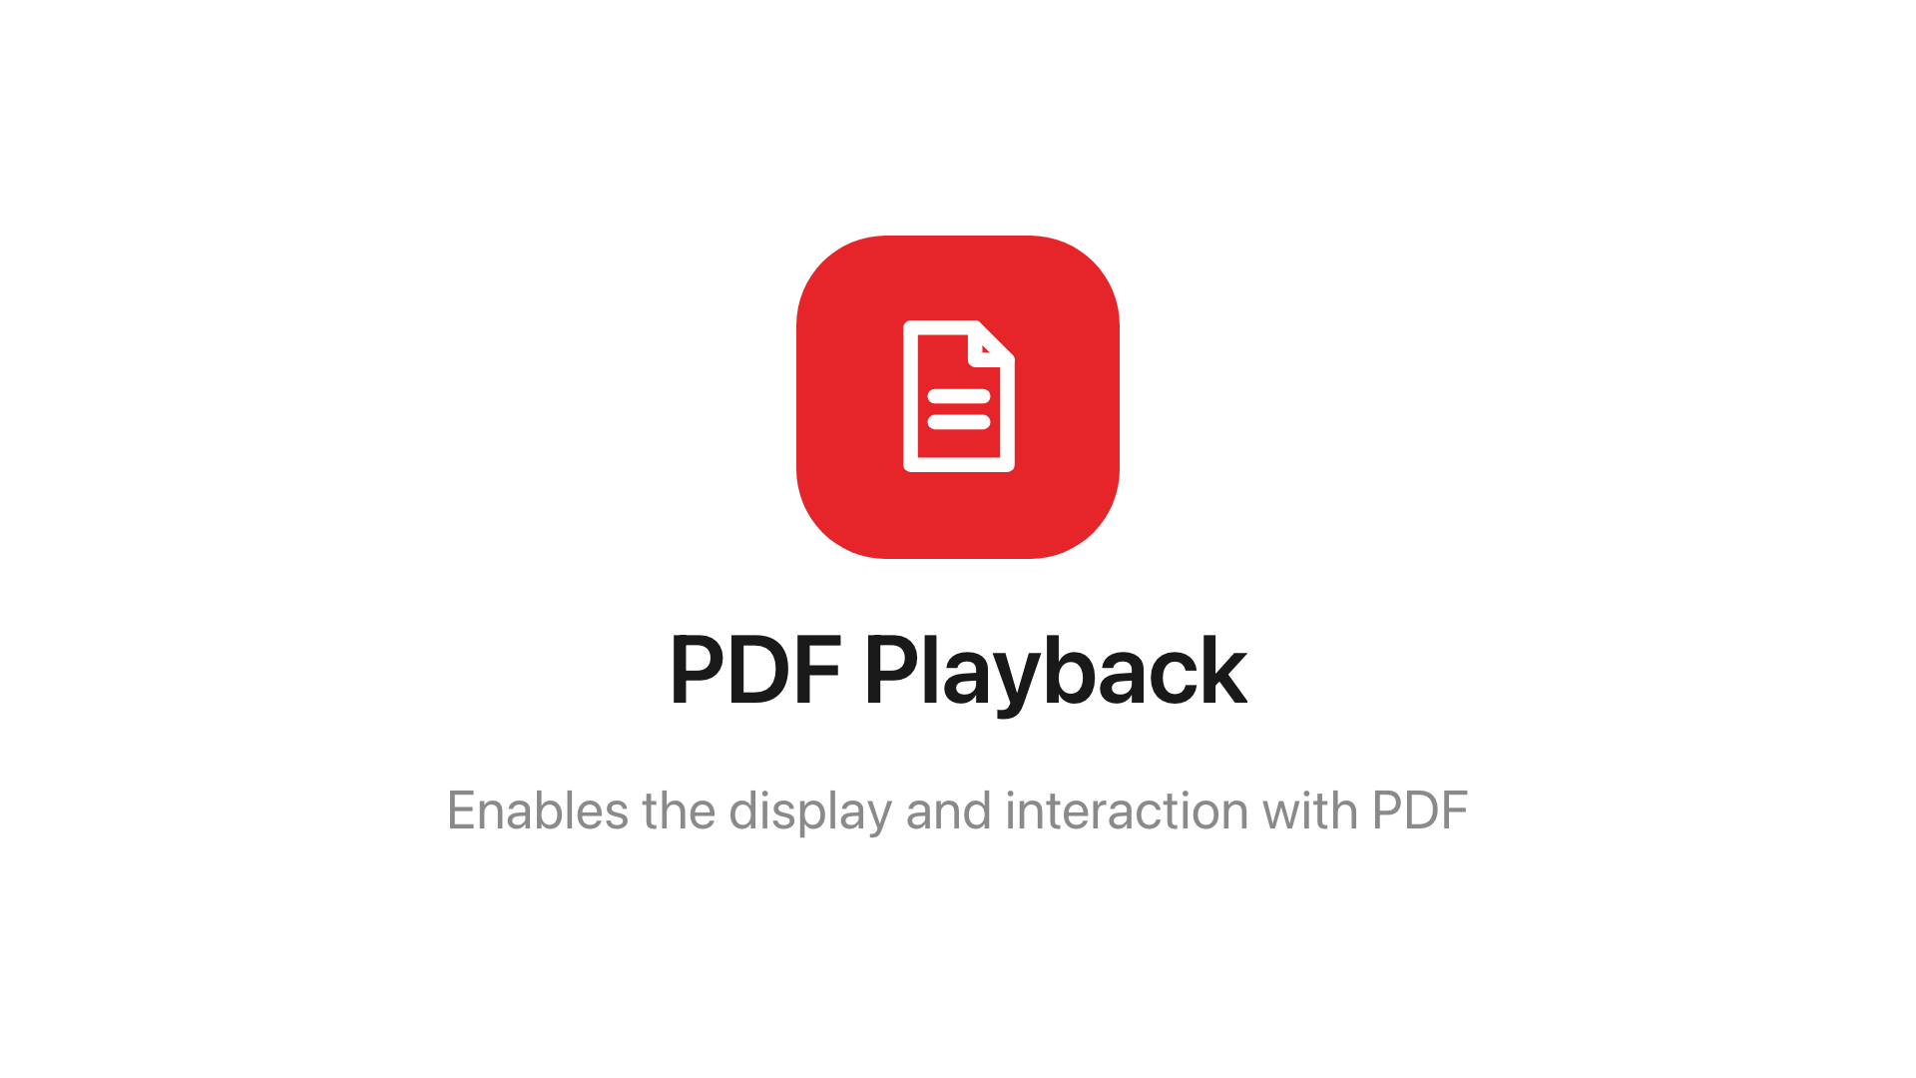
PDF Playback on the main stage.
Can go on: Main stage

Settings
Setting | What it does | When to change it
PDF file | The document it plays — the row opens the file page to upload or pick one | Swapping the document is this one row
Auto change page | Turns the pages on a timer — on by default | Off for a single-page document, or a screen someone reads up close
Seconds per city | With auto-change on, how long each page stays — 5 seconds by default | Dense pages need longer than posters

Long documents are trimmed: the widget plays up to the first 30 pages.

What this does not control
- What the pages say. The screen renders the uploaded file as it is —
fixing a typo means uploading a new PDF.
- Its size and colour. The design-wide settings apply as everywhere —
media widgets ignore the font size — see
Widgets and the places they go.

