The Lunar calendar widget
The traditional Chinese almanac on an info card — the lunar date, the zodiac year, and what the day favours and warns against. Where it fits, and what it reads in.
2026-08-19 · https://offision.com/help/en/signage/lunar-calendar/
Today, by the traditional Chinese almanac: the lunar date written large, the
zodiac year beside it, and the day's favourable and unfavourable activities —
the 宜 and 忌 a reception desk gets asked about before a signing or a move.
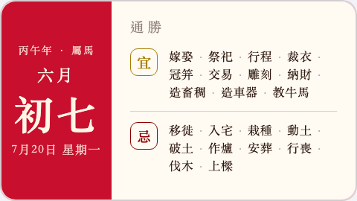
The almanac on an info card.
Can go on: Info cards

Settings
The widget has none of its own — click it and the editor says so:
"This widget uses its standard settings." Everything it inherits — font size,
appearance, background — is the shared settings in
Widgets and the places they go.
The almanac itself renders in Chinese whatever the design's display language —
its terms have no translated form.

What this does not control
- The ordinary date and time. The solar day at a glance is the
Clock widget's Today face.
- Its size and colour. The design-wide settings above are the only ones
it answers to.

