The HLS (HTTP live streaming) widget
A live stream on the screen, played straight from its HLS URL — a camera feed, live TV, a town-hall broadcast. One setting, the stream address.
2026-08-19 · https://offision.com/help/en/signage/hls/
Live video, straight from a stream. Anything that publishes an HLS address — a
camera, a broadcast, an event streamed from a media server — plays here as it
happens, which is what separates it from the uploaded-file widgets around it.
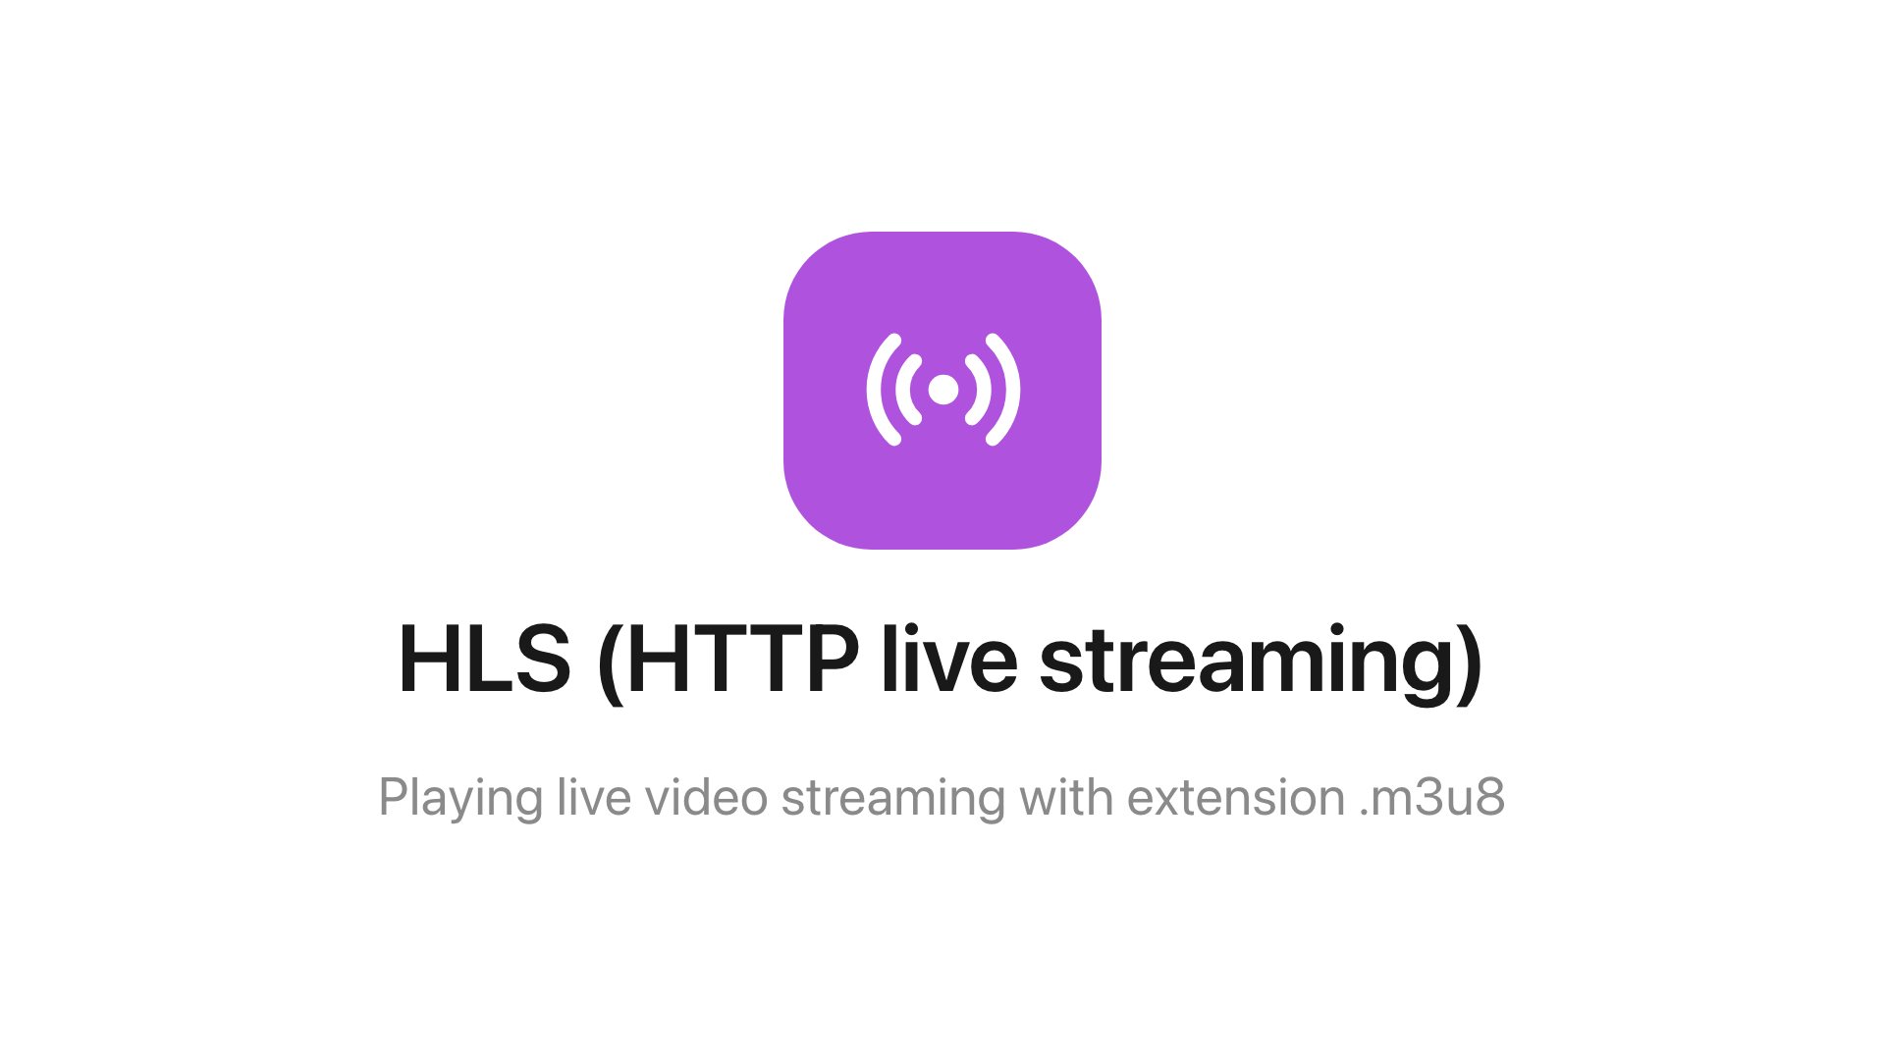
The HLS widget on the main stage.
Can go on: Main stage · Info cards

Settings
Setting | What it does | When to change it
Stream URL | The HLS address the screen plays — typically an .m3u8 link | Pointing the screen at a different feed; a dead link is a black widget

What this does not control
- The stream itself. What is on it, its quality and whether it is up are
the streaming source's business — the screen only plays what arrives, and it
needs a network route to that address.
- Its size and colour. The design-wide settings apply as everywhere —
media widgets ignore the font size — see
Widgets and the places they go.

