Build signage content and put it on a screen
Signage content is a design, not a screen — it belongs to no room and no building. How to create it, put something on it, save it, and pair the hardware that plays it.
2026-09-07 · https://offision.com/help/en/signage/build-signage-content/
Signage content belongs to no room and no building. It is a design — a welcome
screen, an availability map, a video that loops — and the same one can run on
every screen in the company. The hardware is a separate record, and it is the
hardware that knows where it is standing.
That is the whole reason creating content never asks which room it is for. It
asks about the screen: how big, what shape, and whether anyone can touch it.
Before you start:
An account that can manage signage and devices. The screen powered on, on the
network, and running the Offision player app — it should be showing a
six-character code. If you have no hardware yet, Preview window in the
wizard's brand step opens a screen in a browser tab and pairs exactly like the
real thing.

1. Create the content
Go to Signage › Content and choose Add.
Where in Offision: admin app → signage/signage-content (Signage)
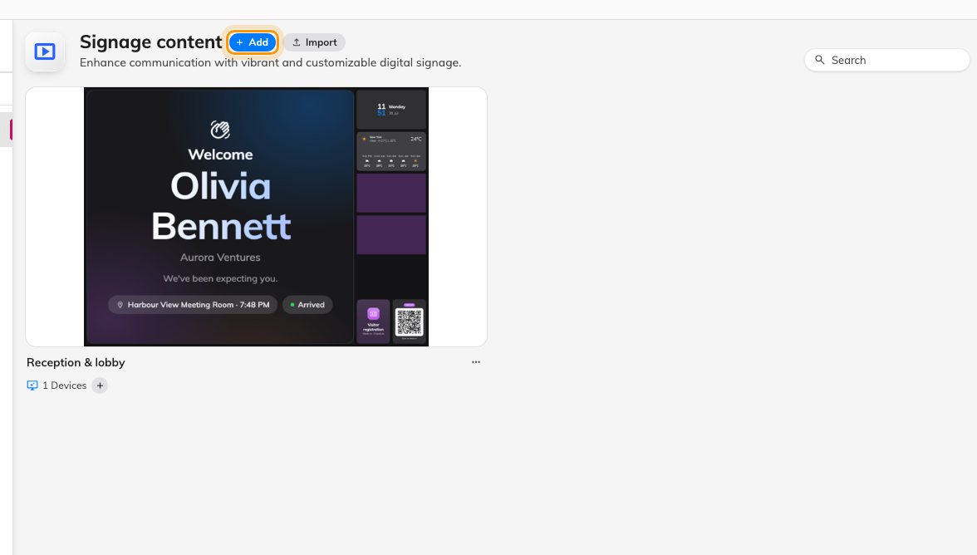
The content list, and the button that starts a new design.
The wizard asks two questions. The first is what the screen is for:
Purpose | Starts you with
Reception & lobby | A welcome screen, self-service buttons and a walk-in QR code
Floor display | A room map and today's bookings
Company communications | Video and announcements
Wireless sharing idle screen | The cast screen with a schedule beside it
Service panel | Service requests and tasks

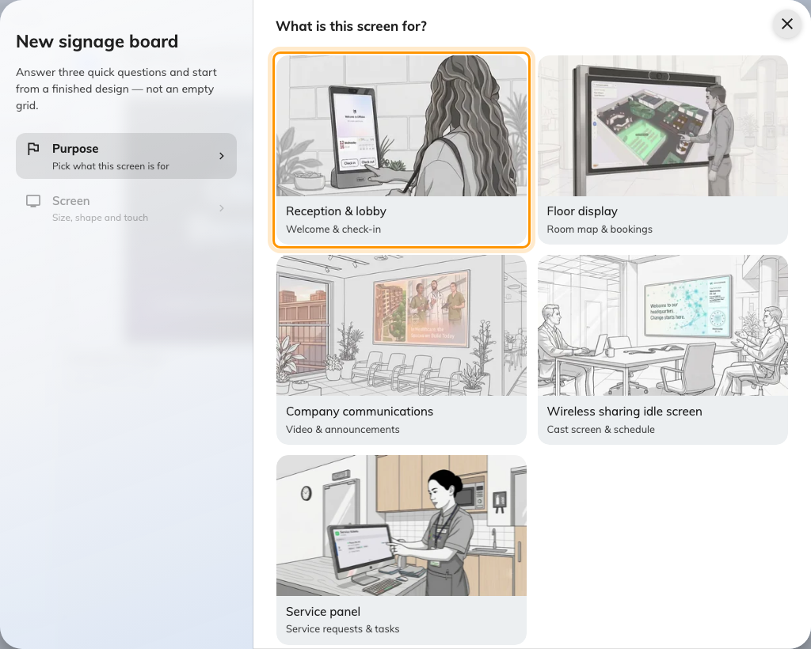
Reception & lobby, the first of the five purposes.
Picking one moves you straight on — there is no Continue button. The purpose also
becomes the content's name, which you can change in a moment.
Two purposes behave differently:
Wireless sharing idle screen skips the screen question entirely: it is only
ever a 43-inch landscape wall, so the wizard creates the content immediately.
Old template (legacy), the quiet link under the tiles, is not this system at
all — it opens a blank design in the classic free-form editor, where everything
is dragged and resized by hand. Nothing in these articles applies to it.

2. Describe the screen
The second question is the hardware: Orientation and Touch screen across
the top, then physical size and shape below.
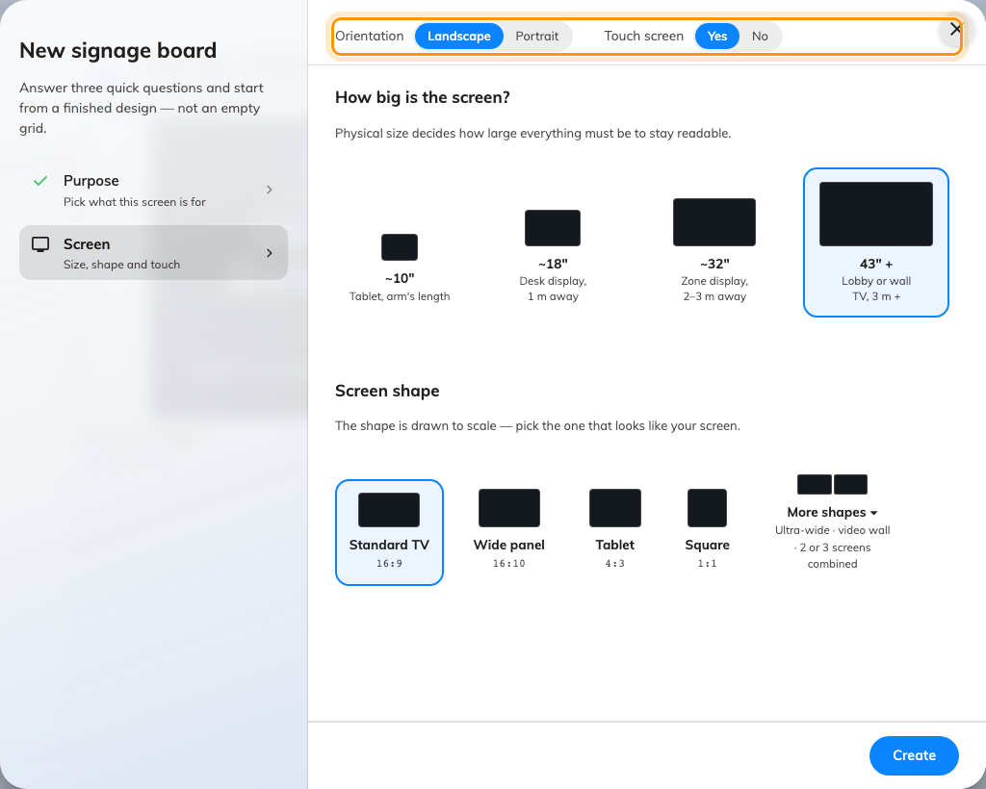
Orientation and touch decide the shape of the design; the size decides how large everything on it has to be.
Size is measured in inches, not pixels, and it is not cosmetic — it is what
decides how large the text has to be. Each option says the distance it is written
for: ~10" tablet at arm's length, ~18" on a desk a metre away, ~32" for a
zone display at two or three, 43" + for a lobby wall at three or more.
Shape is drawn to scale — Standard TV (16:9), Wide panel (16:10),
Tablet (4:3), Square (1:1). More shapes underneath adds the ultra-wide
and video-wall shapes, including two or three panels stacked into one canvas.
Touch screen is the answer people get wrong. On a screen nobody can touch, the
interactive widgets are hidden rather than shown-but-dead, and the visitor
self-service buttons are quietly swapped for a QR code — there is no point
offering a button nobody can press. Answer it honestly, or you will spend a while
wondering where your buttons went.
None of these answers is final. All four move to the editor's Screen page
later, and the design re-fits itself, so one drawn for a 10-inch tablet can be
widened to a 43-inch wall without starting again.
Choose Create. The content opens in the editor.

3. Learn the two surfaces
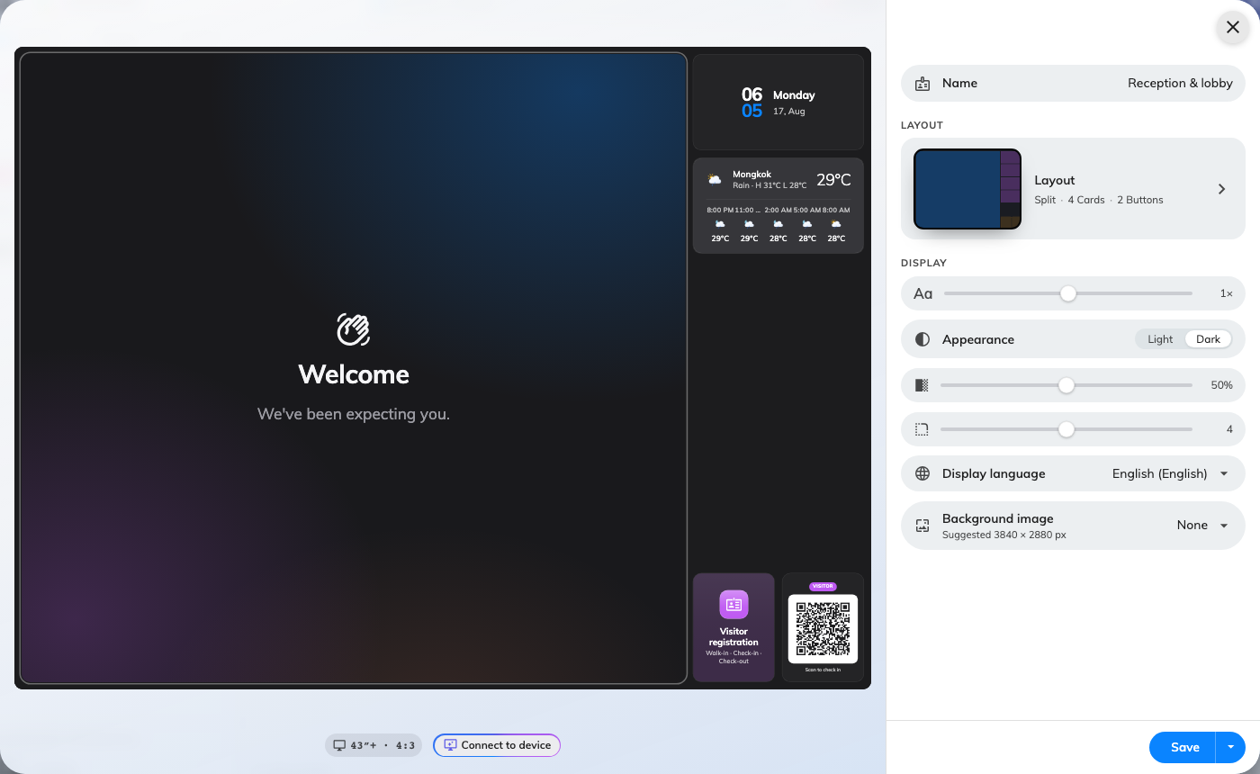
The screen as it will look, on the left; the settings for whatever you last clicked, on the right.
The editor is a live preview on the left and a sliding rail on the right, and
there are exactly two ways to change anything:
- Click a part of the preview to change what is in it. The big area, each
card, each button — clicking one opens its settings in the rail. This is the
whole of Widgets and the places they go.
- Open the Layout page in the rail to change what parts there are — how many
cards, whether there is a column beside the stage, which edge it sits on. See
Change a layout.
The rail's first page is the content's own settings — font size, appearance,
language, the background and the rest, each applying to the whole design rather
than to any one widget. They are listed in
Widgets and the places they go. The one to do now is
Name: give it one that says where it will be shown, since the purpose name it
arrived with will not stay distinctive for long.

4. Put something on it
Click the largest area of the preview — the main stage — and pick a widget.
Booking lists, room maps, video, a website, a welcome screen: what is offered
depends on where you clicked, because a tall list and a small square tile cannot
hold the same things.
That is as far as this article goes. Which widget can sit where is
Widgets and the places they go; playing several in turn
is Scenes; interrupting everything when a visitor arrives is
Takeovers.

5. Save it
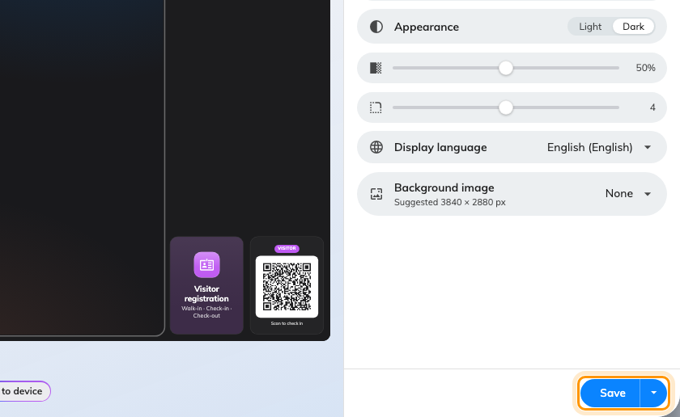
The save control, on every page of the rail.
The button at the foot of the rail is in two halves. The pill saves and leaves you
where you are — it flashes Saved and goes back to blue. The small caret beside
it offers Save and close.
Nothing is written until you press it. The ✕ in the corner asks before throwing
unsaved work away, and clicking outside the editor or pressing Escape will not
close it.

6. Connect the screen and give it a location
The content still shows nowhere. Nothing you have done so far has touched
hardware.
The screen itself is showing a six-character registration code. Add it under
Devices › Signage › Devices, or press ＋ on the content's own
card, and the wizard asks for the content, the brand of hardware, and those six
characters, and then for its Location on the floor plan — which every
location-aware widget on the screen reads. The whole walkthrough, brand by
brand, is in
Connect a signage screen.

8. Check it worked
Devices › Screen monitoring shows a live picture of what each screen is
actually displaying. It is the fastest way to confirm the content landed without
walking back to it — see
see what every screen is showing.
Then change something small in the editor, save, and watch the screen catch up.
That is the only check that proves the pairing, the content and the network are
all working at once.

What this does not cover
- Which widget goes where —
Widgets and the places they go — and playing
several things in turn — Scenes.
- Changing the shape of the design itself —
Change a layout.
- A reception screen specifically, where the walk-in QR code and the
device's location need more care than a general screen does — see
Set up a lobby screen for visitors.
- The screen's own settings — its name, its location and its connection are
edited on the device, not on the content, in Devices › Signage ›
Devices.

