The Booking status - Map widget
The floor plan live — every room and desk coloured by its availability, in 3D or flat from above. Every setting, grouped as the editor groups them: view, status, labels, interaction and location.
2026-09-07 · https://offision.com/help/en/signage/booking-status-map/
The floor plan itself, live: every room and desk drawn where it stands and
coloured by whether it is free, according to the bookings in
Booking. On a touch screen it is also a place to search, book
and take a route away by QR code.
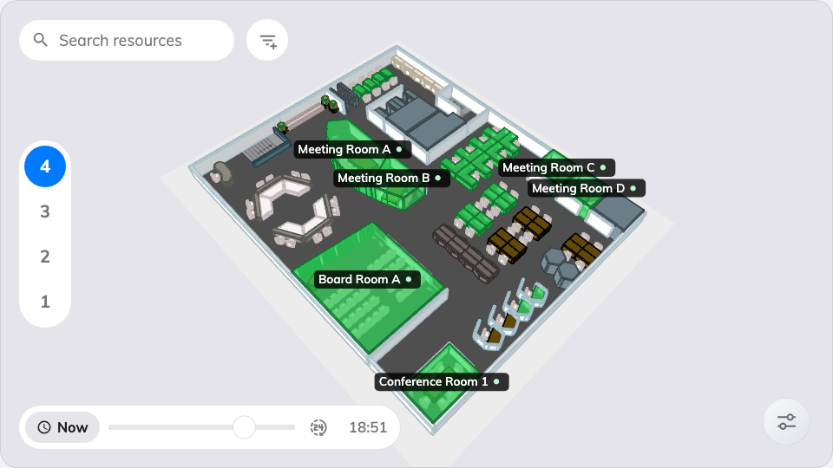
The map on the main stage.
Can go on: Main stage

Settings
The rail folds them into five groups; each is a page of its own.

Map view
The group opens with a card rather than a row. Its title is View mode, and it
holds two pictures of the same plan: 3D and 2D top-down. A design with
nothing stored plays in 3D, so a screen already on the wall is unchanged until
somebody chooses — see
Show the floor plan flat, in 2D.
Under it are the tiles for what a drag cannot say, and they differ per mode. In
3D they are starting poses for the framing — Top down, Tilted, Turn
left, Turn right and Recenter — and the camera itself is framed by
dragging the map in the editor's preview, floor by floor. In 2D there is no
camera to orbit: Turn left and Turn right move the flat map one quarter
turn each and are stored with the widget, while Recenter re-fits the whole
plan in the frame. Reset to default, at the foot of the card, clears the
framing and the turns and returns the widget to 3D.
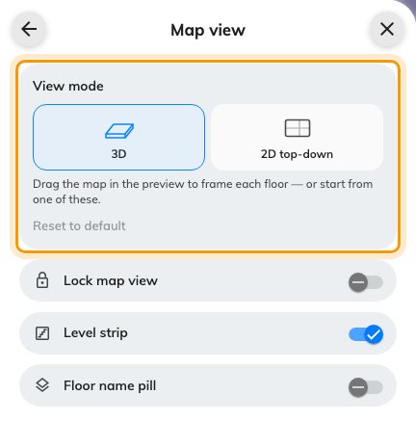
View mode, at the top of Map view: 3D, or 2D top-down.
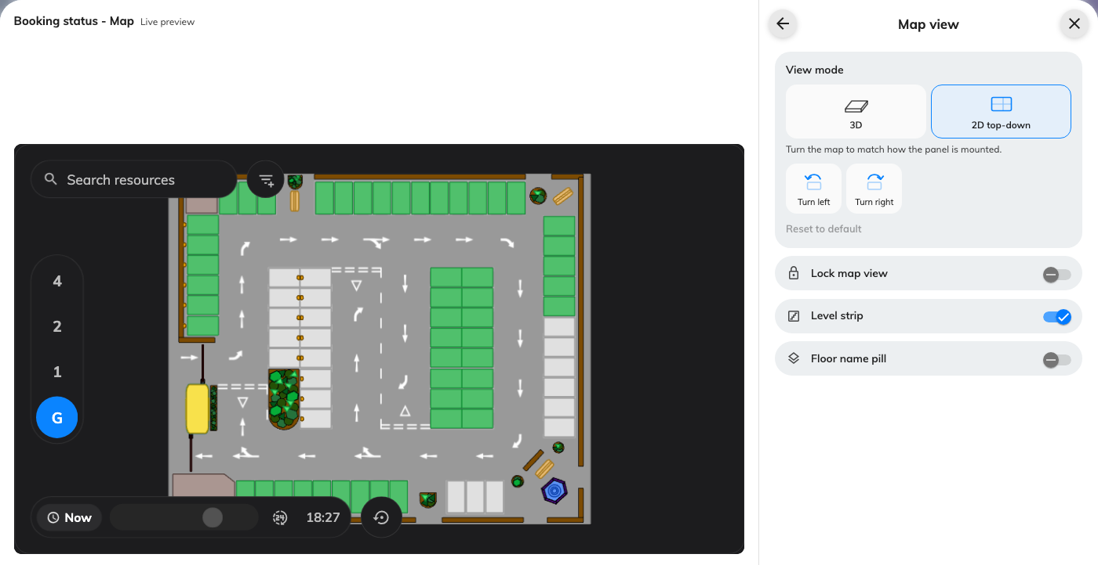
The same floor drawn flat in the live preview, with Turn left and Turn right in place of the 3D framing presets.
The rest of the group is switches.
Setting | What it does | When to change it
Lock map view | Freezes the view where you framed or turned it | The screen must never wander off the pose you chose
Level strip | The floor switcher along the map's edge | Off when the map shows a single floor anyway
Floor name pill | Names the current floor on the map | On when the level strip is off and the audience still needs to know which floor this is

Resource status
Setting | What it does | When to change it
Show remaining time | How long a busy resource stays busy | Off where the colour alone is the message
Show organizer | Who holds the current booking — with Organizer photo and Organizer name as separate switches once on | A staff-facing map; keep it off on a public screen
Availability legend | A key explaining the colours | A lobby audience that has never seen the map before
Short-available color | A third colour for rooms free only briefly, with Short-available threshold (minutes) and the colour to use | "Free but not for long" matters — walk-in meetings near the next booking
In-preparation color | Its own colour while a resource is being made ready, and which colour | Rooms with a service or cleaning gap between bookings
Waiting-check-in color | Its own colour while a booking waits for check-in | Check-in is enforced and the difference between reserved and arrived matters — see how check-in and no-show work

Labels
Setting | What it does | When to change it
Room labels | Whether rooms are named on the plan: Always show, Show when hover or Hidden | A dense plan where every name at once is unreadable
Desk labels | The same, for desks | Desk farms label better by zone than by desk
Equipment labels | The same, for equipment | —
Parking labels | The same, for parking spaces | —
Other resource labels | The same, for everything else | —
Label by access ID | Labels each resource with its access ID instead of its name; resources without one keep their name | The audience navigates by numbers — desk codes, lot numbers

Interaction
Setting | What it does | When to change it
Touch interaction | Whether the map responds to touch at all | Off for a display behind glass; the three switches below apply only while this is on
Resource search | A search box for finding a resource by name | On wherever people arrive not knowing where their room is
Show filter bar | On-screen filtering by resource type | A mixed plan where someone only wants desks
Time slider | Scrubs the map to a future time | People planning ahead, not just looking now
Scan-to-go QR on route | A QR code on a drawn route, to take the directions away on a phone | Works with or without touch — on a non-touch screen it is the only way to take a route along
Allow booking from map | Booking a free resource straight from its pop-up | The map is a booking kiosk, not just a status display
Require check-in | Booking from the map also demands check-in | Your booking policy expects it everywhere else too

Location
Setting | What it does | When to change it
Floors on the map | Which floors load: Follow device location, All resources, By building or By floor, with a matching picker | The screen should show its own building rather than every site
Type | Narrows the plotted resources by type; empty means Any resource type | Rooms only, on a plan that also holds desks
Auto-cycle floors | Steps through the floors on its own, at the Cycle interval (seconds) | A display covering several floors with nobody there to switch them

What this does not control
- The plan itself. Rooms, desks and their positions are drawn on the floor
plan in Booking's resource setup — the map only colours them.
- The widget background. This widget ignores the design-wide widget
background — the plan is its own surface. Everything else in
Widgets and the places they go applies.

