Set up a service people call for during a meeting
More tea, a spill, a screen that will not wake up — services asked for while the booking is running, from the panel, the app or a QR code on the table.
2026-08-25 · https://offision.com/help/en/service/set-up-a-service-people-call-for-during-a-meeting/
Before you start:
Read How a service request works first if you
have not. An in-use service and a booking service are set up on different pages
and cannot be swapped afterwards.
An in-use service is asked for while the meeting is happening. Nobody planned
it: the pot is empty, something has been spilled, the screen will not wake up.
Setting one up is the same form as a booking service with most of it removed —
which is the point of this article, because the differences are all in what is
not there.

1. Add it from the In-use service page
Where in Offision: admin app → service/real-time-service (In-use service)
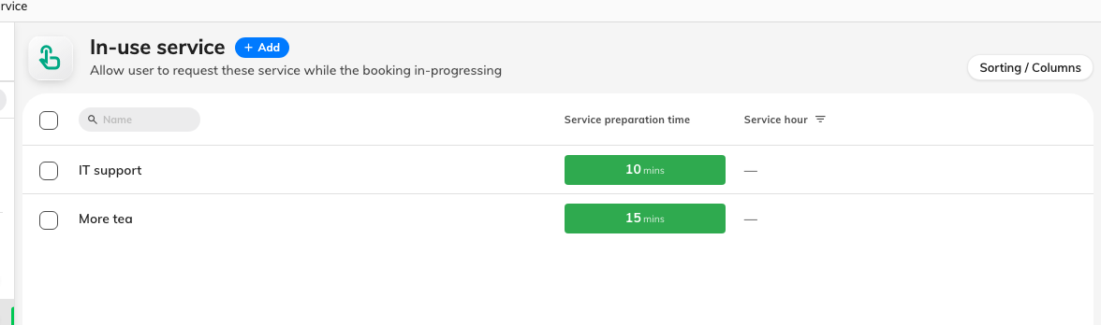
The In-use service list. One column instead of a timeline: how long staff are given.
Add the service here, not on the Booking service page. The page fixes how the
service can be ordered and there is no way to move it later.
Name it for what somebody in the room would ask for — More tea, IT
support, Clean up a spill.

2. Set how long staff are given
Where a booking service has a timeline, an in-use service has a single box:
Service preparation time, in minutes. Fifteen is the default.
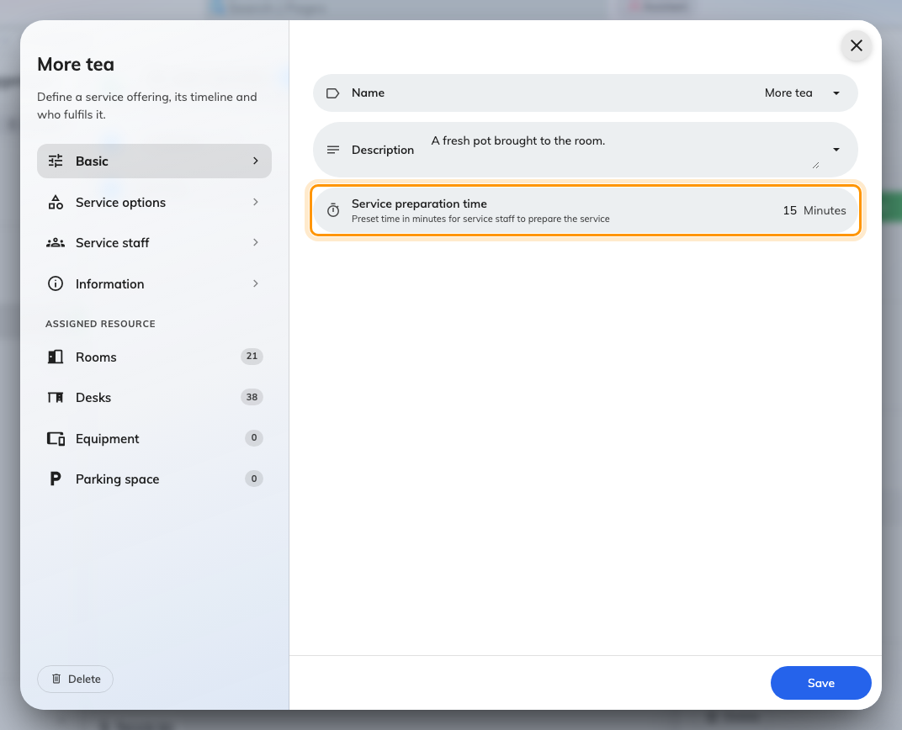
One box instead of a timeline: how long the request is given, counted from now.
That window is counted from the moment the request is sent, not from the
booking. There is no before or after, which means an in-use service never takes
time out of the room and never affects the booking after it. If you have been
worrying about preparation time blocking rooms, none of that applies here.

3. Add options, if there is anything to choose
Service options works exactly as it does for a booking service — a Checkbox
option for which drink, a Numeric one for how many cups, a Text one for anything
else. Keep it shorter than you would on the booking form: this is being tapped by
somebody standing up in a meeting.
For IT support, one Text option — "What is wrong?" — is usually the whole
form.

4. Say who answers
On the Service staff page, name the people who can actually come now. This
matters more than it does for a booking service: a request made at 15:20 is no
use to somebody who sees it tomorrow.
Set Service hours to the hours those people are really on. Outside them the
service cannot be requested at all, which is better than a request nobody
answers.

5. Put it on the rooms
Same as a booking service: pick the rooms under Assigned resource. A room
with no in-use services offers nothing to ask for, and the button to ask does not
appear at all.

Where people press it
All four of these reach the same queue:
Where | What they see
The app, while a booking is running | The in-use bar along the bottom expands; a Service button sits beside Extend and End
The panel outside the room | A Service sheet listing the room's services
The desk booking panel | The same request flow
A QR code on the table | Call service — and this one needs no Offision account at all

In the app it is the island along the bottom of the screen, which appears
whenever one of your bookings is running. Expanding it puts Service beside
Extend and End.
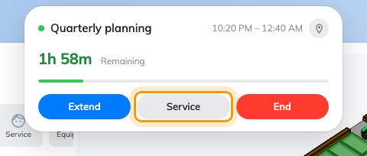
The in-use island, expanded. Service sits beside Extend and End.
Pressing it lists what this room offers, and the request goes with two taps.
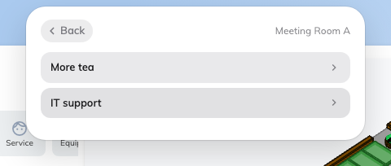
The room's in-use services. Pick one, set the options, Send request.
The QR code is worth knowing about: it opens a small page on the person's own
phone, so a guest in the room who has never heard of Offision can still ask for
tea. The option only appears when the room actually has an in-use service on it.
Whichever they use, the flow is the same three beats — pick the service, set the
options, Send request — and the room is attached automatically, so nobody has
to say where they are.

Check it worked
Book a room for right now and check in, then open the in-use bar in the app. The
Service button should be there, and the service you just made should be in
the list. Send one, and confirm it appears in Service requested in the
console with a member of staff against it.
Nothing to ask for in an empty room:
An in-use service can only be requested against a booking that is running. A room
sitting free offers nothing — that is expected, not a fault.

