Request service at the room panel
The Service button in the panel's dock — what the sheet lists, how a request goes out, and why an idle room offers nothing.
2026-08-20 · https://offision.com/help/en/service/request-service-at-the-room-panel/
The pot is empty, the screen will not wake up. Nobody leaves the meeting to
find someone — the panel by the door takes the request where the problem is.
Before you start:
The Service control appears only while a booking is running, and only on a
room that has in-use services
on it. An idle room offering nothing is expected, not a fault — there is no
panel setting for this button.

Where it is on the panel
Which control you get depends on the panel's skin:
Skin | Where
In-room control | Service in the dock along the bottom
Mini | Request service in the menu, while the room is in use
Modern | No service control — the app or the room's QR code is the route

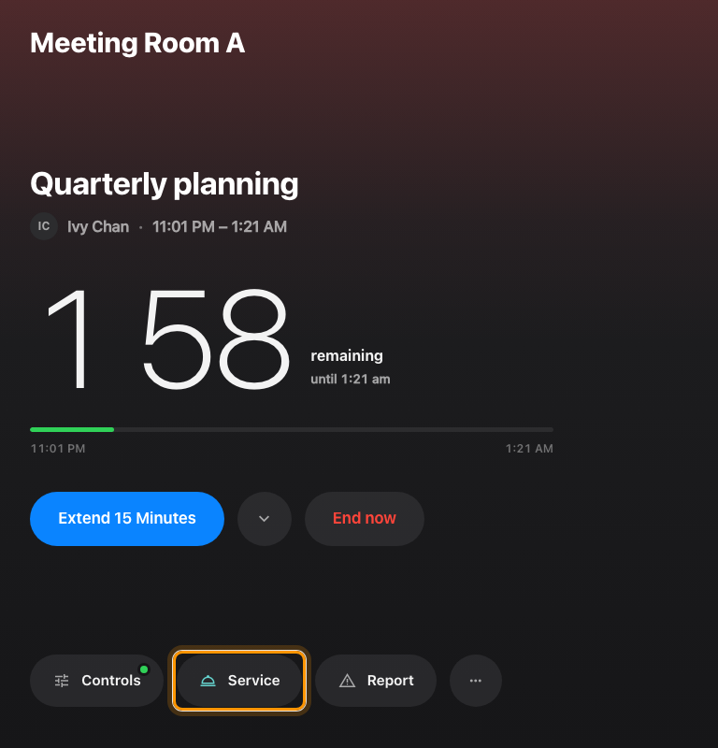
The in-room control skin's dock, with Service in the middle.

1. Open the Service sheet
Tap Service. The sheet lists this room's services under Service items,
and below them any Links the room carries — Request service and
Technical support rows that show a QR code to continue on your own phone,
no account needed.
A room with exactly one service and no links skips the list and opens that
service directly.
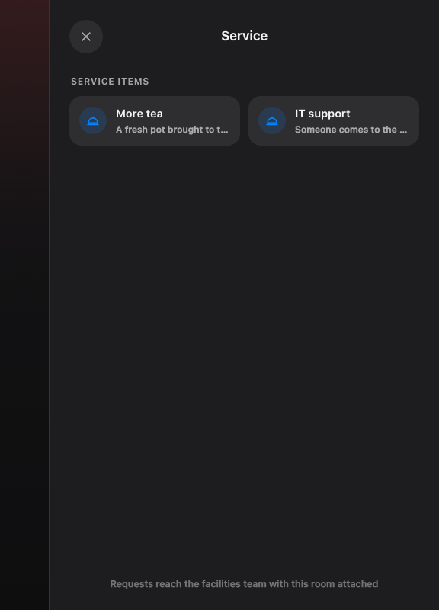
The Service sheet: this room's services, then the links.

2. Fill it in and send
Each service asks only what it was set up to ask — a count, a choice, a line of
text. A red dot marks what must be answered, and Note · optional takes
anything else. Then Send request.
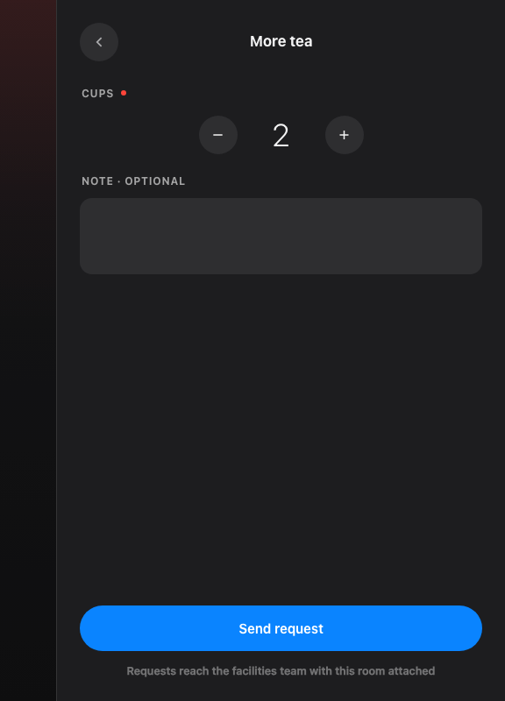
One service, filled in. Send request is the whole form.
The panel confirms — Request sent, The facilities team has been
notified — and the sheet closes itself. The room is attached automatically,
so nobody has to say where they are.

Check it worked
Open Service requested in the admin console. The request is there against
the room, with a member of staff already assigned, and it appears the moment
it is sent — staff working from the queue see it immediately.
Where in Offision: admin app → service/appointment-service-items (Service requested)
When a service is not offered:
Which services a panel offers is set on the service itself, under Assigned
resource — not on the panel. And a service outside its Service hours
disappears from the sheet until they start again, which is better than a
request nobody answers.

