Assign the people who fulfil requests
Who a request goes to, how it gets shared out, and where staff work through the queue. Includes the empty-staff-list trap that sends every request to everybody.
2026-08-18 · https://offision.com/help/en/service/assign-the-people-who-fulfil-requests/
Before you start:
This is set per service, not once for the whole module — so you do it on each
service you create. The people you name must already hold the Service staff
permission.

1. Give people the permission
A person can only receive service requests if they hold Service staff —
"Permission to handle the service request". Without it they will not appear
when you try to name them, and they will not see the queue.
Where in Offision: admin app → service/service-staff (Service staff)
There is a second gate underneath: handling requests is also a licensed
capability. Somebody with the permission but no licence sees nothing, and the
console says so — No service staff license. If a person has been given the
permission and still cannot see a queue, check the licence before checking
anything else.

2. Name the staff on the service
On the service itself, the Service staff page has Service staff / Service
staff groups. Name a group — the cleaners, the pantry team, the IT desk —
rather than individuals, so requests keep flowing when somebody changes role.
An empty list means everybody:
Leave this blank and the request goes to every person in the company holding
the Service staff permission — not to nobody. Nothing on the form says so, and it
is the usual explanation for "why is the IT desk being emailed about tea".

3. Choose how requests are shared out
Auto assign policy decides who a new request lands on.
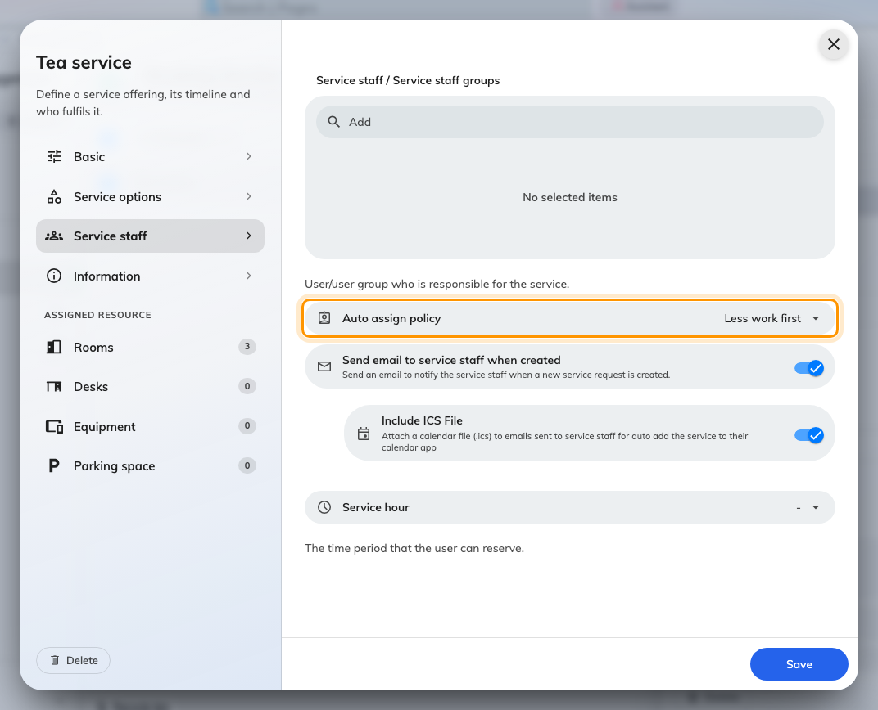
Auto assign policy, on the Service staff page of the service.
Policy | What it does | When to use it
None | The request arrives unassigned and waits for somebody to take it | A small team who watch the queue together
Less work first | Goes to whoever has fewest requests still open | The sensible default for a real team
Random | Spreads them arbitrarily | Where the work is uniform and fairness matters more than load

Less work first counts only requests that are still New or In progress, so
somebody who finished ten this morning is not punished for it.

4. Tell them a request has arrived
Send email to service staff when created emails everybody who could take the
request. A push notification goes out whether or not this is on, so turning it
off means staff must be watching the app.
Include ICS File attaches a calendar file, so the job appears in the staff
member's own calendar at the right time. It is on by default and worth leaving on
for anything with preparation time — a cleaner with the meeting in their calendar
does not need to be told twice.

5. Set when they are working
Service hour is the service's own opening hours. Outside them, the service
cannot be requested at all.
Where in Offision: admin app → service/service-hour (Service hours)
These are separate from the room's business hours and from the company's. A
pantry that stops at four does not stop rooms being booked at half past — it
stops tea being ordered for half past. Setting this honestly prevents the
requests nobody was ever going to answer.

6. Where staff actually work
Where | What it is for
Service requested, in the console | The full queue — list, table or calendar, upcoming or past
The Service page in the app | What most staff use day to day
A service panel on the wall | A shared queue for a pantry or facilities room
The room panel | Ticking off services in the room itself

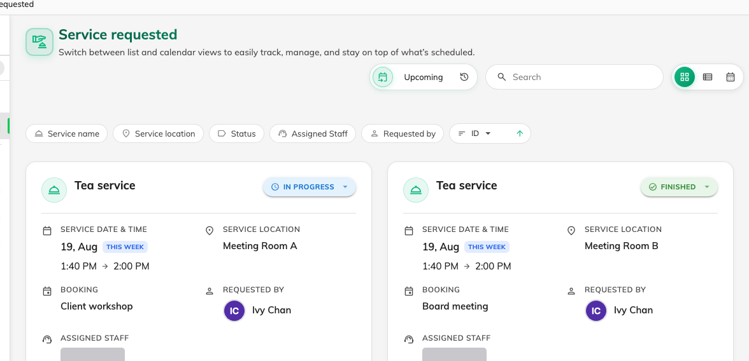
Service requested: every request, what it is on, and where it has got to.
Opening a request shows what was asked for, the options chosen, and Remarks
from organizer. Staff move it on with Processing, Finish or Reject,
and can write a Staff response back.
Only a single update notifies the requester:
The update dialog has a notify organizer tick, and that is the only thing
that tells the person who asked. Changing status or assigning in bulk from the
list never notifies anybody — useful when tidying up, surprising when you meant
to reply.

7. Check it worked
Raise a request as an ordinary user against a room the service covers. Then
confirm three things: it appears in Service requested, it already has a staff
member against it if you set an auto-assign policy, and that person was emailed.
If it arrived unassigned with a policy set, nobody eligible was free to take it —
check the staff list on the service and that those people hold both the
permission and the licence.
Before opening a ticket:
Have ready: the service name, the booking it was attached to, who was expected to
receive it, whether Send email to service staff when created is on, and
whether the person who should have received it holds both the Service staff
permission and a service staff licence.

