Open your service page in the app
What turns an ordinary Offision account into service staff — the Service staff permission, granted in the admin console — which requests then reach you, and where the page appears in the app.
2026-08-20 · https://offision.com/help/en/service-staff/open-your-service-page/
Everything in this guide happens in the Offision app — the same app everybody
books rooms in. Service staff are ordinary users with one extra permission, and
that permission is what grows a Booking service page on the app's left menu.
Before you start:
Somebody with access to the admin console has to grant this. If that is you,
the console side is
Assign the people who fulfil requests.

1. Get the Service staff permission
The permission is Service staff, and it is set on your account in the admin
console, under Service staff in the Service section. Without it the page
does not appear at all — there is no setting in the app that brings it back.
Where in Offision: admin app → service/service-staff (Service staff)

2. Check which services are yours
The same screen decides what you see, not just whether you see anything. Each
service in the catalogue names the staff and staff groups who fulfil it, and
your page shows the requests for those services only.
One thing surprises people: a service that names nobody is offered to
everybody. So an empty page usually means you were not named on any service,
and a page fuller than you expected usually means one service names no one.

3. Open the page
Sign in to the app and pick Booking service from the left menu — the green
icon, with a badge counting what is waiting on you.
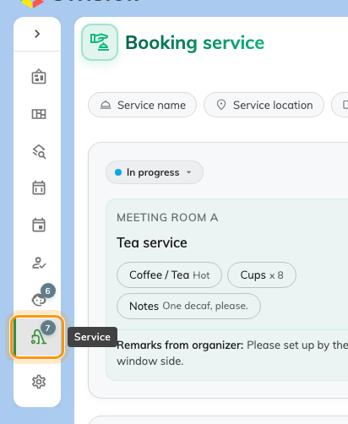
The app's left menu. Booking service carries a count of the requests waiting on you.

Check it worked
The page opens on today's requests. If it opens empty, check the period filter
first — it starts on Upcoming, so anything already delivered is one toggle
away, not missing. What the page shows and how to work it is
Run your service day from the app.

