Sign in and open your reception desk
What turns an ordinary Offision account into a reception desk — the Receptionist permission and a building assignment, both granted in the admin console — and where the Reception page then appears in the app.
2026-08-20 · https://offision.com/help/en/reception/sign-in-to-your-reception-desk/
A receptionist is not a special kind of account. You sign in to the ordinary
Offision app with an ordinary account, and what makes it a reception desk is two
grants an administrator makes in the admin console: the Receptionist
permission, and the building whose desk you staff. Once both are in place, a
Reception page appears in the app of its own accord — there is nothing to
install and nothing to add.
Before you start:
The receptionist needs an Offision account first, like any other member of
staff. The two steps below are made in the admin console, so they take an
administrator — a receptionist's own permission is not enough to grant it to
themselves.

1. Give them the Receptionist permission
This decides whether the Reception page exists for that user at all. Add
beside the title takes a user or a whole user group.
Where in Offision: admin app → visiting/reception-staff (Receptionist)
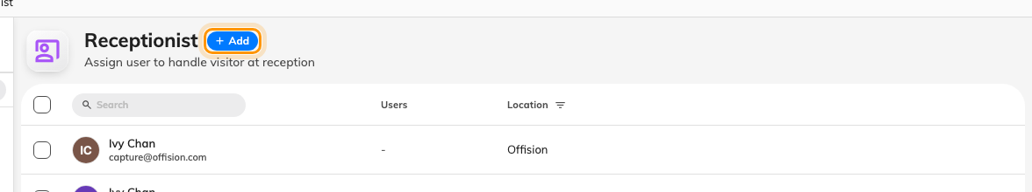
The Receptionist page. Each row also carries a Location — the next step.

2. Put them on the building's reception desk
Each building that takes visitors has a reception of its own, and a receptionist
sees only the visitors of the buildings they are on. This is the step that is
easy to miss, because the permission alone looks like it should be enough — a
receptionist whose Location is still blank opens Reception on You have not
been assigned to any reception setting in the management console.
Where in Offision: admin app → visiting/visiting-location (Visiting location)
Tick the building to open its panel on the right, choose Edit, then
Receptionist in the dialog. Add searches your users and user groups; a
building may have several.
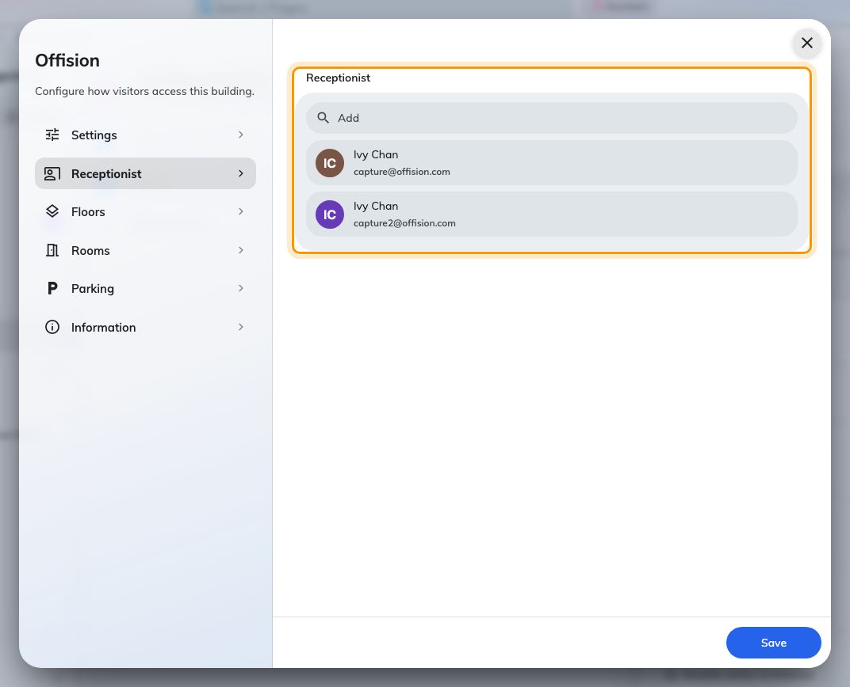
The building's Receptionist page, with the people who staff its desk.

3. Sign in and open Reception
Sign in to the Offision app the way everyone does — the
user guide covers it, including the
first-time password and a forgotten one. Reception is now one of the pages
on the app home: pick it from the menu down the left, or from the page switcher
on a phone.
The entry is personal, not company-wide: only accounts holding the
Receptionist permission have it at all, so a colleague looking at their own
home page will not see what you see — and cannot open your desk by knowing
where it is.
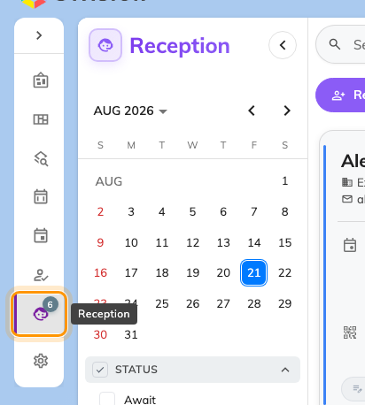
The home menu with Reception — an entry only receptionist accounts have.

4. Check it worked
Reception should open on Today's visitors for your building — a list, or an
empty day, but never an error. The two messages that mean a step above was
missed:
- The Reception page is not in the menu at all — the permission from step 1
is missing, or the account signed in is not the one it was granted to.
- You have not been assigned to any reception setting in the management
console — the permission is there but the building from step 2 is not.
From here, the day-to-day is the rest of this guide — starting with
what the day looks like.

