Run the visitor day from your home page
The Reception page as a working day — the five states a visitor moves through, how to find one person fast, and which action on their card does what, from check-in to check-out to printing the badge again.
2026-08-20 · https://offision.com/help/en/reception/run-the-visitor-day-from-your-home-page/
Reception shows one day of visitors for the buildings you staff, and the whole
job is on this one page: every visitor expected today, everyone already inside,
and everyone gone, each carrying the action that moves them along. The date at
the top is the day on screen — everything below it, including search and every
count, belongs to that day only.
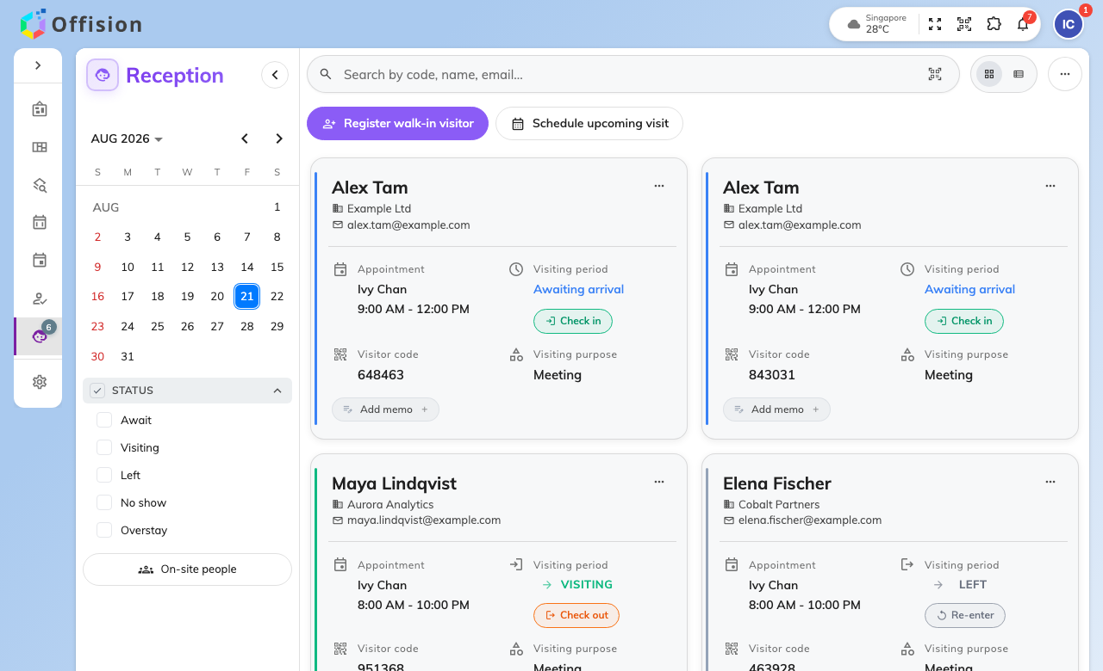
Reception on today, with each visitor's state and next action on their card.

The five states
Every visitor is in exactly one, and the card says which:
- Await — expected, not here yet. The card offers Check in.
- Visiting — in the building. The card offers Check out.
- Left — checked out. Re-enter covers the visitor who returns from
lunch; it does not create a second visit.
- No show — the day ended and they never came.
- Overstay — still inside past their expected leave time. This is Visiting
with a warning colour, not a different state to resolve: check them out
normally when they leave.
The last three are mostly the system's work — an administrator's policy can
sweep the day's stragglers to Left and No
show automatically — so an
evening of manual check-outs usually means that policy is simply not switched
on.

Finding one person fast
The search box matches on code, name, email — it is where a
scanned code lands too, so a
handheld scanner and a typed name end in the same place. Beside it, filters
narrow the list by building and by state, and the two small buttons switch
between card and list view. If someone is missing, check the date first: a
visitor for tomorrow is on tomorrow's page, not today's.

What each card can do
Beyond Check in and Check out, a visitor's card carries the smaller
tools of the desk: print or download their badge, Edit memo for a note the
next shift should read, and View photos where the visiting purpose collects
one. Above the list, Register walk-in visitor takes
the person with no appointment, Schedule
upcoming visit books one for a later day, and More actions holds the
day-level tools — the on-site list and its
export, export of the day, printing every badge
at once, and the label printer connection.

What this page does not control
What a visitor is asked — the form, the photo, the surveys, the badge design —
is configured per visiting purpose in the admin console, under
Visitor management. Inviting a visitor is the employee's own
job, from their app; the desk receives the visit, it does not
create the invitation.

