Register a visitor who arrives without an appointment
Registering someone at the desk who has no invitation. The reception form admits them as it saves — there is no separate check-in afterwards — and which fields it asks for comes from the visiting purpose.
2026-08-20 · https://offision.com/help/en/reception/register-a-walk-in-visitor/
Somebody arrives at the desk with no invitation and asks for a colleague.
Register walk-in visitor takes their details and admits them in one pass —
which is the part worth knowing before you start, because it does not work like
the visitor's own phone registration. Reception registers a visitor as
present: when the form finishes, they are already checked in, and their card
offers Check out rather than Check in.
Before you start:
Reception has to be set up for you first — the Receptionist permission, then
the building whose desk you staff. Both are covered in
Sign in and open your reception desk.
Without the second one the page opens on You have not been assigned to any
reception setting in the management console.

1. Choose Register walk-in visitor
Open Reception from the app home menu. Two buttons sit under the header:
Register walk-in visitor for the person standing in front of you, and
Schedule upcoming visit for one expected on a later date. On a phone both
are on the + button at the bottom right instead.
The distinction is not cosmetic. Reception's walk-in form registers for now
and only for now — the visiting date and arrival time are fixed and cannot be
edited. Anything for a future day is the other button.
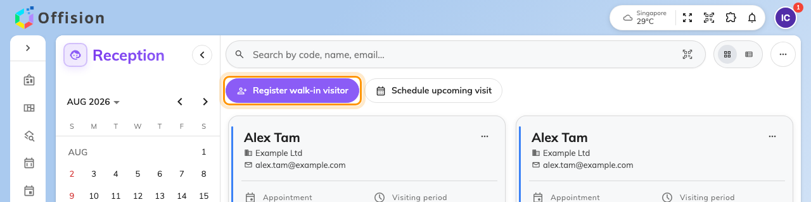
Reception, with Register walk-in visitor beside Schedule upcoming visit.

2. Fill in Visitor information
Everything about the visit and the visitor is on this one step, in this order:
- Visiting purpose — shown only when your organisation has more than one.
It is the first thing to get right, because it decides every field below it
and how many steps the wizard has. The default purpose is already selected.
- Visiting date and Arrival time — today and now, read-only.
- Expected leave time — the only part of the period you set.
- Location — the building, and optionally the room. The list holds only the
buildings you are a receptionist for, so a visitor for another site cannot be
registered from your desk.
- Inviter — who they are here to see. This field appears only when proxy
invitation is switched on for reception; without it, a walk-in is recorded
against no host.
- The visitor's own details — name, email or mobile, company, and whatever else
the purpose asks for. A red dot marks the ones you cannot skip.
Where your organisation has the business-card scanner, Scan business card
fills the visitor's details from a photograph of their card instead of typing.
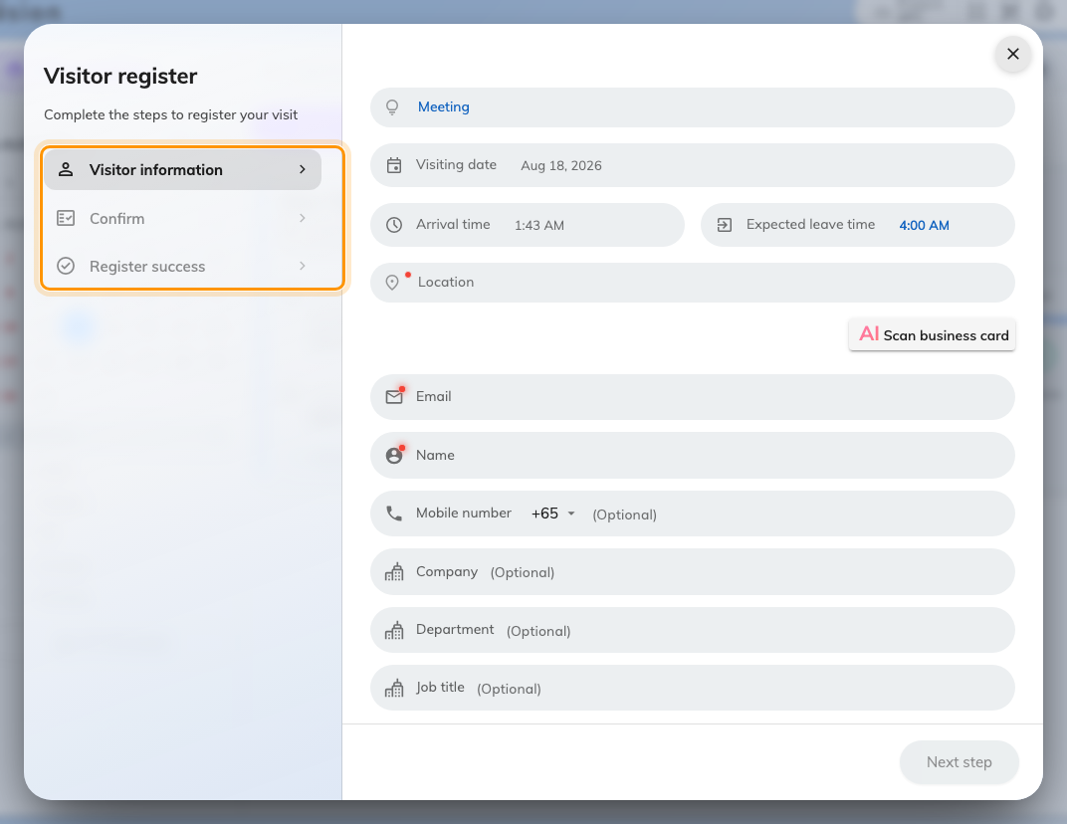
Visitor information. This purpose asks for no photo and no survey, so the wizard is three steps.

3. Take a photo
The purpose decides whether this step exists at all, and whether you may pass
it. Where the photo is required, Next step stays greyed until one is taken —
so a purpose that demands a photo cannot be completed by a receptionist working
from a desk with no camera.

4. Answer any Visitor survey
Each survey attached to the purpose is a step of its own — a health
declaration, an NDA, a site-safety question. Ask the visitor and record their
answers.

5. Confirm and submit
The last step is a read-only recap of everything: the visit, the visitor, the
vehicle and any survey answers. Read it back to the visitor, then Submit.
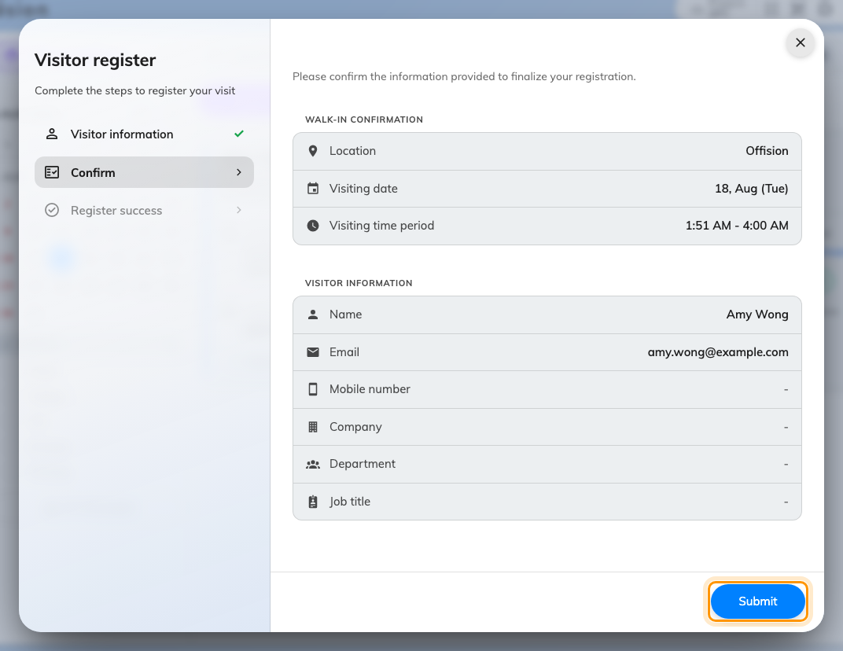
The confirmation step, with Submit in place of Next step.

6. Hand over the pass
The dialog turns into the visitor's pass: Register success, their Visitor
code, and a QR of the same. That code is what they show at a lobby board or a
gate, and what you search on if they come back to the desk later.
A label printer connected to this computer prints the badge on its own, with no
further action. If nothing prints, no printer is attached yet — see
Connect a badge printer to your reception desk.
Register another visitor clears the form and keeps the dialog open, which
is the one to use when several people arrive together. Done closes it.
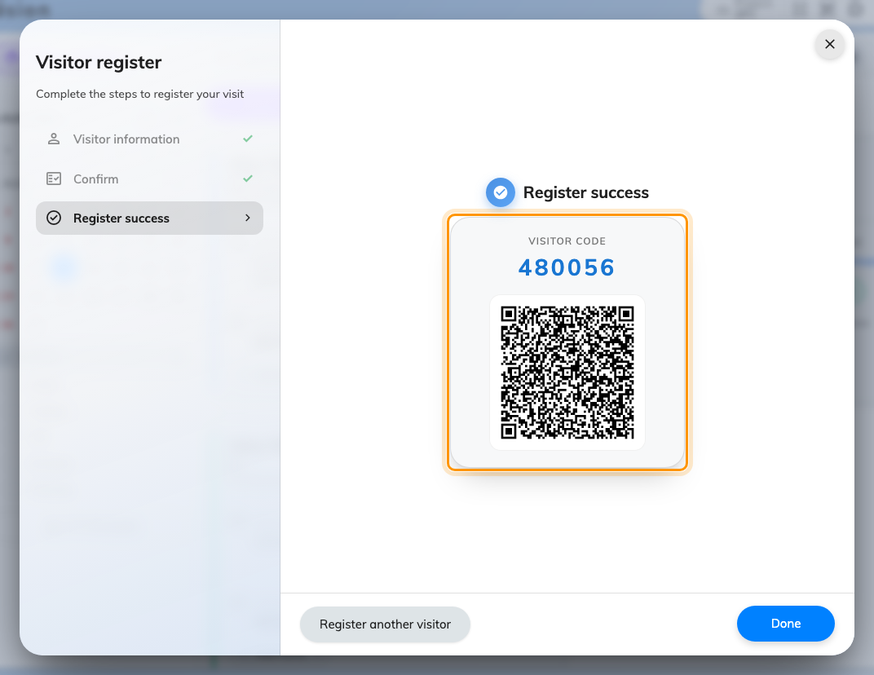
The finished registration, with the visitor code and its QR.

7. Check it worked
Close the dialog and find them on the list. Their card should read Visiting
under Visiting period with the time they arrived, and offer Check out.
If it offers Check in instead, the form did not finish — a reception walk-in
is never left waiting to be admitted.

What the admin console controls
Half of the form is conditional, and each conditional part is one setting on one
admin page. This is the table to read when a field a colleague describes is not
on your screen.
What changes in the form | Setting | Where
The Inviter field appears | Allow proxy visitor invitation by reception | Visitor self registration form
Which visitor fields are asked for, and which are required | the purpose's per-field Hidden / Optional / Required | Visiting purpose
Whether Take a photo is a step at all, and whether it can be skipped | the purpose's Photo field | Visiting purpose
Whether View photos appears on the card afterwards | Reception can view the photo | Visiting purpose
How many Visitor survey steps there are | the surveys attached to the purpose | Visiting purpose
The vehicle section appears | Allow invited visitors to register vehicle | Visiting policy
No pass is issued — the visitor waits for approval | Visitor need approval | Visiting policy
The host is emailed the moment you submit | Notify host when a walk-in visitor arrives | Visiting policy
Which buildings the Location list offers | the building's Receptionist list | Visiting location

The one setting that is reception's alone is the first — everything else is
shared with the visitor's own self-registration.
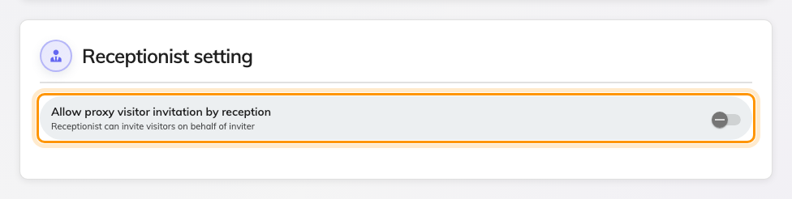
Receptionist setting, the only section of this page that changes reception's own form.
Where in Offision: admin app → visiting/walk-in-setting (Visitor self registration form)
Where in Offision: admin app → visiting/visiting-type (Visiting purpose)
Where in Offision: admin app → visiting/visiting-policy (Visiting policy)
When no pass comes back:
Where the location's policy requires approval, submitting ends on Visiting
request has been submitted and is currently awaiting approval. with no visitor
code and no badge. The visitor has not been admitted — they are recorded and
waiting, and someone has to approve them
before they can go in.
If the photo fails to save:
Failed to save the photo means the registration itself went through and only
the picture did not. Do not register the visitor again — take the photo from
their card on the list instead.

