Export the people on site
Getting the list of everyone currently in the building out of Offision as a spreadsheet — the On-site people dialog, one Excel file per building, and the admin console's export when the desk is not enough.
2026-09-02 · https://offision.com/help/en/reception/export-the-people-on-site/
Who is in the building right now is a question the desk gets at fire drills,
at the end of the day, and whenever security asks — and it has one answer:
On-site people, which lists every visitor currently inside and hands each
building's list over as a spreadsheet.
Before you start:
The list counts visitors whose state is Visiting or Overstay — people
checked in and not yet out. A visitor who slipped past the desk without
checking in is not on it, which is the reason to check everyone in at arrival
rather than at convenience.

1. Open On-site people
On the Reception page, open More actions at the top of the list —
On-site people is the first entry.
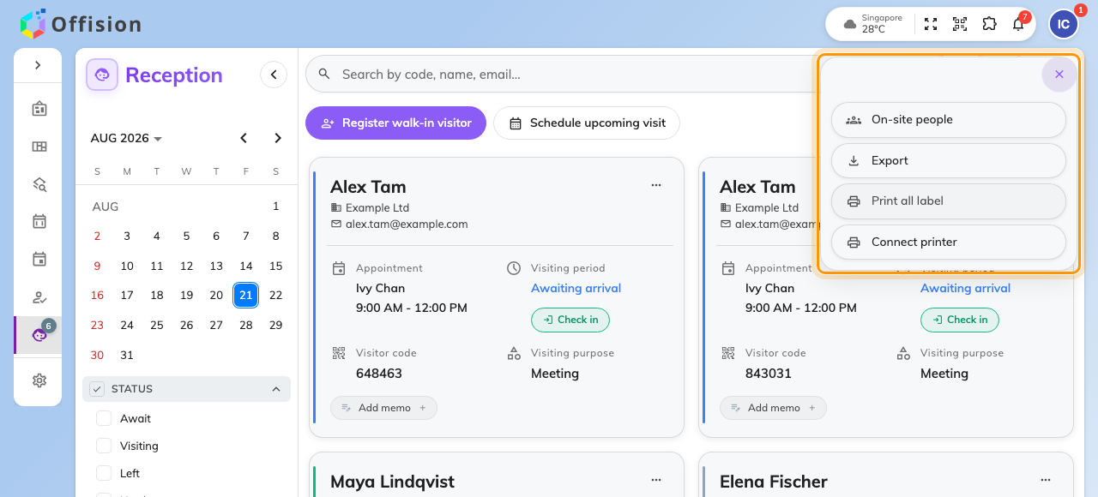
More actions, with On-site people at the top.

2. Read the list
The dialog shows everyone on site, grouped by building, with a count beside the
title and a live clock beside that — so a printout or a screenshot carries the
moment it was true. Each row is one visitor: name, email, phone number,
company.
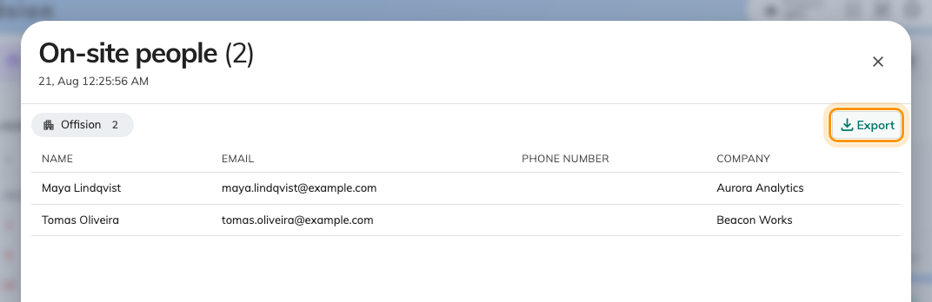
On-site people, grouped by building, with Export on each group.

3. Export a building
Export on a building's header downloads that building's list as an Excel
file — the same four columns as the dialog, named after the building and the
moment of export, so successive exports never overwrite each other. Each
building exports separately; for two buildings, click twice and you have one
file per muster point, which is usually what an evacuation wants anyway.

4. Check it worked
Open the file: the sheet carries the building's name and one row per person
who was in the dialog's group. If a row you expected is missing, the visitor
was not checked in — their card on the Reception page still says Await.
The day's whole list is a different export:
Export in the same More actions menu exports the day — every visitor on
the page in every state, expected and gone included, with the full detail of
each visit. On-site people is the snapshot of now; the day export is the
record of today.

From the admin console
Administrators have the same answer without a desk: the visitor badge list can
be filtered to state Visiting and exported with Export all, which
respects the filter. It covers every building at once, but it is an admin
console page — the Receptionist permission alone cannot open it.
Where in Offision: admin app → visiting/visiting-record (Visitor badge)
For a whole day's records rather than the snapshot of now — everyone who came,
when they checked in and out — the admin console's
Visiting daily report downloads
one day as Excel or PDF.

