Connect a badge printer to your reception desk
Printing visitor badges at the desk — the app a printer can only be reached from, putting a Brother QL on the network, and connecting it from More actions on the Reception page, on Windows, a Mac, or a phone or tablet.
2026-08-25 · https://offision.com/help/en/reception/connect-a-badge-printer-to-your-reception-desk/
A visitor checks in at your desk and you hand them a printed badge. The badge
itself comes from Offision, but the printer does not: a web page is not allowed
to reach hardware on your network, so Offision in a browser tab has no printer
to print to. That is why the printer rows on the Reception page look inert
until you install the app.
The desktop app can reach it. It talks to a Brother QL label printer straight
over the network — no driver, no cable, nothing to install on the printer side —
and once you have pointed it at one, it prints every badge you ask for and
remembers the printer through restarts.
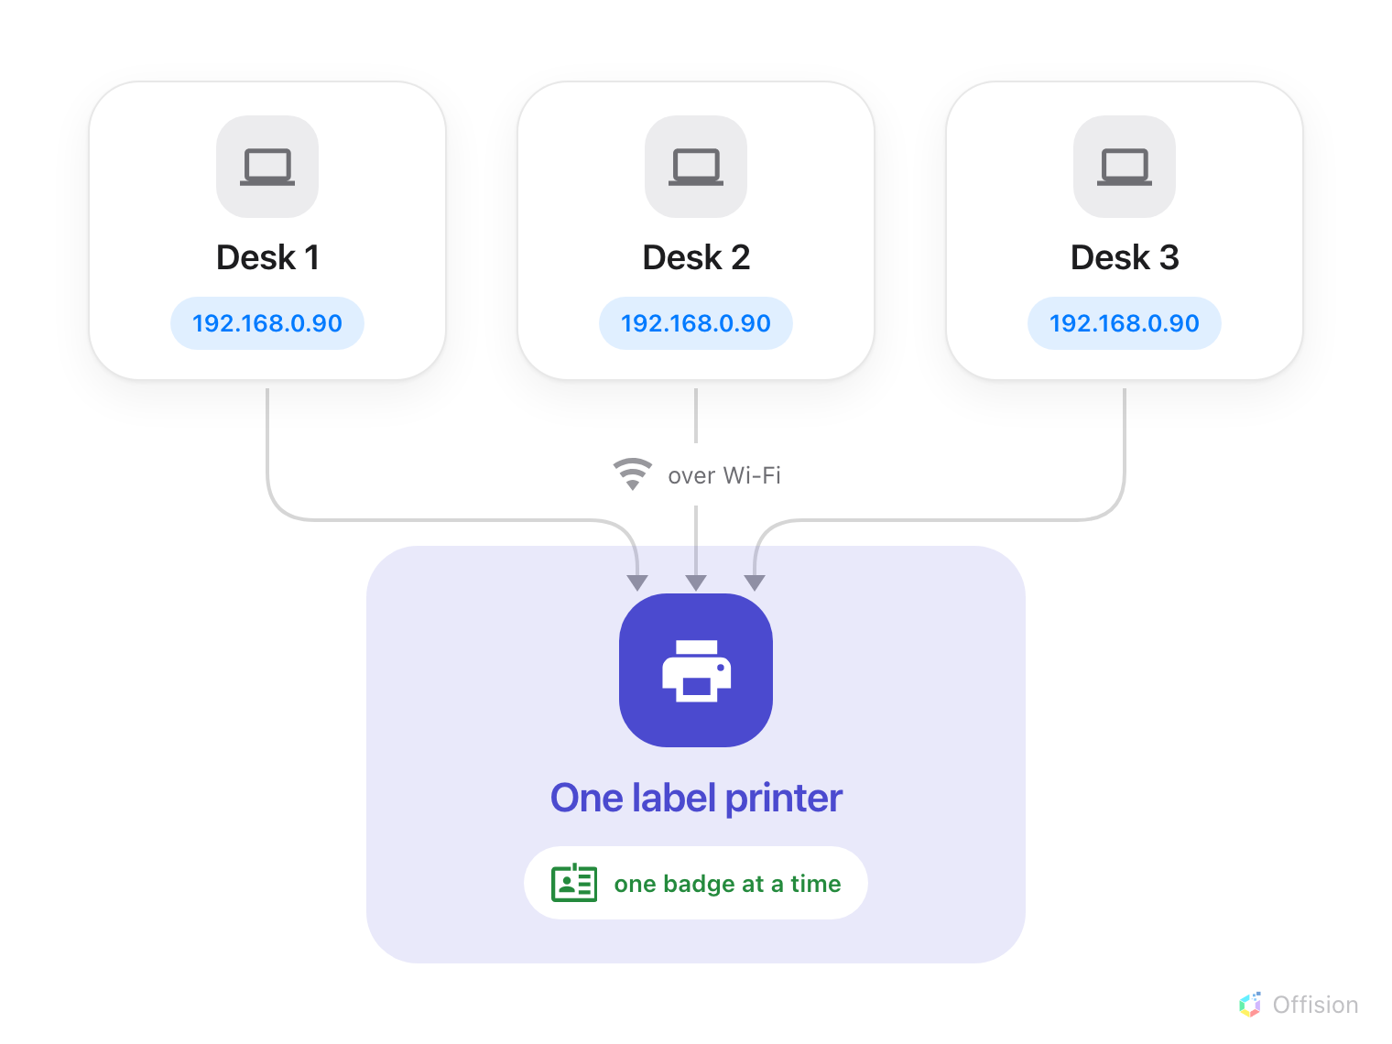
The printer is on the network, not on a cable — so each desk is set up on its own computer, and they all print to the same printer, one label at a time.
Before you start:
An account that already opens the Reception page — if it does not, start with
Sign in and open your reception desk.
You also need permission to install software on this computer, and the printer
has to sit on the same network as it.

1. Install Offision on the desk computer
Take the file for this machine and run it.
Neither installer asks for an administrator password. If you want the longer
version — what the installer does, what macOS asks on first launch, and why you
never have to come back for an update — see
Install the Offision desktop app.
An Intel Mac is not covered by the Mac app, and a browser is no substitute
here: it is the whole of Offision except the printer. A desk on an Intel Mac
needs a different machine, or the
screen at the lobby printing instead.
Every device that can drive a printer is listed in
Which devices can print to a label printer.
The desk does not have to be a computer at all — a phone or tablet prints the
same badges, and its store links are further down.
Then sign in, the same way you sign in to Offision anywhere else, and open the
Reception page.

2. Put the printer on the network
Offision prints to a Brother QL over the network, so the printer needs to be
on your Wi-Fi or plugged into the network — not into the computer. Load a
62&nbsp;mm DK label roll before you start; the app reads which roll is in
there and sizes the badge to it.
Print the printer's own network settings page from its menu while you are
standing at it. The address on that page is what you will need if the app cannot
find the printer by itself.

3. Open Connect printer from the Reception page
At the top of the Reception page, open More actions. With the app installed,
the menu carries a printer row of its own: it reads No printer found until a
printer is set, and Connected once one is.
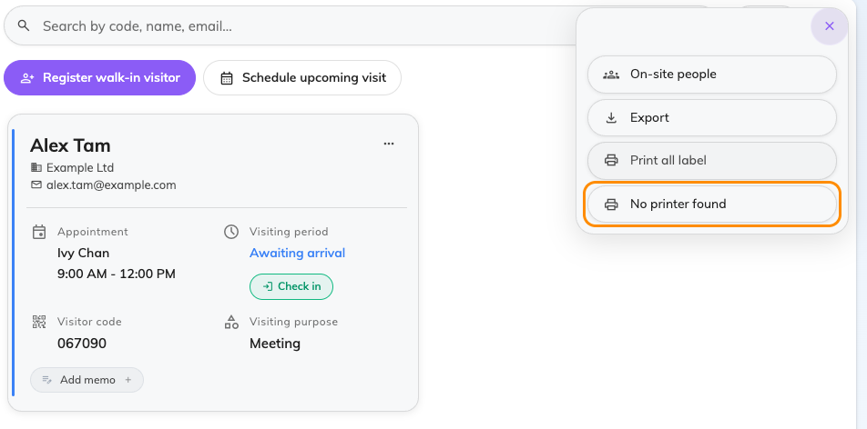
More actions on the Reception page. The printer row reads No printer found until a printer is set.
In a browser that row says Connect printer instead, and opens a page of
printer suggestions rather than a connection — which is the fastest way to tell
that you are not in the app yet.
Choose the row. Connect printer opens, with an empty Printer list and a
large Select a printer tile.
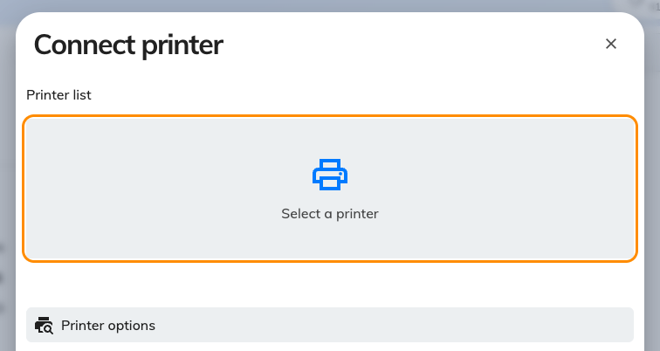
Connect printer, before a printer has been chosen. Printer options underneath lists the models Offision prints to.
Tap Select a printer.

4. Find the printer in Label printing
A window called Label printing opens. This one belongs to the app itself
rather than to the page behind it, so it has its own place on your dock or
taskbar.
Leave Printer brand on Brother. The other choice, System printer, is
a Windows-only fallback for a printer already installed on that PC — on a Mac it
lists nothing, whatever is attached.
Under Printers the app scans the network on its own; Scanning… turns
into the printer's name when it finds it. If nothing appears, Rescan, and
failing that Add by IP with the address from the printer's settings page —
the field shows the shape it expects, Printer IP, e.g. 192.168.0.90.
Choose the printer. Label paper then fills in by itself — the roll's width,
and whether it prints black only or black&nbsp;&amp;&nbsp;red — read from the
printer, not chosen by you. Swap the roll and pick the printer again to re-read
it. Print quality trades speed for sharpness and is fine on Normal.
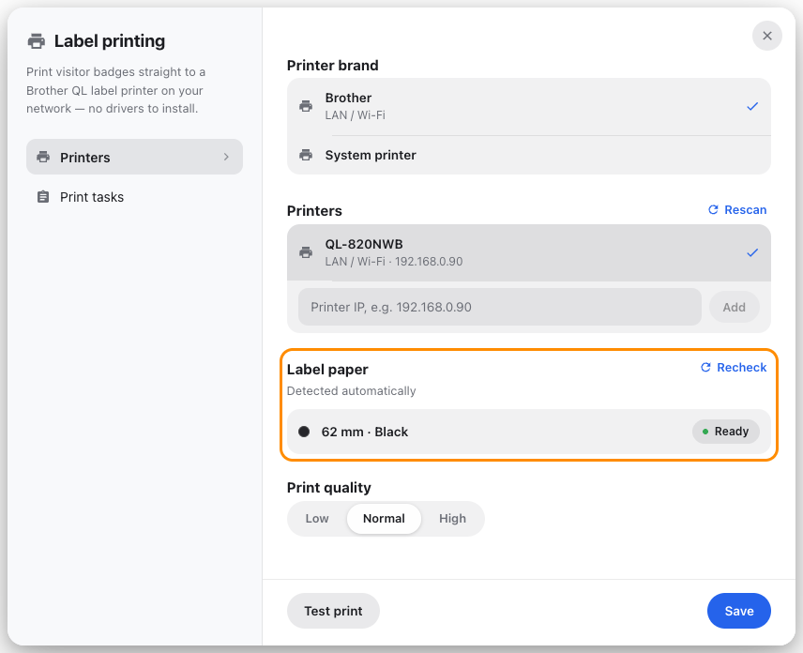
Label printing, with the printer found on the network and its label roll read back from it.
Now Test print. A label should come out within a few seconds — that is the
difference between a printer that is genuinely reachable and a name in a list.
Then Save. The computer remembers this printer from now on, and finds it
again by itself if its address changes.

When a Mac says it can't reach the printer
Can't reach the printer on a Mac is almost always macOS rather than the
printer: an app has to be allowed onto the local network before it can look for
anything on it, and the permission is asked for once, easily missed.
Open System Settings → Privacy & Security → Local Network, switch Offision
on there, and check again. A VPN or a firewall on the machine can block it the
same way, and so can a printer sitting on a different Wi-Fi network from the
computer — a guest network is the usual culprit.
The printer didn't answer is a different message and a different problem:
the printer is reachable but asleep or busy. Wake it and check again.

5. Check it worked
Check a visitor in from the Reception page and watch the label come out. Any
visitor's card can print again on its own, so you do not need a new visitor to
test with.
Back in Label printing, Print tasks keeps every label this computer has
printed, each with a preview. It is where you reprint one, and the first place
to look when someone says their badge never appeared.

If the desk is a phone or tablet
The desk does not have to be a computer. A phone or tablet running the Offision
app prints the same badges to the same Brother QL, which is worth knowing for a
roaming desk or a second entrance that only opens some mornings.
For a phone with no Play Store, see
Install Offision on your phone or tablet.
Three things are different once you are there. More actions carries
Printer setting instead, and it opens the app's own Printer settings
sheet straight away — there is no Connect printer step in between. That
sheet adds a Connection choice: Auto looks everywhere, and LAN /
Wi-Fi or Bluetooth searches one way only, so on a phone the printer may be
paired over Bluetooth rather than sitting on the network. And on an iPhone or
iPad, AirPrint is the other Brand — pick it only if your printer is not a
Brother QL.
Everything else reads the same: the printer scan, Add by IP, the Label
paper the app reads back from the roll, and Test print.

What this does not control
What the badge says and how it looks — logo, name, host, validity — is set once
for the whole company in the visiting settings, not here. See
Change the visitor badge design.
The screen in the lobby prints its own badges from its own printer, set up on
the screen and nowhere else. The two know nothing about each other, and turning
one off does not affect the other — see
Connect a label printer to a signage screen.
A second desk shares the printer happily, but not the setting: repeat this on
each computer, pointing every one of them at the same printer.
Still need help:
Note which brand the Printer brand row is on, whether the printer appeared
under Printers or had to be added by IP, what Label paper reads, whether
Test print produces a label, and whether the job shows up under Print
tasks. Together those separate a printer the computer cannot reach from one it
was never told about.

