Check a visitor in by scanning their code
Reading a visitor's pass at reception — the camera on a phone, a handheld scanner at the desk, or their name. The scan only finds them; a second tap is what checks them in.
2026-08-20 · https://offision.com/help/en/reception/check-a-visitor-in-by-scanning-their-code/
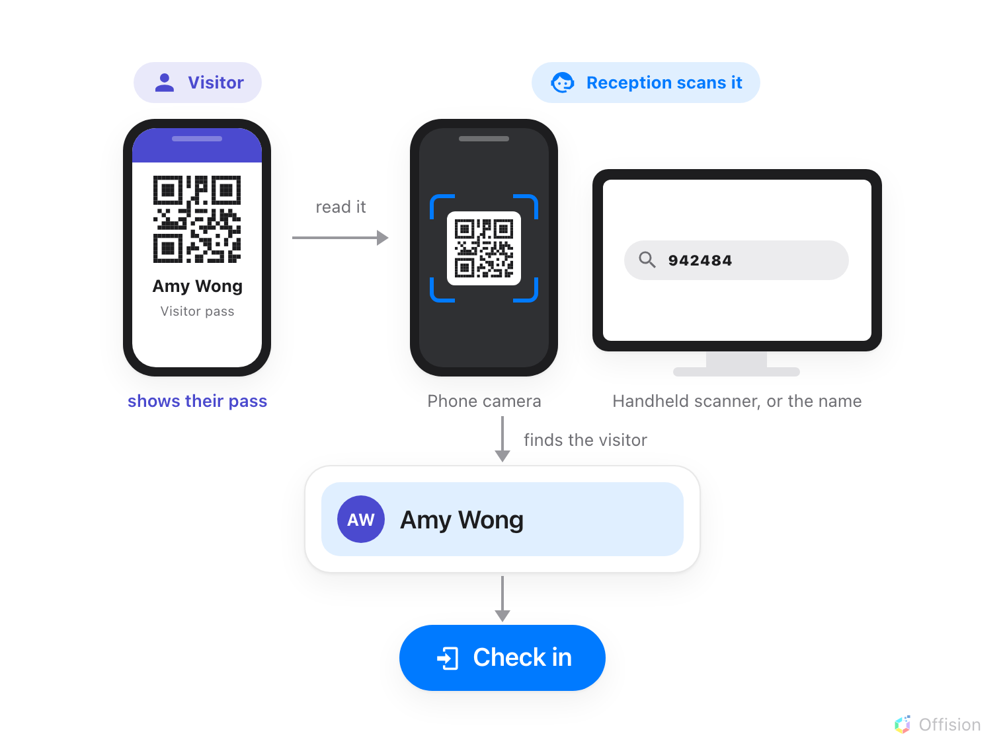
Reading the pass only finds the visitor. Checking them in is the separate step after it.
Before you start:
Your account has to be set up as a receptionist first — the Receptionist
permission, then the building whose desk you staff. Both are covered in
Sign in and open your reception desk.
Without the second one the page opens on You have not been assigned to any
reception setting in the management console.

1. Open Reception and land on the right day
Reception is one of the pages on the app home; pick it from the menu down the
left. It opens on Today's visitors, and the date at the top is the day being
searched.
That date matters more than it looks. Check in is offered only for a visitor
who has not arrived yet and whose visit is today, and the scan only searches
the day on screen. If you are looking at the wrong day, a perfectly good pass
comes back No results found.
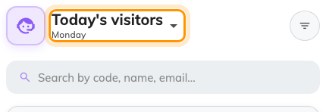
The date at the top is the day being searched.

2. Scan the visitor's code
On a phone, tap the + button at the bottom right and choose Scan. The
back camera opens; hold the visitor's QR code in the frame and it reads in one
shot.
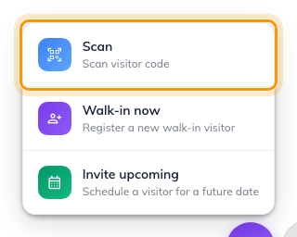
The phone's + button, with Scan at the top.
At a desk there is usually no camera worth pointing across a counter, so use the
search box instead — it matches on code, name, email. A handheld QR scanner
types the code straight into it, and typing the visitor's name works just as
well when they have no pass to hand. The Scan visitor code button beside the
box is the camera version, for a computer that has one.
Every one of those routes ends in the same place: the list narrows to that one
visitor, and the code sits in the search box exactly as if you had typed it.
Scanning does not check anyone in:
Nothing is recorded until you tap Check in. A scan you walk away from leaves
the visitor exactly as they were.
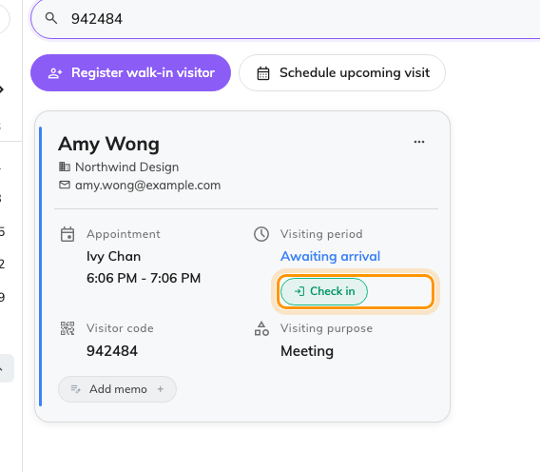
One visitor left in the list, with Check in on their card.

3. Check them in
Tap Check in. What the wizard asks for is set by the visiting purpose, and
how much of it you see depends on the visitor:
- Someone who registered online has already answered the form and the
surveys, so the wizard skips ahead — to Take a photo if their purpose
wants one and they have none yet, otherwise straight to the confirmation.
- Someone walking up unannounced starts at the top — Visitor
information, then a photo and any Visitor survey the purpose asks for,
then confirm.
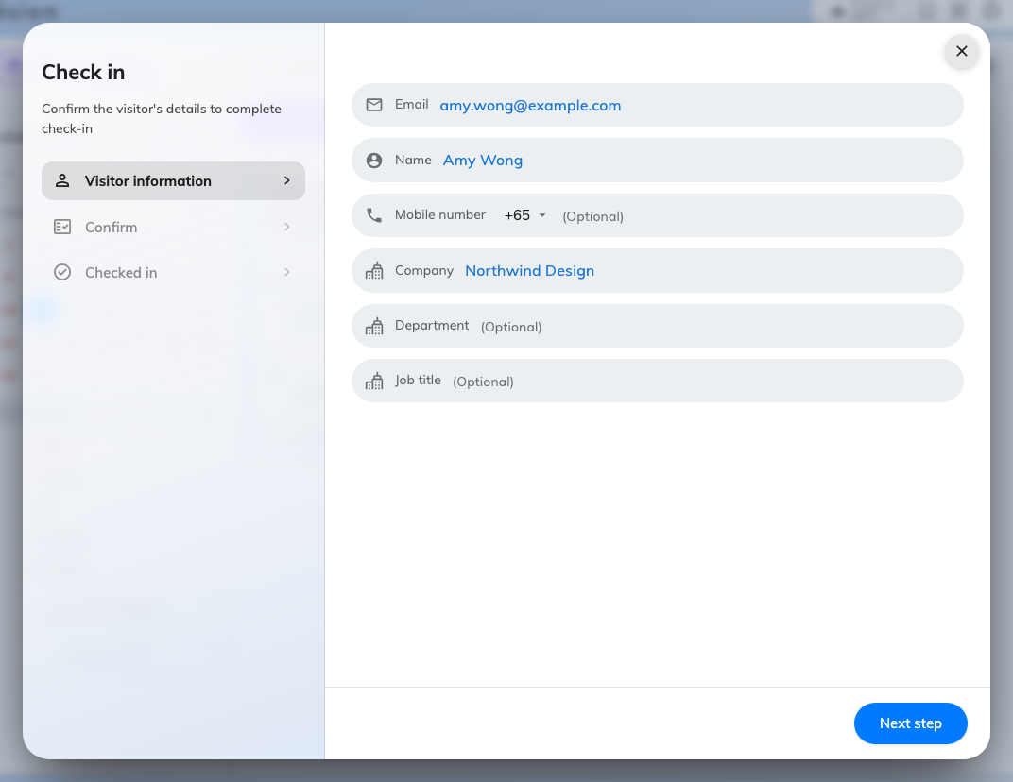
The check-in wizard, with its steps listed down the left.
Change what is asked for on the visiting purpose itself.
Where in Offision: admin app → visiting/visiting-type (Visiting purpose)

4. Check it worked
The visitor's card should now show the time they arrived and Visiting under
Visiting period, with Check out in place of Check in. That is the
whole confirmation — if the card still offers Check in, the wizard was closed
before the last step.
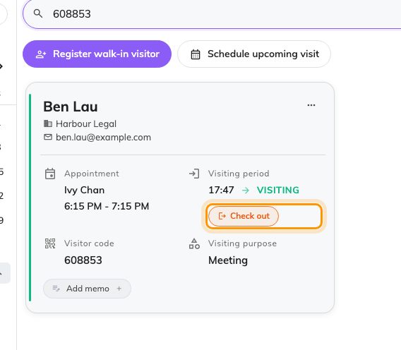
An admitted visitor: the arrival time, Visiting, and Check out in place of Check in.
If the scan finds nothing:
No results found almost always means the date at the top is not the day of
the visit — a visitor who arrives a day early is a common cause. Failing that,
the code belongs to another system: reception matches the visitor's own pass
code, not a badge number issued elsewhere.

