Where the map you drew appears
What the drawing, the assignments and the routes actually buy — the map in people's pockets, on the screens in the lobby, and on the analytics screens nobody outside facilities ever sees.
2026-09-07 · https://offision.com/help/en/map/where-the-map-appears/
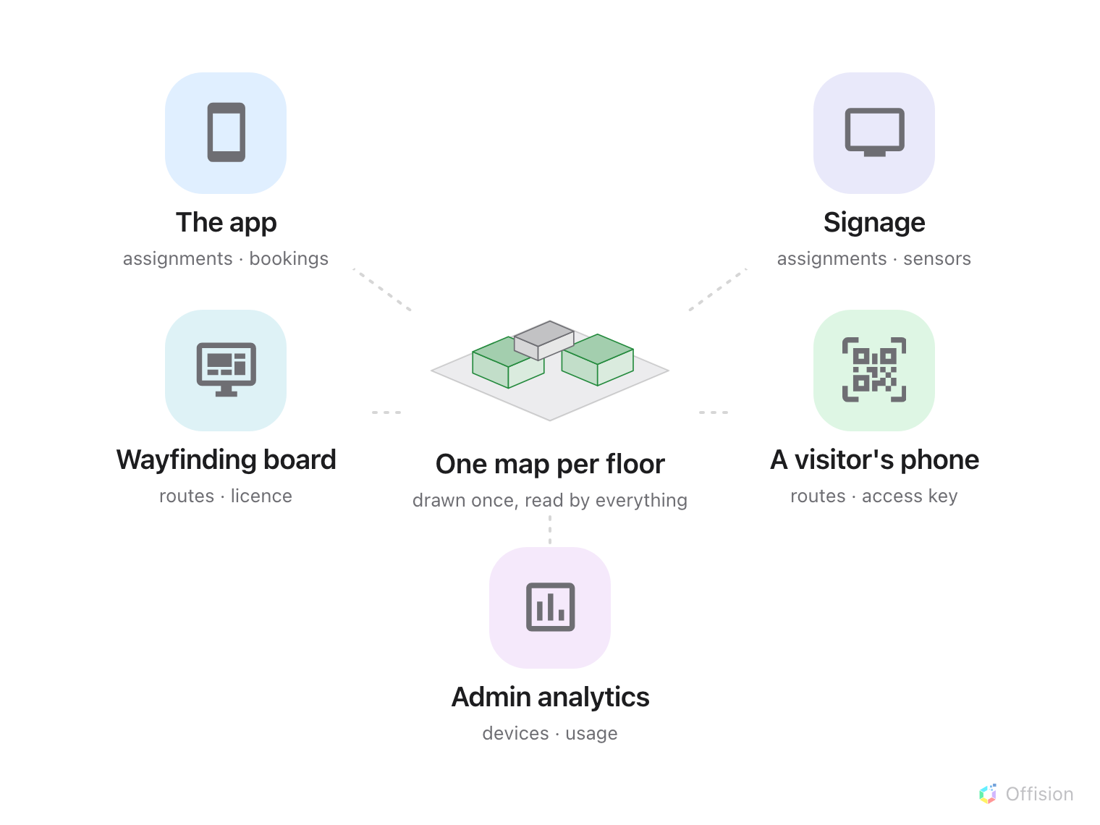
One floor, drawn once. Five surfaces read it, each pulling a different part.
One map per floor, drawn once, read by everything. Nothing on this page is
configured here — each surface is set up in its own module — but knowing where a
floor turns up is what tells you when the drawing is finished, and who notices
when it is wrong.

In the app, in somebody's pocket
The map is how an employee finds a room they have never been to and a desk near
somebody they want to sit with. They can filter it by what they are looking for,
move a time slider so "free" means free when they need it, and book from the map
without leaving it.
This is the surface that punishes an unassigned resource most visibly: a desk
nobody linked is a desk nobody can pick. See
Find a desk on the floor plan.
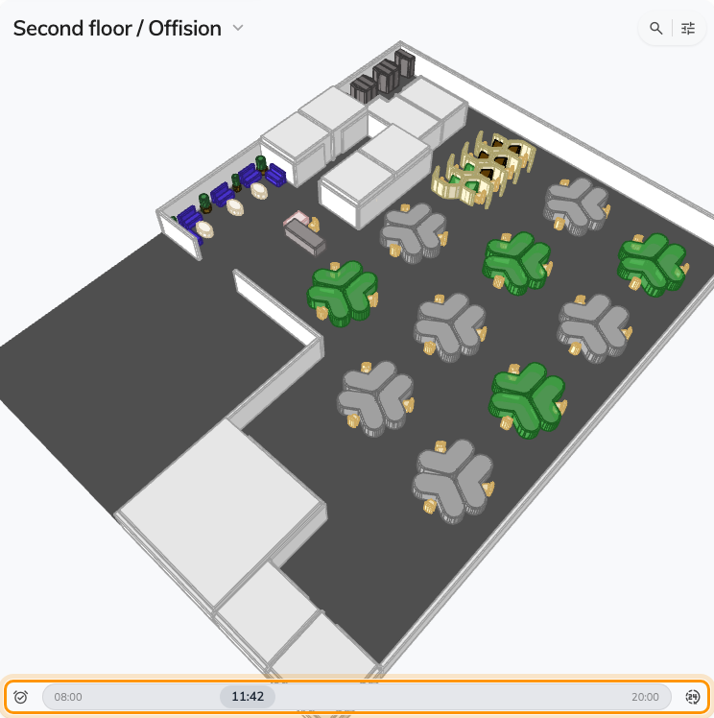
The floor in the app: filter, slide the time, book from the map.

On the screens people walk past
Signage draws the same floor for a room full of people rather than one person:
- Booking status - Map colours every room and desk by whether it is free.
- Occupancy sensor data - Map colours by what the sensors actually see,
which is a different question and often a different answer.
Both are widgets placed on signage content, and each can be given its own view
angle — so a wall-mounted screen can look at the floor differently from the way
the app does. Booking status - Map goes further and can drop the perspective
altogether, drawing the floor flat from above and turned to match how the panel
is mounted: Show the floor plan flat, in 2D.
See Signage content.
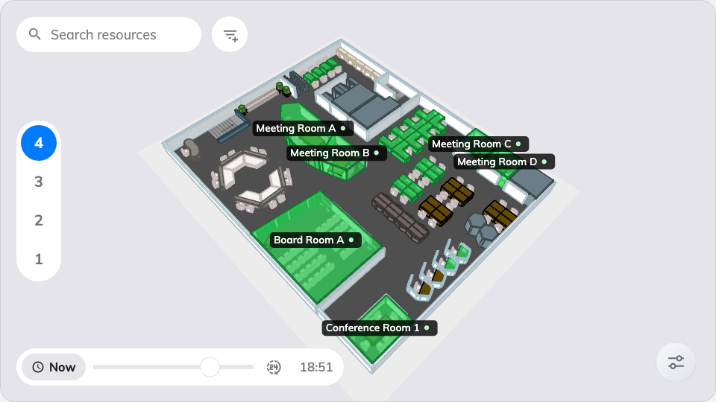
Booking status - Map, on a signage screen.

As a wayfinding board
A large touchscreen in a lobby is the map's most demanding audience: strangers,
in a hurry, who will not scroll. It shows the floor, takes a destination, and
hands the route to a phone by QR so the person can walk away with it.
That is the surface that depends on everything in this module at once — the
drawing, the assignments, the route network and the per-floor licence. See
Set up a Neat Board as wayfinding signage.

To a visitor's phone
Scanning a wayfinding QR — from a board, or from a printed
location access key — opens the
floor on the visitor's own phone, marks where they are, and walks them to where
they are going. No account, no app.

In the admin console, quietly
Three read-only surfaces reuse the same floors, and they are the reason facilities
teams end up caring about a map that employees rarely open:
- Device monitoring puts your panels and sensors on the floor, so an offline
device is somewhere rather than a row in a list.
- Resource usage analytics colours the floor by how much each room is
actually used — the view that ends arguments about which rooms to convert.
- IAQ and cost views do the same for air quality and for spend.

What decides who sees what
Nothing here, and that is worth saying plainly. A map never widens what somebody
may see: people are shown the resources they already had access to, on whichever
floors they already had access to. A map makes things findable, not permitted.
If a floor is not showing up:
Check it has a map at all, then that its resources are assigned — those two
account for nearly everything. Start at
A room or desk does not appear on the map.

