Wayfinding gives no directions on a floor
The map draws, the rooms are there, and asking for directions produces nothing. Four causes, starting with the one the console will tell you about if you look at the right chip.
2026-08-25 · https://offision.com/help/en/map/wayfinding-does-not-run-on-a-floor/
First, one question:
Does the floor show a map at all? If it does not, this is not a wayfinding
problem — start at
Create a map for a floor. Everything below
assumes a drawn floor that will not give directions.
Solution 1 — The floor has no wayfinding licence (most common)
Wayfinding is licensed one floor at a time, and an unlicensed floor behaves
exactly like this: everything looks complete, the map draws, and no route is ever
produced.
The console says so in two places. On the floor list, the chip beside the floor's
title reports the state and opens the dialog that changes it. In the editor's
Route mode, an unlicensed floor carries a warning — "Routes you draw here
are still saved. Wayfinding will not run on this floor until a license is
assigned to it."
That wording is the thing people misread: the network you drew is safe. Only the
running of it is gated.
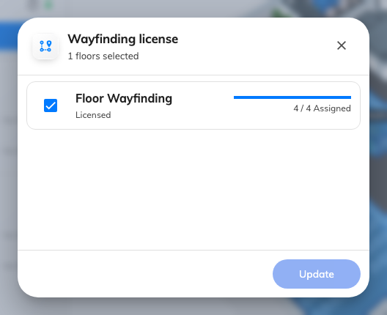
The seats the tenant holds, and whether this floor has one.
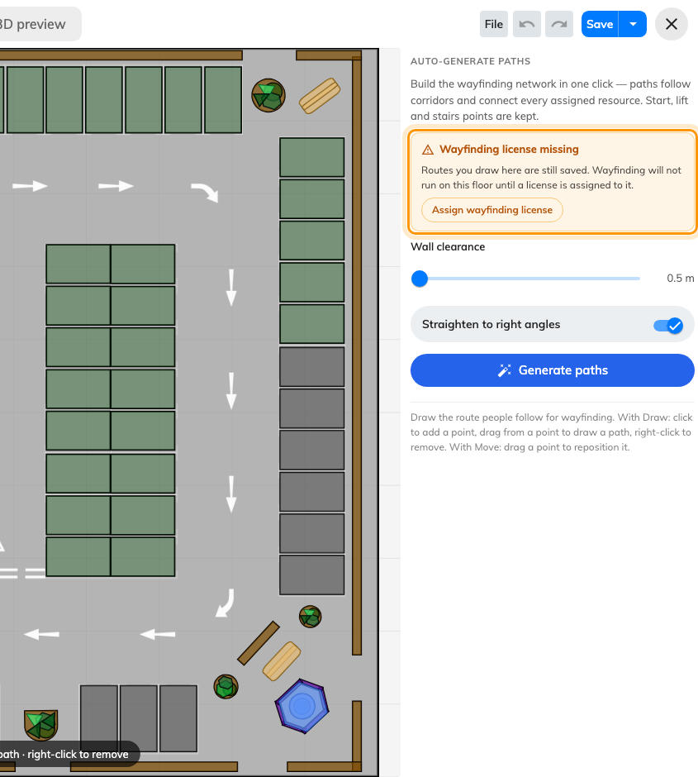
Route mode on an unlicensed floor. The drawing is kept; only running is gated.
Where in Offision: admin app → map/floor-plan (Map)
Solution 2 — No paths were ever drawn on it (most common)
A map and a route network are two separate drawings on the same floor, and
finishing the first does nothing for the second. A floor drawn by somebody who
never opened Route has no network at all.
Open the floor, switch to Route, and look. Empty is empty. The fastest fix is
Generate the walking paths automatically,
then correct by hand.
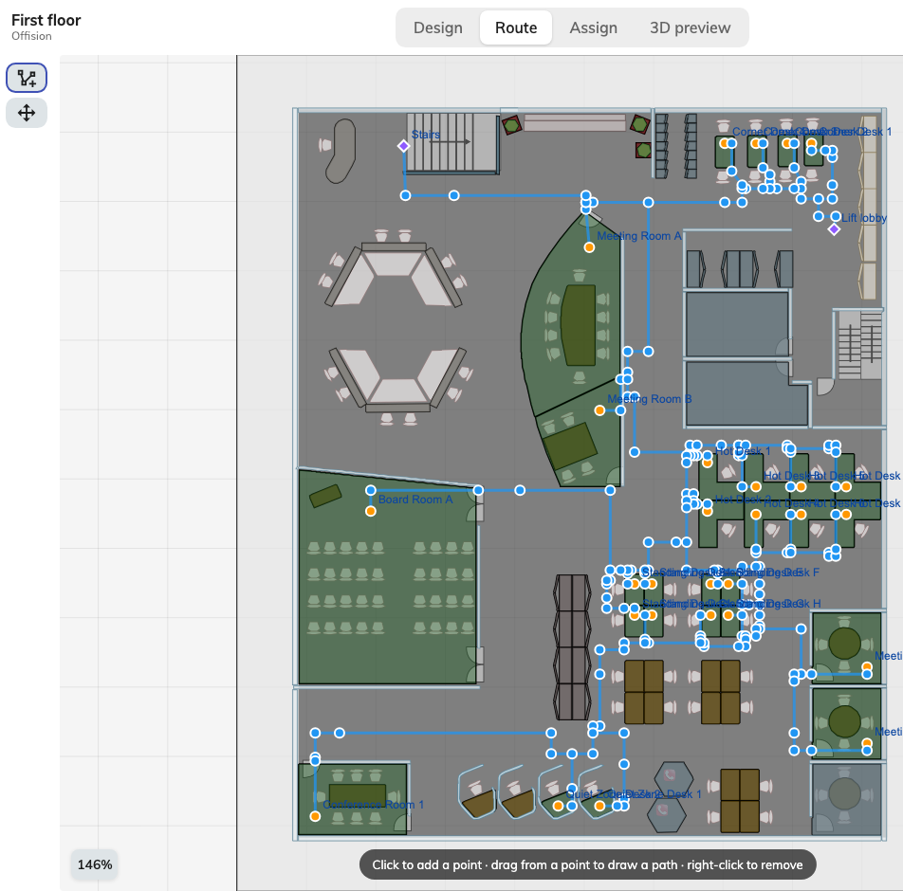
What a drawn network looks like. If Route mode shows nothing like this, there is none.
This and the licence together account for almost every report, and they are
easily told apart: the licence chip is on the floor list, the empty network is in
Route mode.
Solution 3 — The destination is not assigned to an area (common)
Routes connect assigned resources. A room that has no place on the map has
nothing to route to, so directions to it fail while directions to its neighbours
work — which reads as an intermittent fault and is not one.
Check the room in Assign mode: a row saying Not yet linked to a map is
your answer. See
A room or desk does not appear on the map.
The same thing explains a count that looked wrong when you generated: Connected
N resources only ever counts assigned ones.
Solution 4 — Routes work on a floor but not between floors (common)
A different failure with the same symptom, and worth separating because three of
the causes above will not explain it.
A route leaves one floor at a lift or stairs, and those are facilities
that must be marked on both floors, with the network reaching them on each.
A building whose floors each have a fine network and no lift marked routes
perfectly within a floor and refuses to go between them.
Check that every floor involved is licensed, too. One unlicensed floor in the
middle breaks every route that would have passed through it.
The commonest version of this is two separate facilities called Stairs, one per
floor, instead of one facility with a position on each — which connects nothing.
See Connect floors with lifts and stairs.
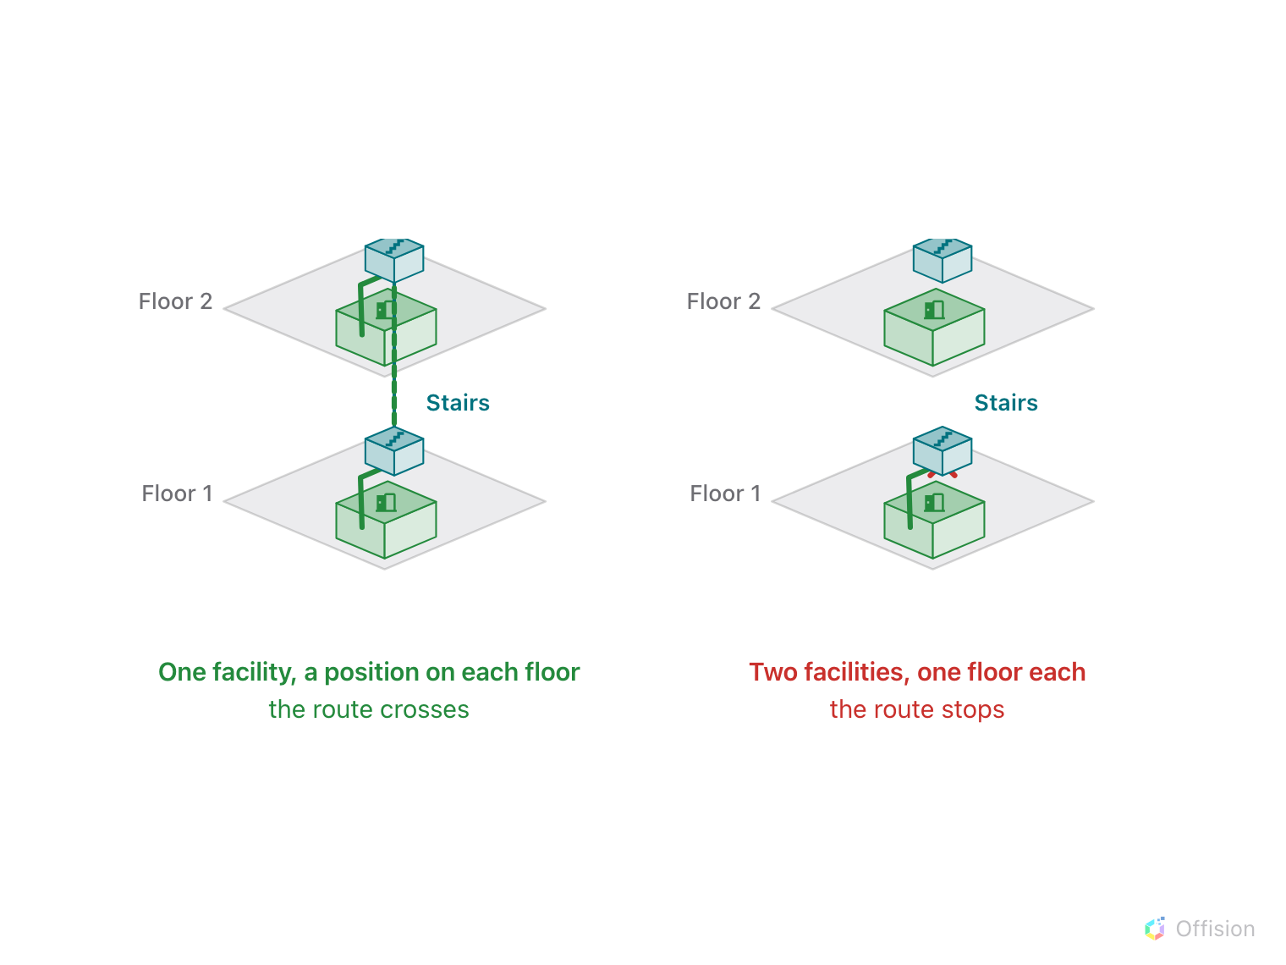
One facility with two positions joins the floors. Two facilities with one each join nothing.
Before you ask for help:
Have ready: the building and floor, what the wayfinding chip on that floor says,
whether Route mode shows any paths, whether the destination's row says
Not yet linked to a map, and whether the route was within one floor or
between two. Those five separate all four causes above.

