The map is the wrong size
Rooms that come out four metres wide when they are eight, a floor that looks squashed in 3D, or walking routes that refuse to fit down a corridor. All of it is one number, set once.
2026-08-25 · https://offision.com/help/en/map/the-plan-is-the-wrong-size/
First, one question:
Measure one room you know the size of, by selecting it and reading W and
D in Position & size. If those numbers are wrong, the whole floor is
wrong by the same factor and this page is the right one. If they are right, the
problem is that one object, not the map.
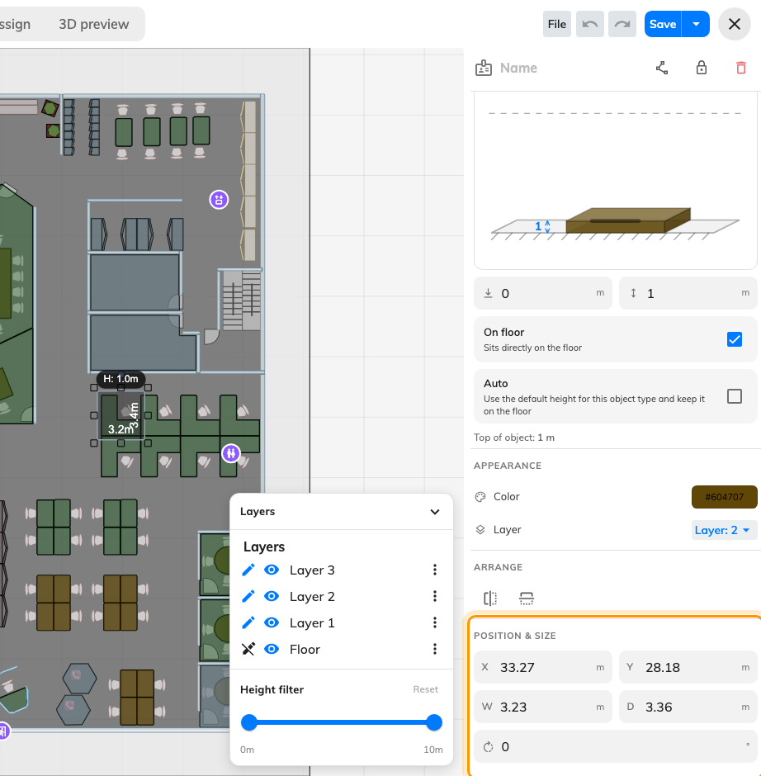
W and D, in real metres or feet.
Nothing on a map is stored in pixels. Everything is in real metres or feet,
derived from one number stated when the floor was imported — so a floor entered
at the wrong width looks perfectly normal and is wrong everywhere it matters.
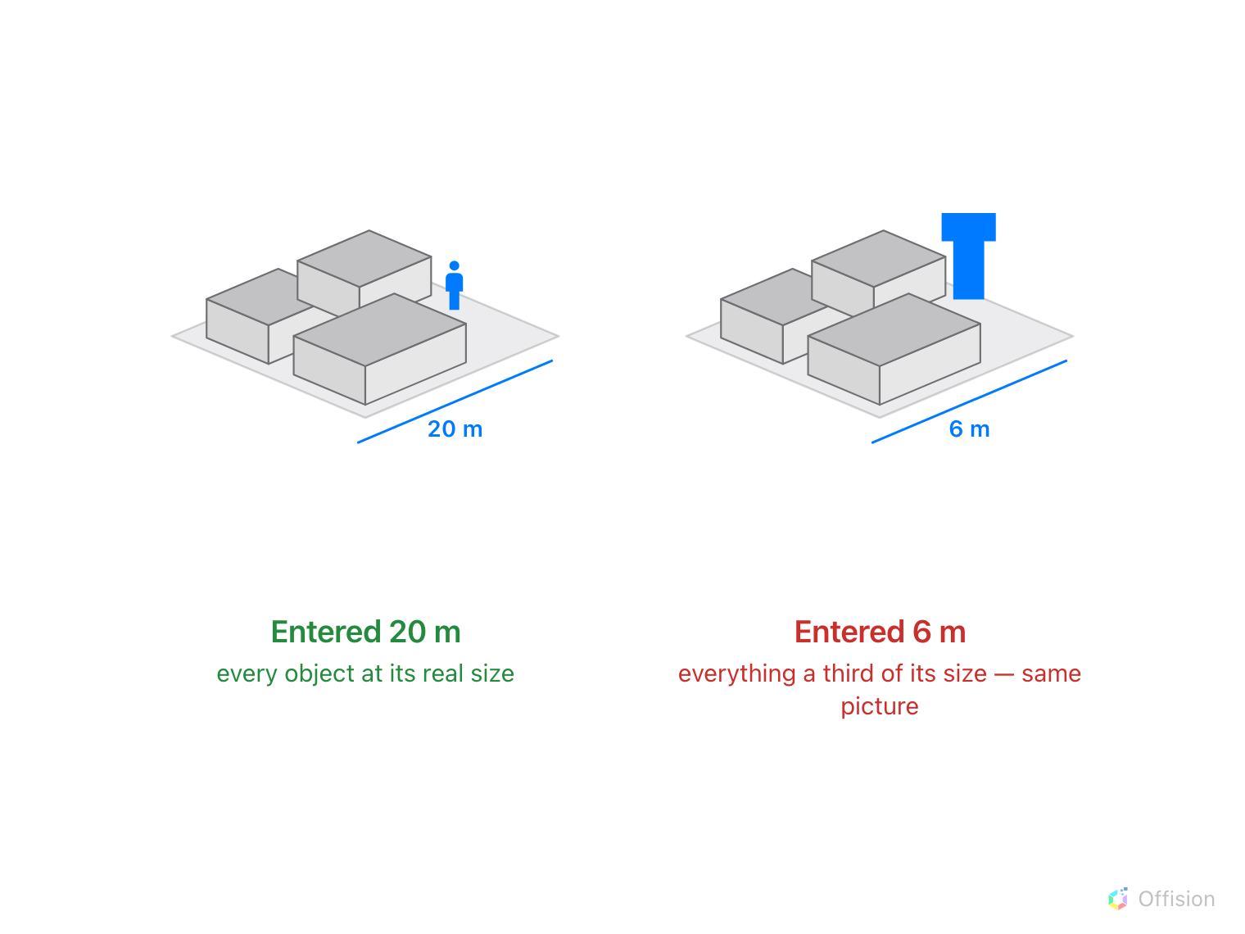
The picture looks the same either way. Only something of known size shows the number was wrong.
Solution 1 — The floor's real width was never right (most common)
When a plan is imported, the editor asks for the actual floor dimensions and
offers a Scale slider. It is asking how wide the floor is in the building,
not how wide the image is — and because the picture looks the same either way,
an estimate here is invisible until something else disagrees with it.
The symptoms are all proportional: every room out by the same factor, furniture
that looks right against the walls but wrong against a person, and a 3D view
that reads as too tall or too flat because the heights are correct while the
floor is not.
There is no scale box to correct afterwards. Either redraw the objects at their
real sizes — practical on a small floor, since W and D can be typed — or
import the image again with the right width and trace it once more. Take the
number off the plan rather than estimating it.
Where in Offision: admin app → map/floor-plan (Map)
Solution 2 — Metres were read as feet, or the other way round (common)
The scale question carries an m / ft switch, and it is easy to type a number
from a plan in one unit while the editor is set to the other.
The tell is the size of the error. A floor about three and a third times too
large was entered in feet and read as metres; one about a third of its real size
is the reverse. Anything else is an ordinary mistake in the number itself.
The fix is the same as above: the unit is part of the same one-off decision.
Solution 3 — Resize floor to fit image stretched the floor (less common)
Update floor image carries Resize floor to fit image, which matches the
floor's outline to the new picture's proportions. Given a picture cropped
differently from the original — extra white space, or a trimmed margin — it
resizes the floor to that instead.
Undo it if the editor is still open. Otherwise, replace the image with one
cropped the same way as the original and resize again.
Where you only want a clearer picture behind an unchanged drawing, leave that
option off.
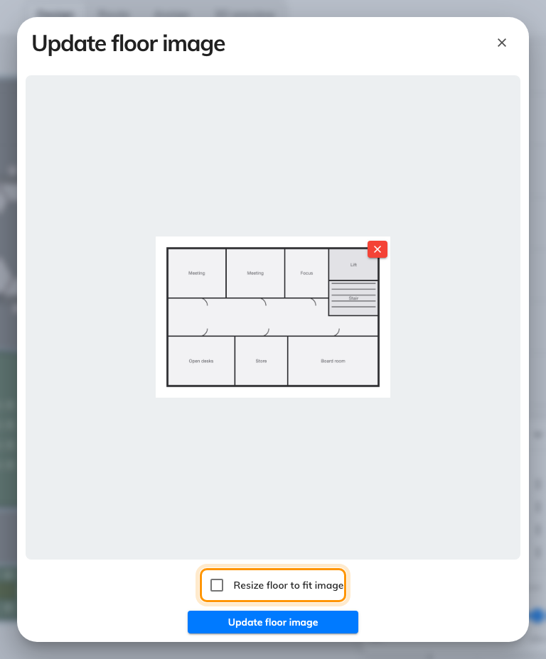
Resize floor to fit image. Off keeps the drawing exactly as it is.
Solution 4 — It is the 3D view, not the map (rare)
A floor that looks wrong only in 3D preview but measures correctly in
Design is not a scale problem at all. Two things do it: every object left at
its default height, which flattens a floor, and a saved camera at a very low or
very high angle, which distorts one.
Check a wall's height first, then reset the angle with Use default viewport
and orbit again. See
Frame the default 3D view.
Before you ask for help:
Have ready: the floor and building, one room's real dimensions and the W and
D the editor shows for it, whether the plan was imported in metres or feet,
and whether the floor image has been replaced since. The ratio between the real
size and the shown size identifies the cause on its own.

