Show the floor plan flat, in 2D
A plan is always drawn flat — what varies is how it is shown. Where a signage screen chooses between the 3D map and a flat 2D top-down one, how to turn that flat map to match a panel bolted sideways, and which surfaces have no such choice.
2026-09-07 · https://offision.com/help/en/map/show-the-floor-plan-flat/
There is no second, flat kind of map to make. A floor is drawn flat once, and
what changes is how a surface shows it — in perspective, or straight down from
above. A signage screen is where that choice is made.
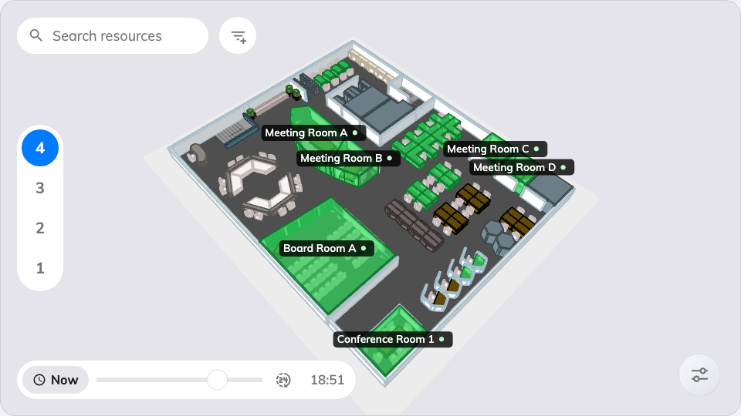
The same widget in 3D — the default, and what the flat view replaces.

You already drew it flat
The map editor is a flat drawing tool: rectangles, ellipses and furniture seen
from above. The 3D map is what comes out of giving each of those shapes a
height — see
What an Offision map is made of. If no floor is
drawn yet, that is the job to do first:
Create a map for a floor.
So "make a 2D floor plan" is never a drawing decision. Nothing below changes the
plan; it changes what one screen does with it.

Turn a screen's map flat
The setting lives on the Booking status - Map widget, on the signage design
the screen plays.
- Go to Signage › Content and open the design.
- Click the map in the preview. Its settings open in the rail beside it.
- Open Map view. The first card is View mode, showing two pictures of
the same plan: 3D and 2D top-down.
- Choose 2D top-down. The preview rebuilds the map flat.
- Save.
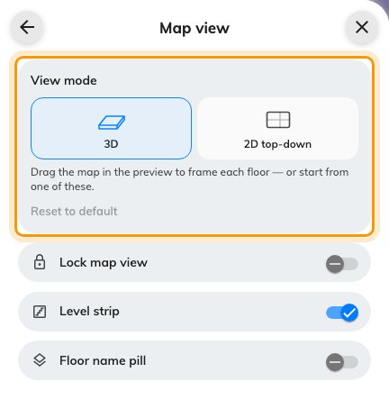
View mode, the first card in Map view: 3D, or 2D top-down.
Where in Offision: admin app → signage/signage-content (Signage)
A design with no stored answer plays in 3D, which is what every screen did before
the choice existed. Switching costs nothing and throws nothing away — the framing
you had in 3D is still there if you switch back.

Turn it to match the wall
A flat map has no camera to orbit, so Map view offers turns instead of
angles: Turn left and Turn right move it a quarter turn at a time, and
Recenter re-fits the whole plan in the frame. The hint on the card says what
they are for — "Turn the map to match how the panel is mounted."
That is the real use for a flat map. A plan drawn with the entrance at the bottom
reads upside down on a screen hung on the opposite wall, and a quarter turn puts
the door where the person standing in front of it expects it.
The turn is one answer for the whole widget, not one per floor, because the thing
being corrected is how the panel is bolted up — a property of the screen, not of
the building. Lock map view, below the card, then holds it there so nobody
nudges it.
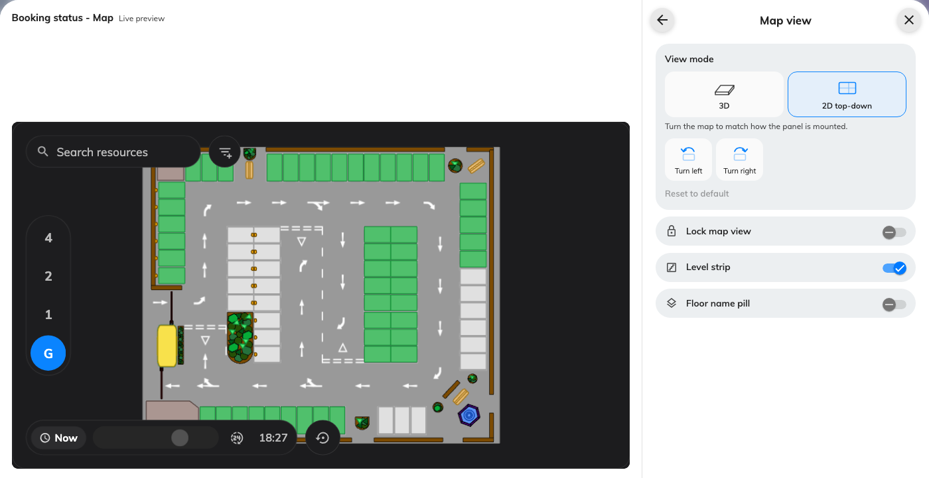
The same floor drawn flat in the live preview, with Turn left and Turn right in place of the 3D framing presets.
Reset to default undoes both:
Reset to default at the foot of the card clears the framing and the turns,
and returns the widget to 3D.

What still draws in 3D
The choice is per widget, and only one widget has it. Everywhere else the floor
is drawn in perspective:
- The app, on a phone or in a browser — see
Find a desk on the floor plan.
- The map editor's 3D preview, and the opening angle saved there — see
Frame the default 3D view.
- The Occupancy sensor data - Map widget, which colours by what the sensors
see rather than by bookings.

What this does not control
- The plan itself. Shapes, heights and which room is which are all the map
editor's, and identical in both views.
- The colours. Free, busy, short-available and the rest come from the
widget's Resource status group either way — see
The Booking status - Map widget.
- Whether the map draws at all. A screen whose graphics engine cannot render
a floor shows Map unavailable, and 2D does not rescue it — see
The screen says "Map unavailable".

