Put facilities on the map
Exits, toilets, lifts, escalators and stairs — the things nobody books but everybody looks for. Create them once, then mark where each one is on the floors that have them.
2026-08-25 · https://offision.com/help/en/map/put-facilities-on-the-map/
Before you start:
The floors you want to mark need maps already — see
Create a map for a floor. Facilities can be
created before that, but they have nowhere to sit until a floor is drawn.
A facility is a place people need and nobody books: a door out, a toilet, a lift.
They matter more than they look, because they are what somebody scans a map
for when they are lost, and they are what a walking route uses to cross floors.

1. Create the facility
Open Facilities under Map and add one. It has a type, and the type is
what decides its icon and how it is treated:
exit · toilet (with male, female and accessible variants) · lift ·
escalator (with up and down variants) · stairs · others · custom
Where in Offision: admin app → map/facility (Facilities)
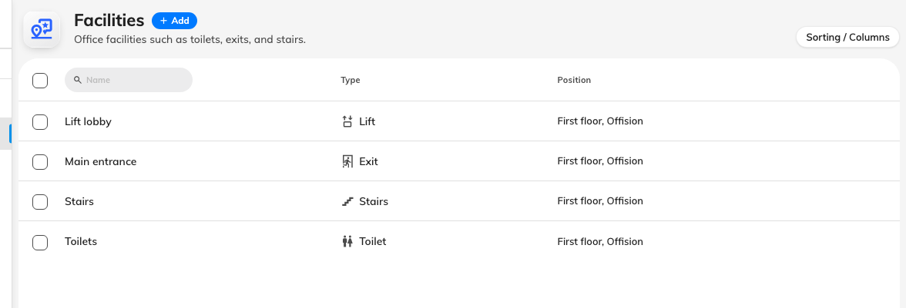
One row per facility. The type decides the icon people see.
Name it for what somebody would call it — Main entrance, Lift lobby —
not for its type. The name is what shows when a person taps the marker.
Pick the closest real type rather than others: the icon is how it is
recognised at a glance, and lift and stairs additionally tell wayfinding
that this is a place a route can change floor at.

2. Mark where it is
A facility can sit on more than one floor — a stairwell runs the height of the
building, and each floor gets its own marker. Add a position per floor and pick
the spot on that floor's plan.
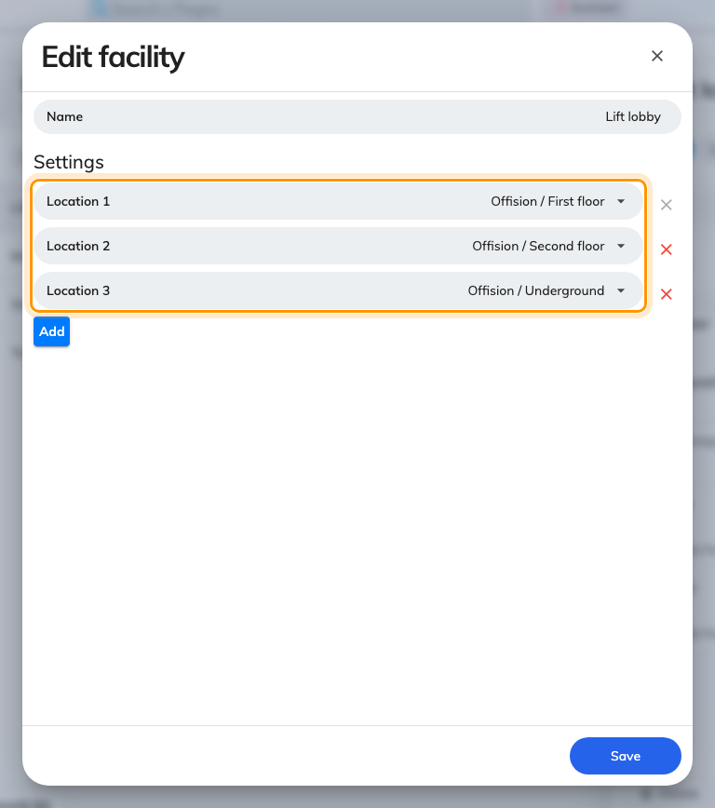
One facility, a position per floor.
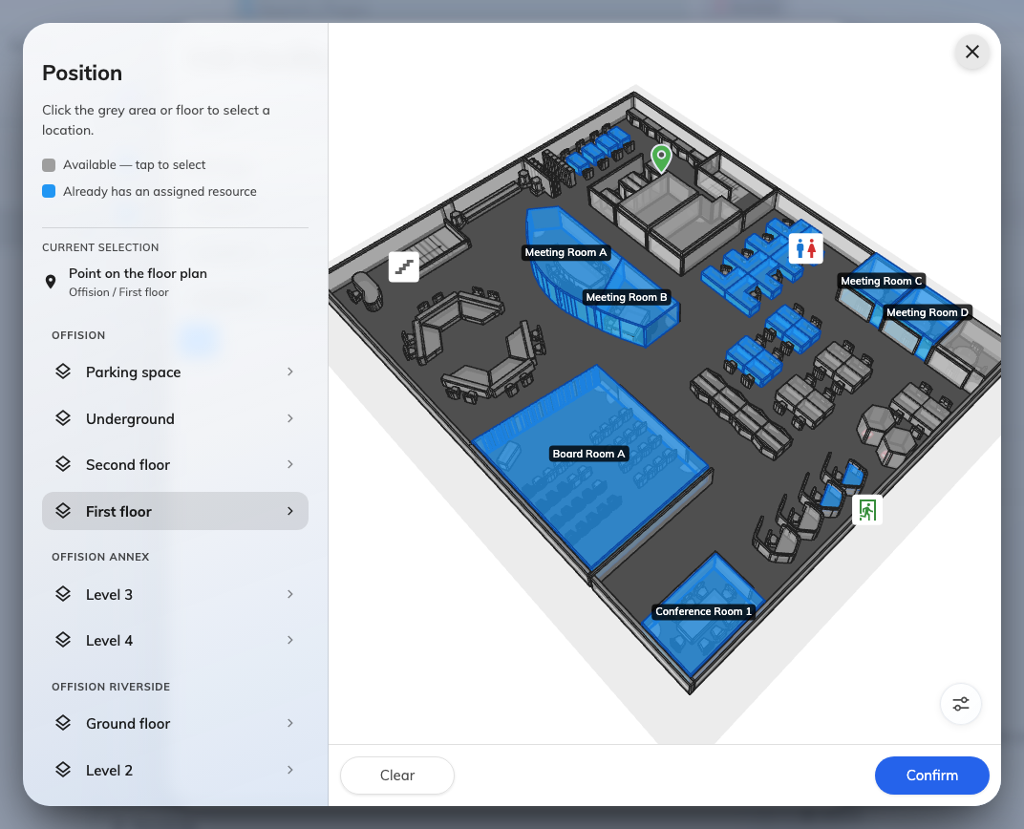
Pick the floor on the left, tap the spot on the right.

3. Or place it from the editor
The other way round, and usually quicker when you are already drawing: open the
floor in the editor, switch to Assign, and choose Facility at the bottom
of the type rail. The panel lists your facilities; drag one onto the plan, or tap
it and then tap the spot.
A facility already placed on this floor is marked in the list, so you can see at
a glance what is still missing.
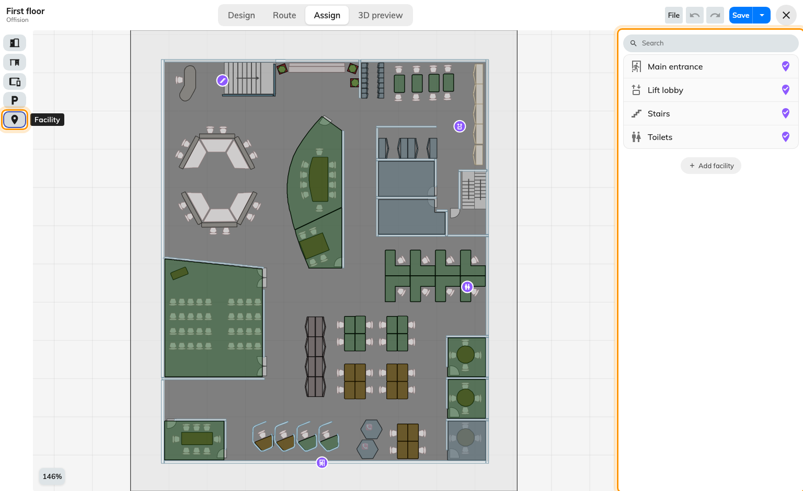
Facility, at the bottom of the rail. Placed ones are marked in the list.

4. Give it its own icon, if you need to
custom takes an image of your own. Worth it for something the standard set
has no idea about — a first-aid point, a bike store — and not worth it for
anything the type list already covers, since a familiar icon beats a bespoke one.

5. Check it worked
Open the floor's map in the app. The facility markers should be where you put
them, and tapping one should show its name. If your estate uses wayfinding, ask
for directions to a room on another floor and check the route goes via the lift
or the stairs you marked — that is the part that fails quietly when a floor's
lift was never placed.

What this does not control
- Anything bookable. A facility is a marker. It has no calendar, no capacity
and no permissions.
- Whether wayfinding works. Marking a lift does not build a route network —
see How wayfinding finds a path. It
only tells an existing network where the floors join, and joining them properly
has rules of its own:
Connect floors with lifts and stairs.
- Cleaning, maintenance or supplies. A toilet on the map is a location, not
a job. Those are service requests.

