Put a QR start point in the lobby
A printed sticker bound to one spot on one floor. Somebody scans it, the map knows where they are standing, and directions can start from there. About five minutes.
2026-08-25 · https://offision.com/help/en/map/put-a-qr-start-point-in-the-lobby/
Before you start:
The floor needs a map and a route network, or a scan will say where the person is
and then have nowhere to walk them — see
How wayfinding finds a path. You will
also need somewhere to put a printed sticker.
Directions need two ends. The room is the easy one. This is the other: a fixed
point in the building that a phone can be told about by pointing a camera at it.

1. Create the key
Open Location access key under Map and add one.
Where in Offision: admin app → map/location-access-key (Location access key)
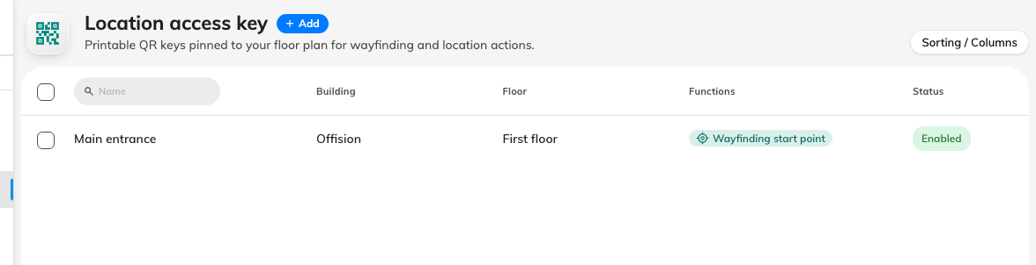
One row per printed sticker.
Name it for the physical place the sticker will be stuck — Main entrance,
Lift lobby, level 3. That name is what you will match against a sticker on a
wall in two years' time, and it is the only way to tell two keys apart once they
are printed.

2. Bind it to a spot
A key belongs to a building and a floor, and can additionally be pinned
to a coordinate on that floor's map.
The coordinate is what makes it worth doing. Without one, a scan places the
person on the floor in general; with one, it places them at the door, and the
route starts from where they are actually standing. Pin it wherever the sticker
will physically go.
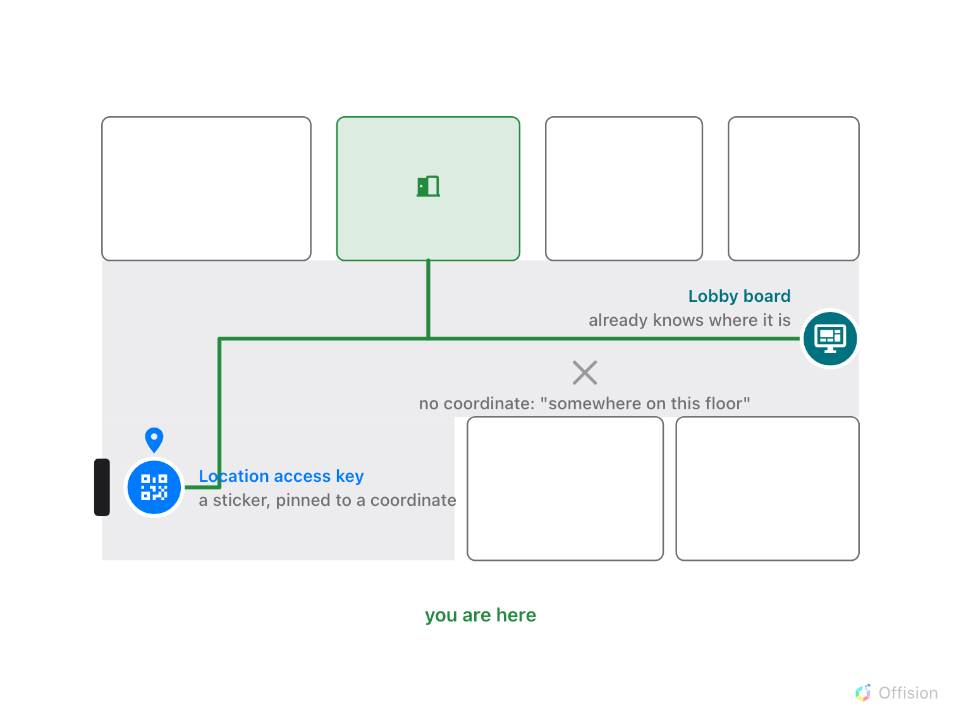
Pinned to a coordinate, the route starts at the sticker. Without one, it starts somewhere on this floor.

3. Leave it enabled
A key can be turned off without being deleted, which is what you want when a
sticker is coming down for a refurbishment — the printed code stays valid for
when it goes back up.

4. Print it and put it up
The code behind a key is permanent and generated by Offision; it is never
something you choose. That is deliberate, because it is going onto something
physical: it has to keep working long after whoever created it has forgotten it.
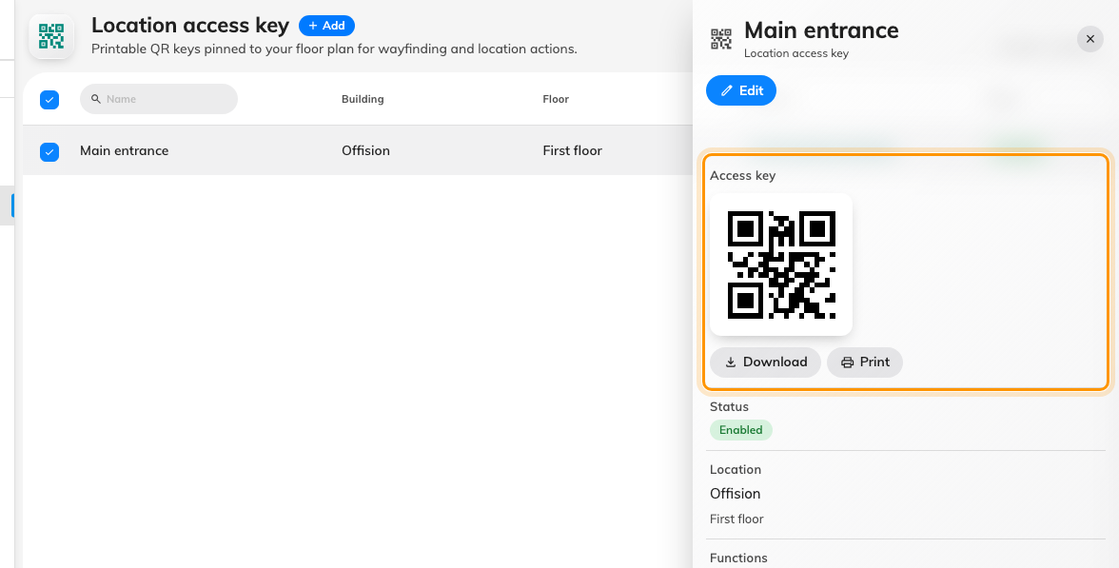
The code is generated by Offision. Download or print it from the key.
Put the sticker where somebody standing lost would look — beside the door, by the
lifts, at the top of the stairs — and at a height a phone can reach comfortably.

5. Check it worked
Scan it with a phone that is not signed in, which is the case that matters:
most people scanning a lobby QR are visitors. The map should open at that floor
with "you are here" on the spot you pinned. Then ask it for a room and check the
route starts at the sticker rather than at the middle of the floor.

What this does not control
- Who may see what. A scan opens the map; it does not sign anybody in or
grant them anything.
- Where the route goes. That is the network drawn in Route mode. A key only
says where it begins.
- Screens. A lobby board already knows where it is, so it needs no key. This
is for walls, not for hardware.

