Every setting in the map editor
A field-by-field reference for the map editor — the header, the tool rail, the canvas switches, the layers panel and every box in the properties panel, grouped the way the screen groups them.
2026-08-25 · https://offision.com/help/en/map/map-editor-settings-reference/
Everything the map editor can be told, in the order the screen puts it. For what
to do with any of it, start at
What an Offision map is made of.

The header
Control | What it does | When to use it
Design / Route / Assign / 3D preview | Switches which job you are doing. The drawing is the same in all four; the rail and the panel change | Design to draw, Route for walking paths, Assign to link rooms and desks, 3D preview to look and to save the camera
File → Import by image ( .png / .jpg) | Replaces the whole map from a picture, after warning you it overwrites | Starting again from a corrected plan. To change only the picture behind the drawing, use Update floor image instead
File → Import by floor plan data ( .ofp) | Replaces the whole map from an Offision map file | Copying a finished floor onto another floor, or into another tenant
File → Export Map (.ofp) | Downloads this floor as a map file | Before a big change, or to reuse the floor somewhere else. It is the only backup of a drawing there is
File → Contact us | Opens a request to Offision about this floor plan | When you would rather have the map drawn for you — it is a paid service
Undo / Redo | Steps back and forward through this session's edits | Freely. Generating or clearing route paths counts as one step, so both are recoverable
Save | Writes the map, leaves the editor open | Often. Nothing reaches the server until you do
Save & Close (the arrow beside Save) | Writes and leaves | When you are finished

The tool rail — Design
Tool | What it does | When to use it
Select | Picks up a shape so the properties panel can edit it | The default. Return to it after drawing
Add rectangle | Draws a rectangle on the current layer | Rooms, walls, blocks. Most of a floor
Add ellipse | Draws an ellipse on the current layer | Round tables, planters, curved walls
Add workspace furniture | A catalogue of drawn objects in four groups — Room setting, Desk / Chair, Cupboard / Locker / Server rack, Shape | Anything recognisable. A drawn desk reads better in 3D than a rectangle, and comes with a sensible height
Update floor image | Swaps the picture behind the drawing, keeping everything drawn on it | A better scan of the same plan. Resize floor to fit image in that dialog matches the floor to the new picture

The first four are disabled while Floor is the layer being edited. That is
the layer of the slab itself, and nothing can be drawn on it.

The tool rail — the other modes
Mode | Rail | What it holds
Route | Draw, Move | Draw adds points and paths; Move repositions a point without redrawing it
Assign | One button per resource type — rooms, desks, equipment, parking spaces — plus Facility | Chooses which list the panel shows. It does not filter the map
3D preview | View angle | An indicator, not a button. The camera is set from the panel on the right

The canvas switches
In the menu behind the zoom percentage, bottom left. The three snapping switches
are saved with the map, so they are how the next person finds it.
Setting | What it does | When to change it
Zoom in / Zoom out | Steps the magnification | Freely. The zoom and position you leave are saved with the map, so the floor reopens where you left it
Zoom to fit | Frames the whole floor | After losing your place. The fastest way back
Zoom to 100% | Draws the floor at true scale | To judge whether an object is really the size you think
Zoom to selection | Frames what is selected | Working on one room of a large floor
Show grid | Draws a metre grid behind the plan | On, while drawing. Off, when judging how the floor looks
Snap to grid | New and moved shapes land on the grid | On, for a floor drawn from measurements
Snap to objects | Shapes align to what is already there | On, for rows of desks and walls that must meet

The layers panel
Four layers, fixed: Floor, Layer 1, Layer 2, Layer 3. They cannot
be added to or renamed.
Control | What it does | When to use it
Pencil | Makes that layer the one being edited — and only shapes on it can be selected | The first thing to check when a shape will not select
Eye | Hides the layer from view | To work on what is underneath. It hides nothing from anybody else
Layer menu | Import by image onto that layer, or Update floor image on the Floor layer | Tracing a second plan over the first
Height filter | Narrows the drawing to a band of heights, reporting how many objects are shown | Selecting furniture under waist height without catching the walls. Reset puts it back

The properties panel
Appears on the right when something is selected. With several selected it
applies to all of them, and a box whose values differ reads Mixed.
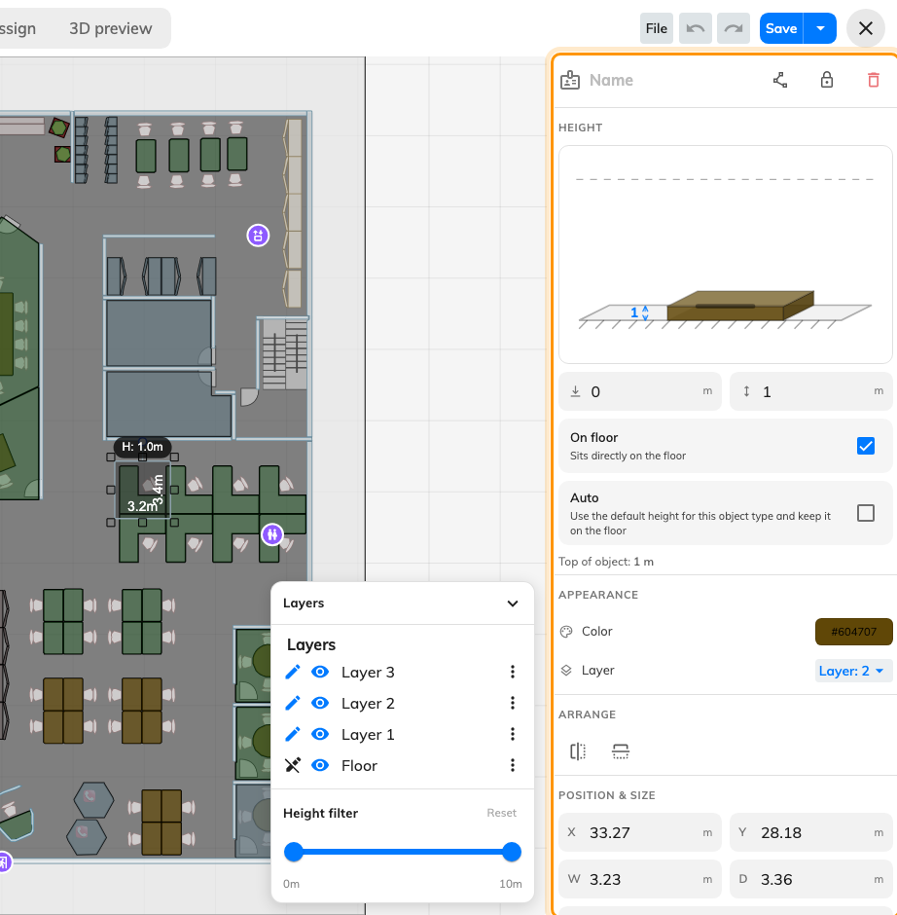
The panel fills the right-hand side whenever something is selected.

Header row
Field | What it does | When to change it
Name | Names the object | Always, for anything you will look for later. It is what identifies the shape in Assign mode
Edit points | Turns the shape into draggable points and edges | A room that is not a rectangle. Right-click an edge to add a point, a point to remove it, Esc to finish
Lock / Unlock | Stops the object being moved or resized | Once a wall is right. Unlock all is in the right-click menu
Delete | Removes the object | Removing the shape does not remove the room it was assigned to

Height
Field | What it does | When to change it
Side-on diagram | Shows the object between floor and ceiling, and can be dragged instead of typing | Judging a height by eye rather than by number
Elevation (left box) | How far the object's base sits above the floor | Only for things that hang — a shelf, a wall-mounted screen
Height (right box) | How tall the object is | Walls to the real ceiling height, partitions around 1.2–1.5 m. Disabled while Auto is on
On floor | Pins the base to the floor — "Sits directly on the floor" | On for almost everything. Clear it to set an elevation
Auto | Uses the default height for that kind of object — "Use the default height for this object type and keep it on the floor" | Leave on for catalogue furniture; turn off for walls and anything unusual
Top of object | Elevation plus height — where the object actually ends | Read-only. Check it against your ceiling height

Appearance
Field | What it does | When to change it
Color | The object's own colour on the map | To tell kinds of space apart at a glance. Availability colours are applied over this by whatever is drawing the map
Layer | Moves the object to another layer | Tidying a floor drawn on one layer — walls to 1, furniture to 2

Arrange
Field | What it does | When to change it
Flip horizontal / Flip vertical | Mirrors the object | A desk drawn facing the wrong way
Align left / center / right / top / middle / bottom | Lines several objects up on one edge. Two or more selected | Making a row of rooms share a wall line
Distribute horizontally / vertically | Spaces objects evenly. Three or more selected | A run of desks or parking bays

Position & size
All in metres or feet, and all typeable — usually faster and always more exact
than dragging.
Field | What it does | When to change it
X / Y | Where the object sits on the floor | Placing from measurements rather than by eye
W / D | Width and depth | Sizing a room off the plan you are tracing
Rotation | Turns the object, in degrees | A room at an angle to the building. Rotate rather than redraw

What this does not control
- Which rooms exist. Rooms, desks, equipment and parking spaces are created
in Booking; the editor can open that form without leaving the screen, but it
does not own them.
- Who can see or book anything. Nothing in this panel affects permissions or
availability.
- What the map looks like on other screens. Labels, and which of them show,
are a display setting under UI customization. Availability colouring belongs to
the surface drawing the map.
- The floor's ceiling height. Heights are measured against it; it is not set
here.

