A Map 2.0 draft could not save
[Map family: new] Distinguish unsaved Map 2.0 edits, saving failures and another editor’s version conflict; export current work before reloading and check the published map separately.
2026-10-03 · https://offision.com/help/en/map/map-2-draft-could-not-save/
Map family: new
Where in Offision: admin app → map/floor-plan (Map)
Check the editor:
This guide is for Map 2.0. For the Classic editor's Save and session recovery, use Classic unsaved changes.
Solution 1 — The latest edits are still a draft (most common)
Draft means changes are not all saved; Saving means a save is in progress. Finish the drag or placement and wait for Saved before leaving. Edits made during a save need their own subsequent save. Saved does not mean published: Update is a separate review and publication action.
Solution 2 — The save failed (common)
With Could not save, keep the editor open and check the connection. Once it is working, make the next intended edit or retry Update if you are ready to publish; Update saves first and must succeed before publication. Do not close the editor assuming that a failed save was recovered automatically.
Before a reload, use the header's File → Export map to keep a .ofp2 copy of the map currently on screen, including unsaved drawing edits. Check that the download completed. This is a drawing backup, not a backup of resource assignments. If Exported without some pictures appears, some pictures are missing from the file; retain their original files too.
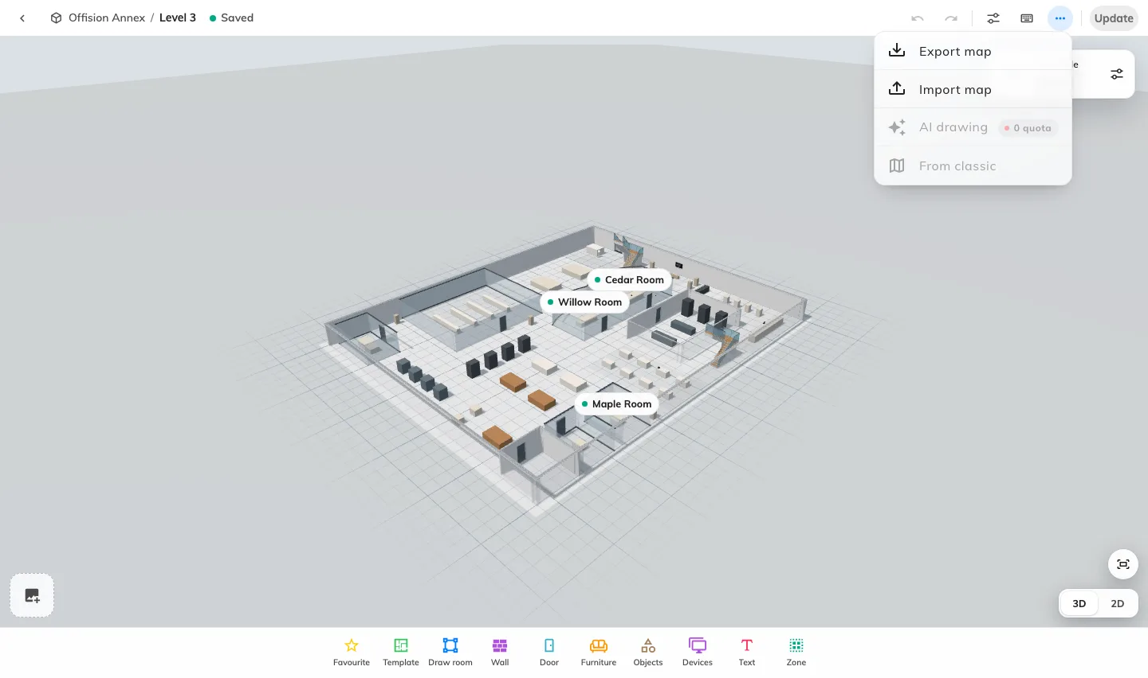
The File menu keeps a copy of the Map 2.0 drawing before a reload. Export does not publish or back up resource assignments.
Solution 3 — Another editor changed the draft (less common)
Changed elsewhere. Reload. means the draft on the server has moved on. Autosaving stops to avoid overwriting it; repeated Update attempts do not resolve the conflict. Coordinate with the other editor and export your current drawing before reloading. Reopen the floor to load the saved draft, compare the changes and reapply the work that should be kept.
Importing an exported map replaces the current draft and does not merge competing edits. Use map import/export only after deciding which drawing to keep. A retained server revision is not a promise of a restore button in this editor.
Still unable to save?:
Keep the building/floor name, exact error, time and whether another editor was working. Retain the exported drawing and original pictures. Check the published map separately; it can still show the previous successful update.

