Give objects height
The step that turns a flat drawing into the 3D map — how tall each object is, how far off the floor it starts, and the filter that hides everything above waist level while you work.
2026-08-25 · https://offision.com/help/en/map/give-objects-height/
Before you start:
You need a floor with shapes already drawn on it — see
Draw the rooms and furniture. Work in
Design mode; the heights set here are what 3D preview stands up.
Every object on the map is a flat footprint plus two numbers: how far off the
floor it starts, and how tall it is. Those two numbers are the entire difference
between a plan and the 3D map.

1. Select something and find the Height panel
Click a shape. The panel on the right fills, and Height is the first section
in it — a small side-on diagram with two boxes under it.
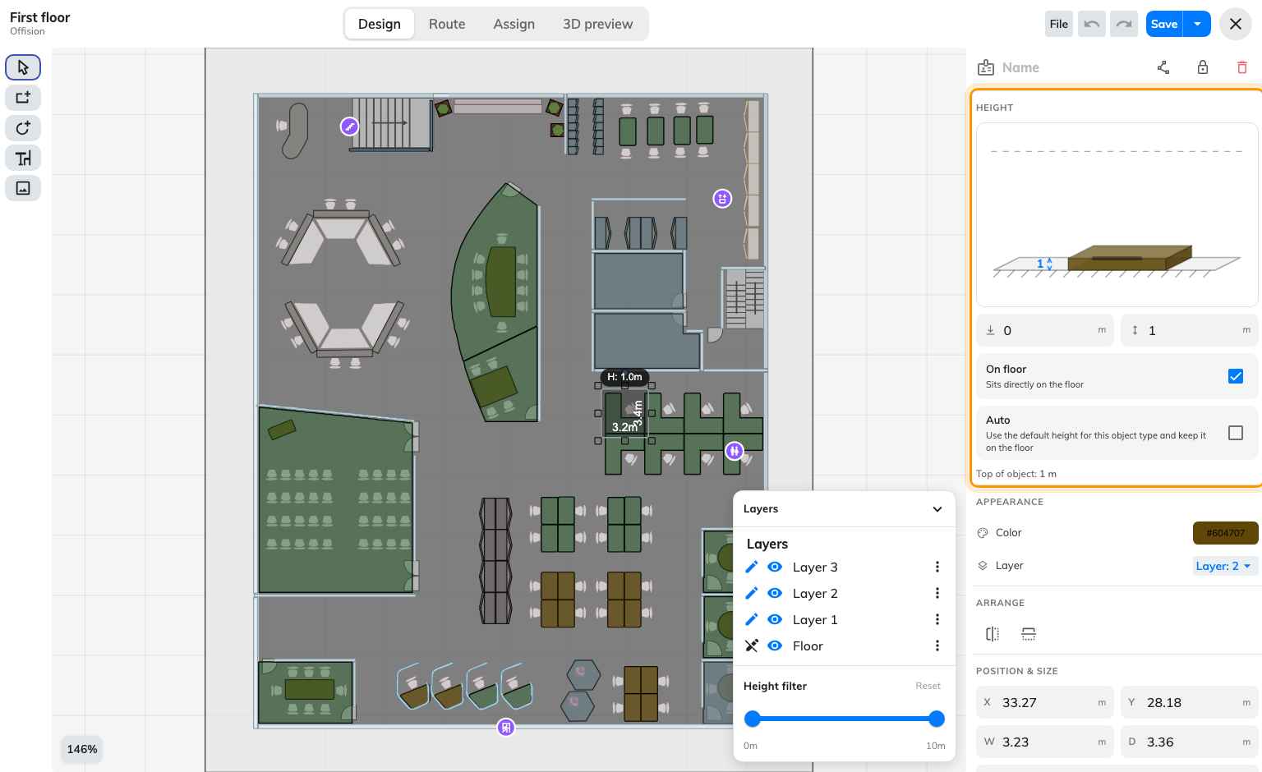
How far off the floor it starts, and how tall it is.
The diagram is not decoration: it shows the object against the floor and the
ceiling, and you can drag it instead of typing.
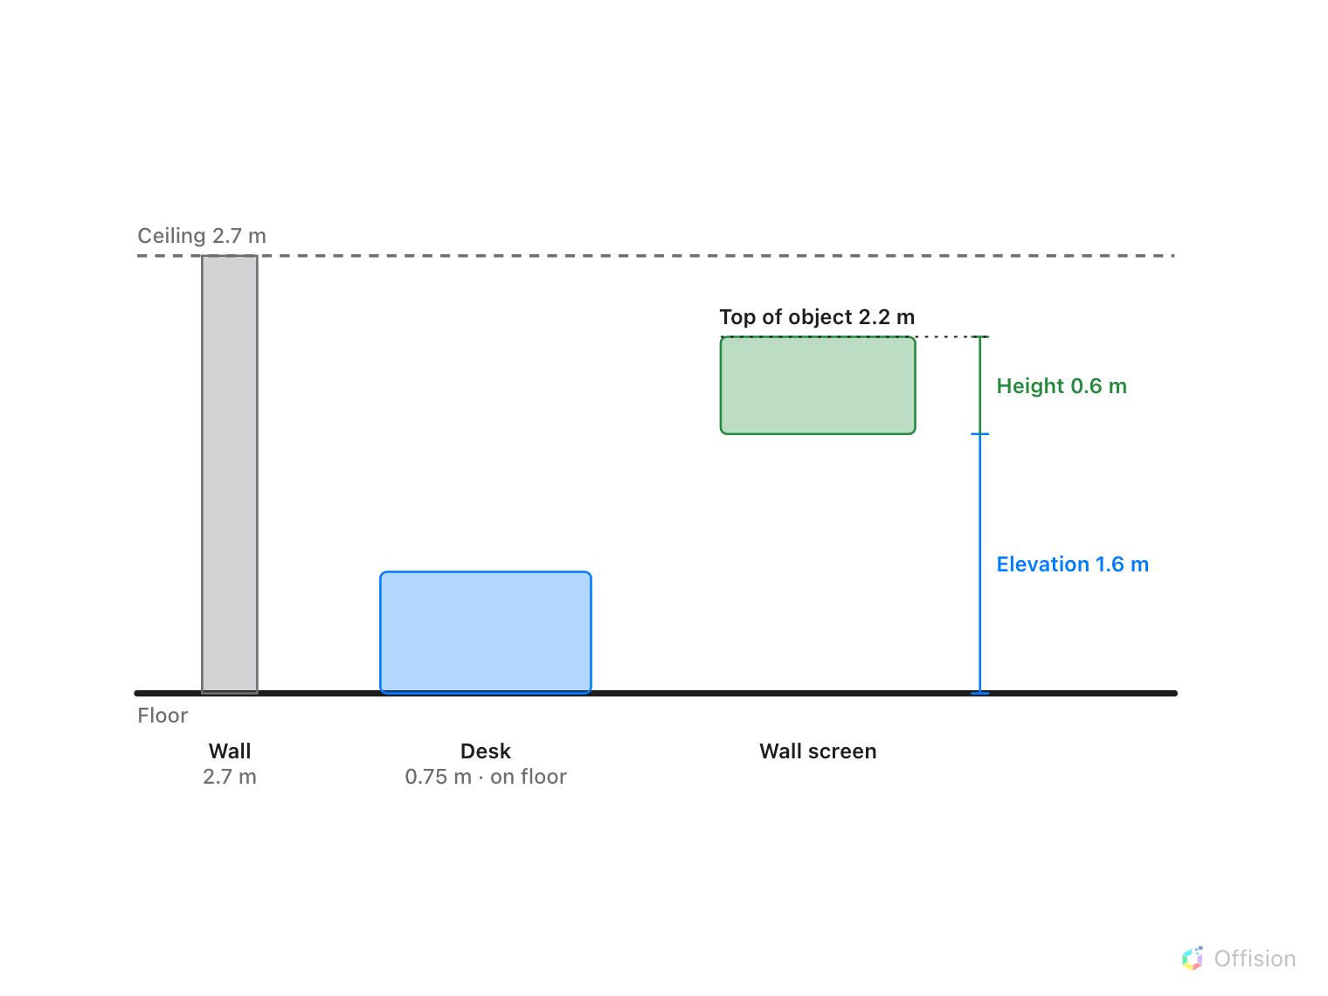
Elevation is where the object starts, height is how tall it is, and top of object is the sum to check against the ceiling.

2. Set the height
The right-hand box is how tall the object is, in metres or feet. Useful
starting points, because they are what people get wrong:
- A full-height wall is the floor-to-ceiling height, usually 2.5–3 m. Walls
drawn at 1 m are the commonest reason a 3D map looks like a doll's house.
- A partition between desks is 1.2–1.5 m — high enough to read as a divider,
low enough to see over.
- A desk is about 0.75 m, a chair about 0.45 m, a cupboard 1.8–2 m.
Nothing forces these; a floor reads well when the tall things are genuinely tall
and the low things genuinely low, and badly when everything is the same height.

3. Leave Auto on where you can
Auto — "Use the default height for this object type and keep it on the
floor" — gives the object the sensible default for what it is and stops you
having to decide. Leave it on for furniture out of the catalogue, which already
knows what it is. Turn it off for walls, partitions and anything unusual, at
which point the height box becomes editable.

4. Lift things off the floor with elevation
The left-hand box is elevation: how far the object's base sits above the
floor. Zero for almost everything, which is what On floor — "Sits directly on
the floor" — pins it to.
Elevation is for the things that hang: a shelf at 1.4 m, a wall-mounted screen at
1.6 m, a soffit above a reception desk. Clear On floor, then type the height
of the underside.
Underneath, Top of object adds the two together and shows where the object
actually ends. It is the number to check against your ceiling height — an object
whose top exceeds it will poke through the floor above in a stacked view.

5. Work one storey at a time
Once a floor has furniture on it, selecting a wall behind a desk becomes
fiddly. Height filter, in the layers panel, narrows the drawing to a band of
heights — pull it down to a metre and the walls disappear, leaving only the
desks and chairs to click.
It reports what it is doing — 12 of 40 shown — and Reset
puts everything back. It is a view filter only: nothing is hidden from anybody
else, and nothing is saved by it.
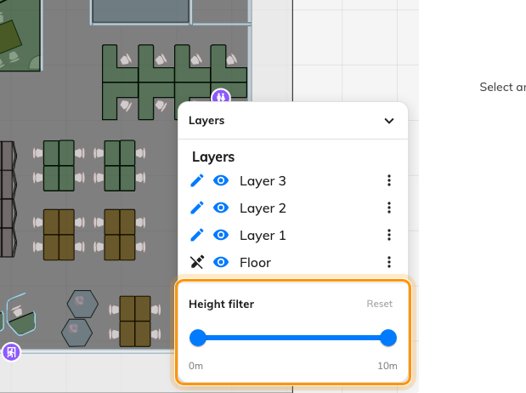
Pull the band down and the walls disappear — from the editor only.

6. Set several at once
Select several objects — all the partitions, say — and the Height panel applies
to the lot. Where they currently differ, the boxes read Mixed; type a value
and they all take it. It is much the fastest way to fix a floor where every wall
was left at its default.

7. Check it worked
Switch to 3D preview. Walls should read as walls, desks should sit below
them, and you should be able to see over the partitions but not through the
rooms. Anything that looks wrong here is a height, not a drawing.

What this does not control
- Ceiling height is a property of the floor, not of the objects on it. The
Height panel measures against it but does not set it.
- The floor above. Elevation lifts an object within its own floor; it does
not move anything between floors.
- What people see. Height affects the 3D drawing. It has no bearing on
whether a room can be booked, or on who can see it.

