Generate the walking paths automatically
One button builds the whole network from the floor you already drew — paths follow the corridors and reach every assigned resource. The two settings that shape the result, and what survives a regenerate.
2026-08-25 · https://offision.com/help/en/map/generate-the-paths-automatically/
Before you start:
Assign the floor's rooms and desks first. Generating connects assigned
resources, so running it on a floor where nothing is linked produces corridors
that lead nowhere — see
Assign rooms and desks to the map.
This is the way to build a network, and hand-drawing is the way to correct it.
The generator reads the floor you have already drawn, threads paths down the gaps
between your objects, and joins every assigned resource to them.

1. Open the panel
Switch to Route. The panel on the right is Auto-generate paths, and it
says what it will do: paths follow corridors and connect every assigned resource.
Start, lift and stairs points are kept.
Where in Offision: admin app → map/floor-plan (Map)
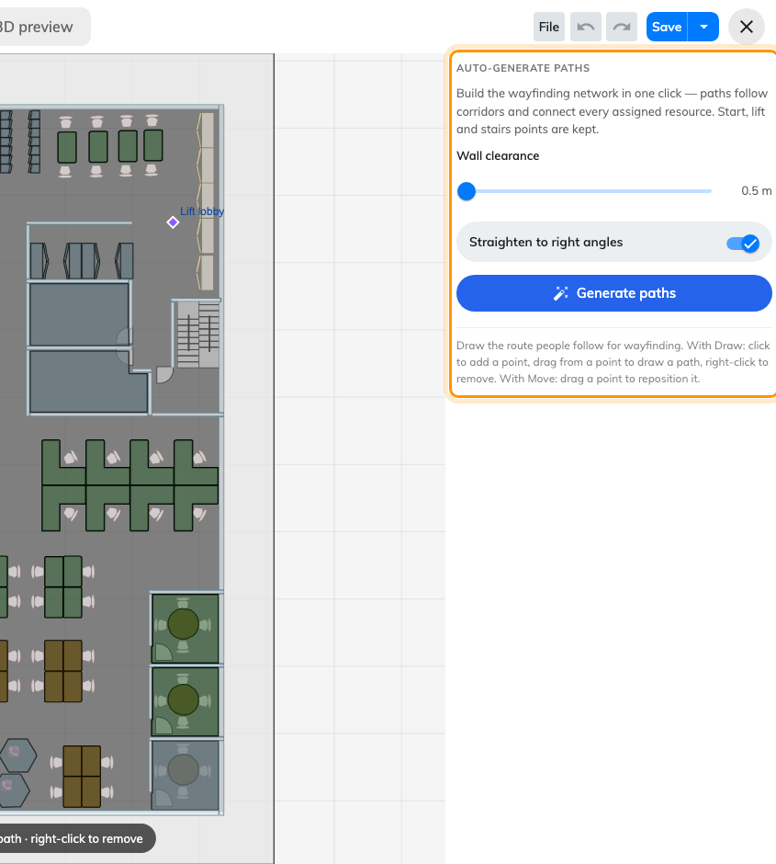
Two settings, one button.

2. Set the wall clearance
How far a path is kept from the things you drew, from 0.5 m to 5 m.
It is the setting that decides whether the result is usable. Too small and paths
hug the walls and thread through gaps a person with a trolley could not use; too
large and a genuine corridor is treated as impassable, leaving a wing
unreachable.
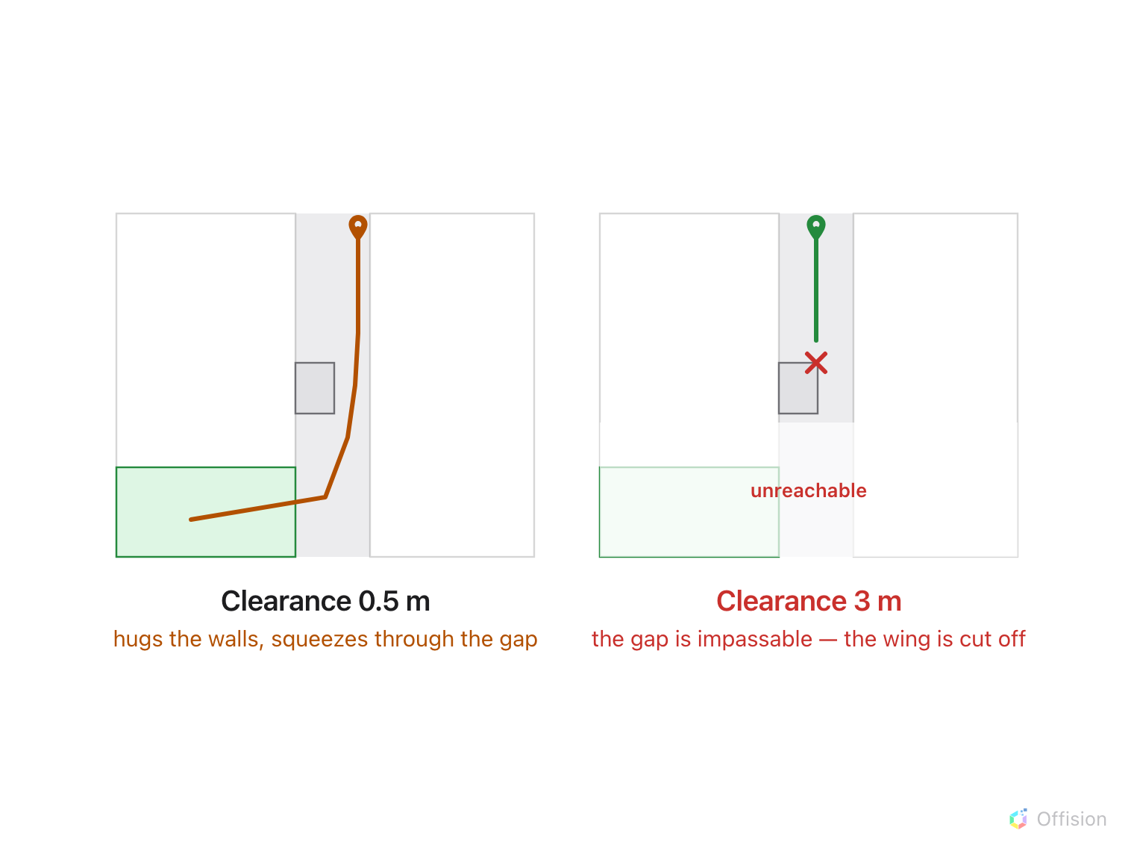
Too small and paths squeeze through gaps nobody uses; too large and a real corridor is treated as impassable.
Start around 0.5–1 m for an ordinary office and raise it only if the paths are
squeezing through places people do not really walk.

3. Decide about right angles
Straighten to right angles makes the network follow the building rather than
cut across it. On a rectangular floor it produces something that looks drafted
and reads clearly on a small screen.
Turn it off for a floor that is genuinely not rectangular — an atrium, a curved
frontage — where forcing right angles adds corners nobody walks.

4. Generate
Generate paths builds the network and reports what it did: Connected N
resources. That number is the check. Compare it with how many resources you
assigned on this floor — a figure well below it means some are cut off, usually
behind a clearance that is too generous.
Running it again asks first, because it replaces everything. What survives is
deliberate: start points, and lift and stairs points. Undo restores the previous
network, and it is one step.

5. Correct by hand
The generator gets the corridors right and the judgement calls wrong. Switch to
the Draw and Move tools for the rest — the fire door people actually use,
the shortcut through the kitchen you would rather they did not take. See
Draw the walking paths by hand.
Corrections survive until the next generate, which is the reason to get the
clearance right before you start hand-editing rather than after.

6. Clear, if you need to start over
Clear all paths removes the paths and the connection points, keeping start,
lift and stairs points. It also asks first, and undo restores everything.

7. Save
Save in the header. Nothing is written until you do, including on a floor
with no wayfinding licence — the licence gates whether directions run, never
whether the drawing is kept.

8. Check it worked
Ask for directions to a far corner of the floor, then to a room on another floor.
The second is the one that catches a missing lift, because the generator can only
join floors where a lift or stairs was marked.

What this does not control
- Which resources exist to connect. Generating never creates or assigns
anything; it joins what is already assigned.
- Whether a person may walk the route. Access rights are not consulted.
- Other floors. Generating is per floor. A four-floor building is four runs.

