Frame the default 3D view
The angle a floor opens at, everywhere it is shown — orbit the map until it looks right, save the camera, and know what to do when somebody has saved a bad one.
2026-09-07 · https://offision.com/help/en/map/frame-the-default-3d-view/
Before you start:
Worth doing last, once the floor is drawn and the heights are set — the angle
you save is the angle everybody sees, and it is only worth choosing when there
is something to look at.
A floor is a three-dimensional thing shown on flat screens of very different
shapes, so somebody has to decide which way it faces when it first appears. That
decision is made here, once, and every surface that draws the floor inherits it.

1. Open 3D preview
The fourth mode. The canvas is replaced by the real 3D map — the same one the
app and the screens in the lobby draw.

2. Orbit until it looks right
Drag to rotate, scroll to zoom, and drag with the secondary button to pan. The
panel on the right says it in one line: orbit, zoom and pan to frame the plan,
then save it as the default 3D view.
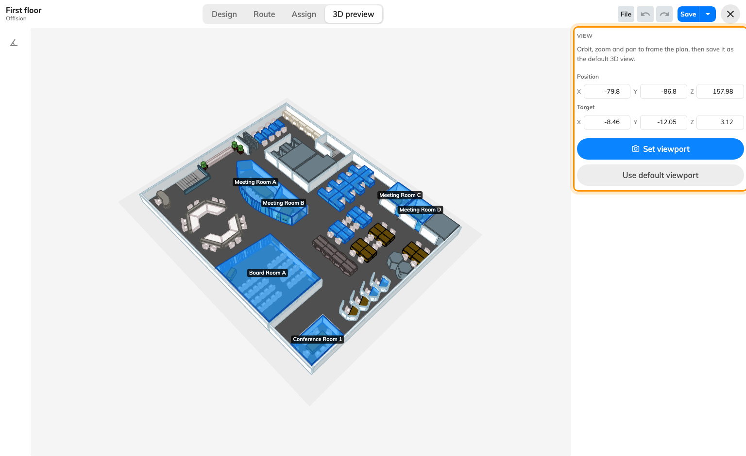
Frame it on the left; save it on the right.
What to aim for, given where this ends up:
- Show the whole floor. Somebody arriving at a lobby board needs to find
themselves, and a view cropped to the interesting half is no use to them.
- Point the entrance towards the bottom. A map is easiest to read when the
way in is nearest the viewer.
- Tilt, do not flatten. A near-vertical camera throws away the heights you
just set; a very low one hides the far side of the floor behind the near
walls. Somewhere around halfway is what the samples use.
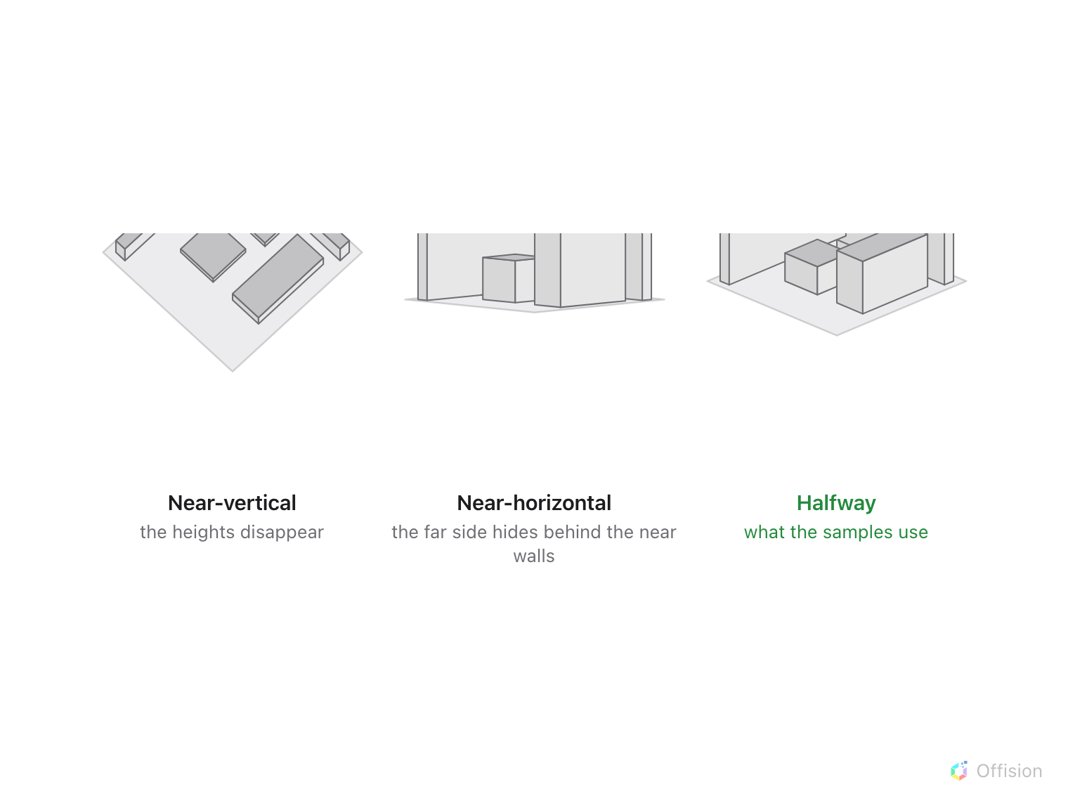
Halfway keeps the heights and the far side both visible.

3. Save it
Set viewport stores the camera exactly where it is, after asking to confirm.
The Position and Target boxes above the button mirror the camera while
you move it, and typing in them moves the camera — useful for nudging one axis
without disturbing the framing, and for copying a good angle onto another floor.
Use default viewport goes back to the automatic angle and clears what was
saved. That is the fix when a floor opens somewhere strange and nobody remembers
why: reset it, orbit again, save again.
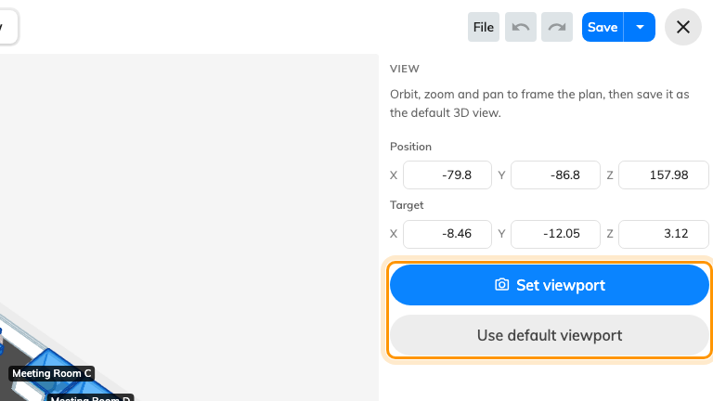
Set viewport saves the camera; Use default viewport clears it.
Neither button writes anything on its own. Save in the header is what
commits it, exactly as it does for the drawing.

4. Check it worked
Close the editor. The preview beside the floor list should be at the angle you
chose. Then open the floor on the app's map — same angle. That is the whole
point of the setting.

What this does not control
- How anyone looks at the map afterwards. This is the opening view, not a
lock. People can still orbit and zoom for themselves.
- The signage widgets' own framing. A board or a signage screen showing a
floor plan can be given its own angle in its editor, which overrides this one
for that screen — and the Booking status - Map widget can drop the
perspective entirely and draw the floor flat, where there is no angle to
inherit at all: Show the floor plan flat, in 2D.
- Anything about the drawing. The camera is not part of the floor; changing
it moves nothing and breaks nothing.

