Draw the walking paths by hand
Route mode's two tools — click to drop a point, drag from one to lay a path, right-click to remove. When hand-drawing beats generating, and the mistakes that leave a network with a hole in it.
2026-08-25 · https://offision.com/help/en/map/draw-the-walking-paths/
Before you start:
Draw the floor and assign its rooms first. Routes connect assigned resources,
so a network drawn before anything is assigned has nothing to arrive at — see
Assign rooms and desks to the map.
Most floors are better started with
Generate the paths automatically and
corrected by hand afterwards.

1. Switch to Route
Open the floor in the editor and choose Route. The plan greys back, the rail
narrows to two tools, and the canvas carries a hint telling you what each click
does.
Where in Offision: admin app → map/floor-plan (Map)
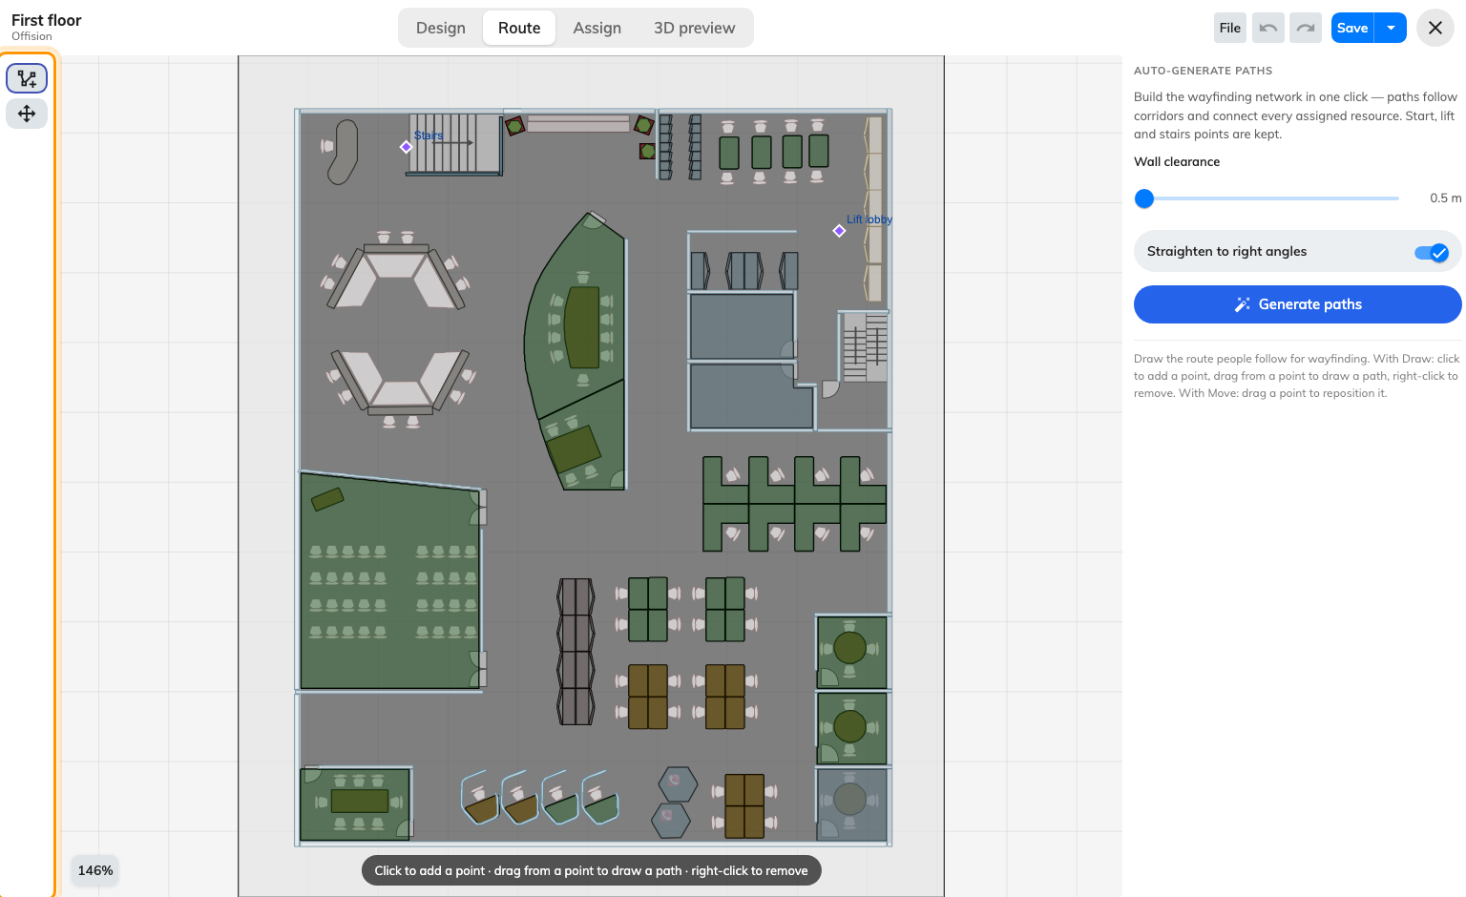
Two tools: Draw, and Move.

2. Draw
With Draw armed, three gestures are the whole tool:
- Click on empty floor to drop a point.
- Drag from an existing point to lay a path to wherever you release. That is
how points get joined — clicking two points near each other does not connect
them.
- Right-click a point or a path to remove it.
Work along the corridors, not around the rooms. A network is a skeleton of the
routes people walk: down the middle of each corridor, a branch to each door.
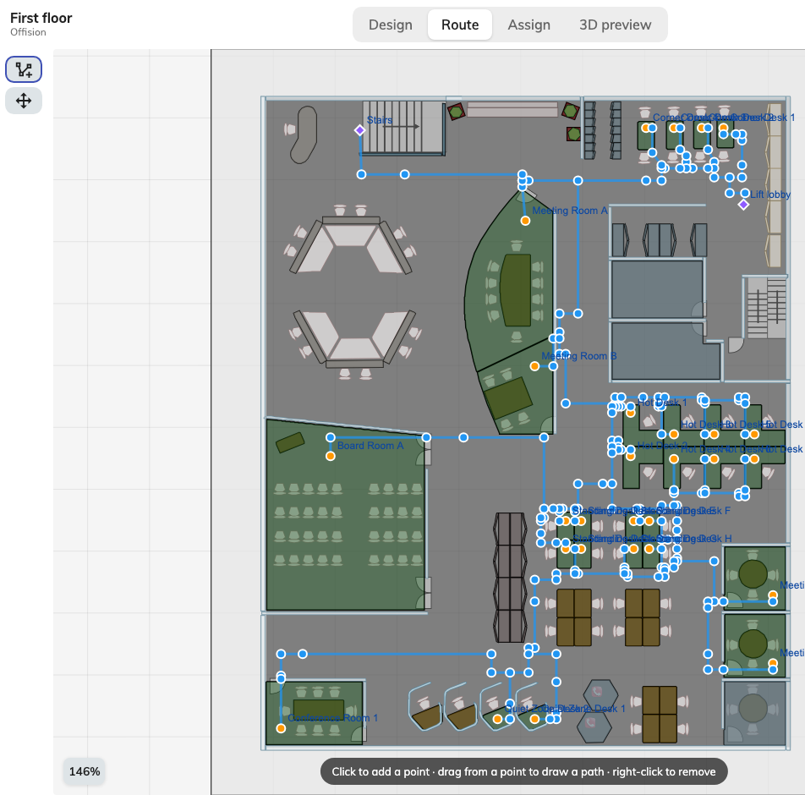
A network: a spine down each corridor, a branch to each door.

3. Move
Move drags an existing point without redrawing anything joined to it — the
paths follow. Use it to nudge a corridor line off a wall, and to pull a branch
onto a door it landed beside.

4. Join everything to everything
The failure that is hard to see is a network in two halves: each half is fine and
no route crosses between them. It happens where two people drew different wings,
and where a corridor was drawn as two paths that visually meet but share no point.
Two habits avoid it:
- Start every new path by dragging from an existing point, not by clicking a
fresh one nearby.
- Follow one loop of the floor end to end before branching off to rooms.

5. Mark where floors join
Lifts and stairs are how a route leaves the floor, and they are facilities rather
than route points. Mark them on every floor they serve, and put a route point at
each one, so the network reaches the place the route changes level.
The rule that catches people is that it must be one facility with a position
on each floor, not one facility per floor — see
Connect floors with lifts and stairs.

6. Save
Save in the header. Routes are part of the map, so nothing is written until
you do — and that is true on an unlicensed floor as well. The licence gates
whether wayfinding runs, never whether your drawing is kept.

7. Check it worked
Ask for directions to a room on the floor, from the app or from a lobby board.
Then ask for one on another floor, which is the test that catches a missing lift.
A route that appears but takes an odd path is usually a missing branch rather
than a wrong one: the network found the only way it had.

What this does not control
- Which rooms can be reached. A room joins the network by being assigned to
an area, not by having a path drawn at it.
- Whether directions are offered at all. That is the per-floor licence — see
How wayfinding finds a path.
- Doors, locks and access rights. A path is a line. It does not know whether
the person following it may go through what it crosses.

