Draw the rooms and furniture
Design mode — tracing the walls with rectangles and ellipses, dropping in desks and chairs from the furniture catalogue, and the four layers that decide what you can select. About half an hour for a real floor.
2026-08-25 · https://offision.com/help/en/map/draw-the-rooms-and-furniture/
Before you start:
The floor needs a map to open at all — see
Create a map for a floor. If you imported an
image, it is already behind the canvas and you are tracing over it.
Everything here happens in Design, the first of the four modes. You are
drawing a flat plan seen from above; heights come afterwards, in
Give objects height.

1. Learn the rail
Five tools down the left, and they are the whole drawing kit.
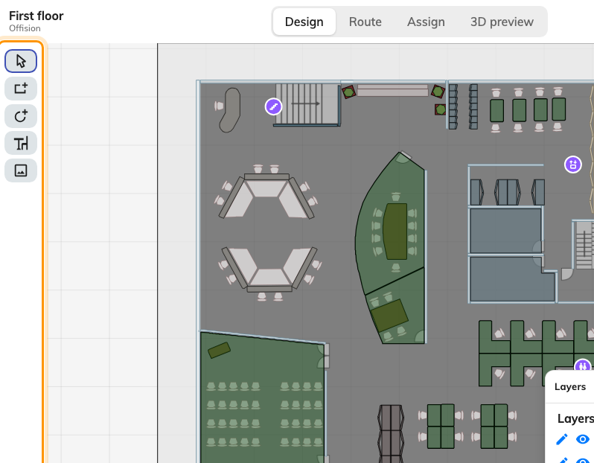
Select, rectangle, ellipse, furniture, and the floor image.
- Select — the default. Click a shape to pick it up; the panel on the right
fills with its properties.
- Add rectangle — a room, a wall, a block of anything. Most of a floor is
these.
- Add ellipse — round tables, planters, the occasional curved wall.
- Add workspace furniture — a catalogue of drawn objects rather than blank
shapes, in four groups: Room setting, Desk / Chair, Cupboard /
Locker / Server rack, and Shape.
- Update floor image — replaces the picture behind the drawing without
touching anything you have drawn on it.

2. Trace the rooms
Draw a rectangle over each room on the image behind you. Do not try to be exact
on the first pass: drop the shape roughly, then correct X, Y, W and
D numerically in Position & size on the right. Typed numbers are faster
than dragging and they are in real metres, so they can be taken straight off the
plan.
For a room that is not a rectangle, draw the nearest one and then use Edit
points. The canvas tells you the rules while you are in it: drag points or
edges to reshape, right-click an edge to add a point, right-click a point to
remove it, and Esc when you are done.
Give each shape a name in the box at the top of the panel. It is not
compulsory, but an unnamed rectangle is indistinguishable from every other one
in six months' time, and the name is what you will look for in Assign mode.

3. Keep it straight
The zoom percentage in the bottom-left corner is a menu, and the bottom half of
it holds three switches that do most of the work of making a hand-drawn plan
look drafted:
- Show grid puts a metre grid behind the drawing.
- Snap to grid makes new and moved shapes land on it.
- Snap to objects aligns them to what is already there, which is what you
want for a row of desks against a wall.
For anything the snapping cannot fix, select several shapes and use the
alignment buttons in Arrange: align left, centre, right, top, middle,
bottom, and — with three or more selected — distribute them evenly.

4. Use the layers to stop fighting the drawing
There are four, they are fixed, and they cannot be added to: Floor, then
Layer 1, Layer 2 and Layer 3.
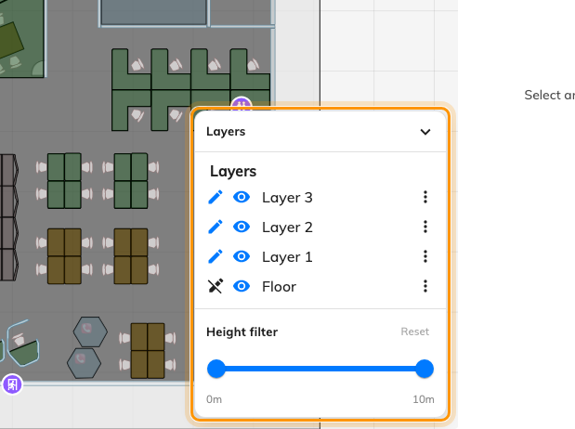
Which layer you are editing, and which ones you can see.
Each row has a pencil and an eye. The pencil says which layer you are editing
— and only shapes on that layer can be selected, which is the single most common
cause of "I can't click my room". The eye hides a layer while you work on
another.
Floor is the floor slab itself and its image, and it is deliberately not
editable: while it is the current layer, the shape tools are greyed out. That is
not a fault; switch the pencil to Layer 1 and they come back.
A workable habit is rooms and walls on Layer 1, furniture on Layer 2, and Layer 3
for anything you are experimenting with.

5. Tidy up
- Lock a shape you have finished with, so a stray drag cannot move it.
Unlock all from the right-click menu when you need them back.
- Group the shapes that make up one thing — a desk and its chair — so they
move together.
- Duplicate a shape you are about to draw twenty of, then reposition the
copy numerically.
- Right-click gives you all of these plus Copy, Paste, Select all,
Show all hidden and Zoom to fit.

6. Save
Save writes the map and keeps the editor open; the arrow beside it offers
Save & Close. Save often — you will be here a while, and although an
interrupted session is offered back to you when you return, a saved one needs no
recovering.

7. Check it worked
Switch to 3D preview. Every shape you drew stands up at its default height,
which is the fastest way to spot the two mistakes that are invisible in plan: a
room drawn at twice its real size, and two shapes you thought were adjacent
overlapping each other.

What this does not control
- What the shapes mean. A rectangle named "Meeting Room A" is not the room
called Meeting Room A until it is assigned to it in Assign.
- How tall anything is. Every shape gets a sensible default height; changing
it is Give objects height.
- The colours people see on the app. The colour set here is the object's own.
Availability colouring — free, busy, occupied — is applied on top of it by
whatever surface is drawing the map.

