Create a map for a floor
Four ways to start a floor — a sample, an empty canvas, an image of your own plan, or a map file — and the one question the editor asks that everything else depends on. About fifteen minutes.
2026-08-25 · https://offision.com/help/en/map/create-a-map-for-a-floor/
Before you start:
The building and its floors have to exist already — see
Add a building and its floors.
You need permission to edit settings, not just read them; without it the floor
opens but the Edit button does nothing. Have your plan to hand if you have
one, as an image or as an .ofp file.

1. Pick the floor
Open Map. The list down the middle is your buildings and their floors. A
floor that already has a map carries a tick; one that does not says No floor
plan. Selecting a floor shows what is on it.
Where in Offision: admin app → map/floor-plan (Map)
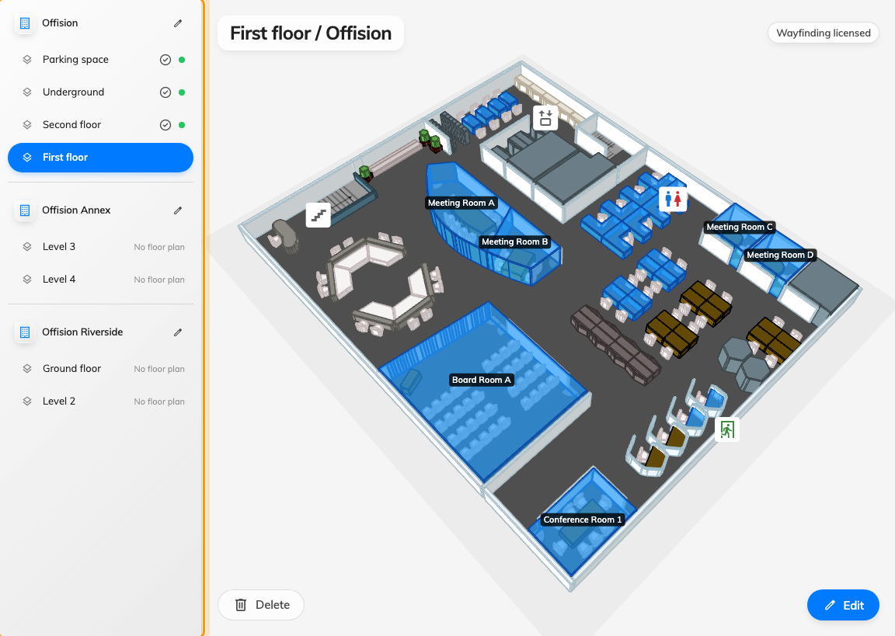
One row per floor. The tick means there is a map on it.
Then Create map on a floor with nothing on it, or Edit at the
bottom of one that already has a map.

2. Choose how to start
The editor opens on a screen with two columns, and which one you use depends on
whether you already have a plan.
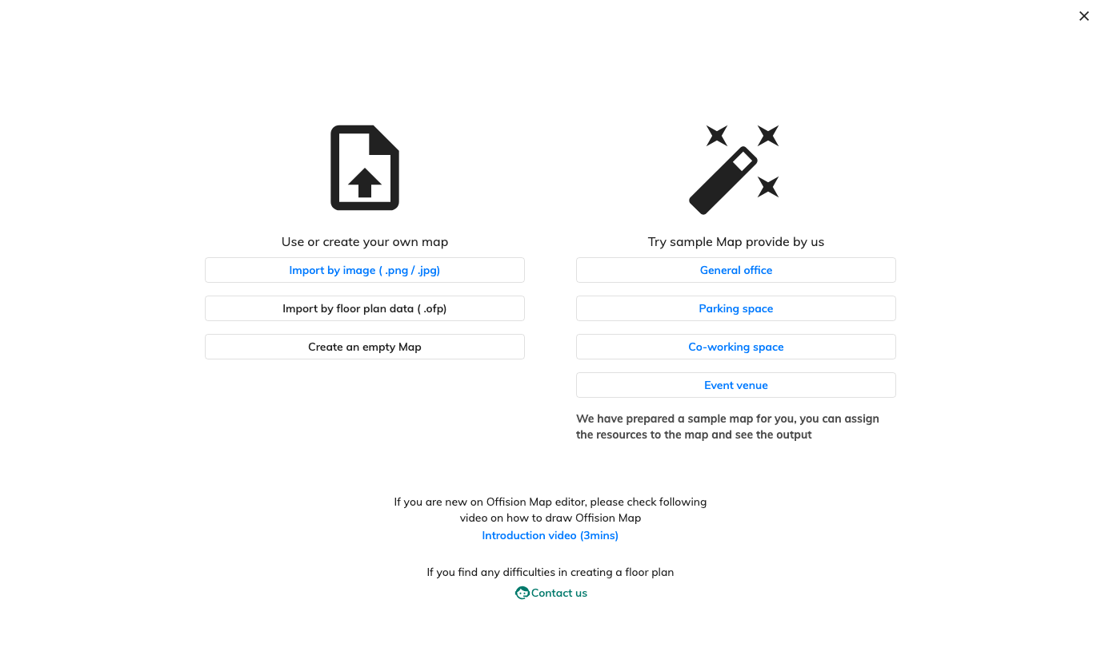
Four ways in. The left column is your own plan; the right is ours.
Use or create your own map
- Import by image ( .png / .jpg) — the usual choice. You bring a picture of
the plan and trace over it. PNG and JPEG only.
- Import by floor plan data ( .ofp) — an Offision map exported from another
floor or another tenant, which arrives complete.
- Create an empty Map — a blank floor to draw from scratch. Reasonable for a
simple rectangular floor, slow for anything else.
Try sample Map provide by us
Four ready-made floors — General office, Parking space, Co-working
space and Event venue. They are worth ten minutes even if you intend to
draw your own: a sample gets you to the part that matters, which is linking your
rooms and desks to it, before you have committed to anything.

3. Make the floor image, if you need one
The image is only ever traced over, so it does not have to be beautiful — it has
to be straight, to scale, and readable. Two three-minute walkthroughs are
linked from the import dialog itself, and they are the shortest route if you are
starting from a PDF or a printout:
- Making the plan in PowerPoint
- Making the plan in Photoshop
Keep the long edge at or under 4096 pixels. Larger images are scaled down before
they are drawn, so the extra pixels cost loading time and buy nothing — and on
panels and kiosks the limit is lower still.

4. State the floor's real width
After you choose an image, the editor asks for the actual floor dimensions
and gives you a Scale slider, in metres or feet.
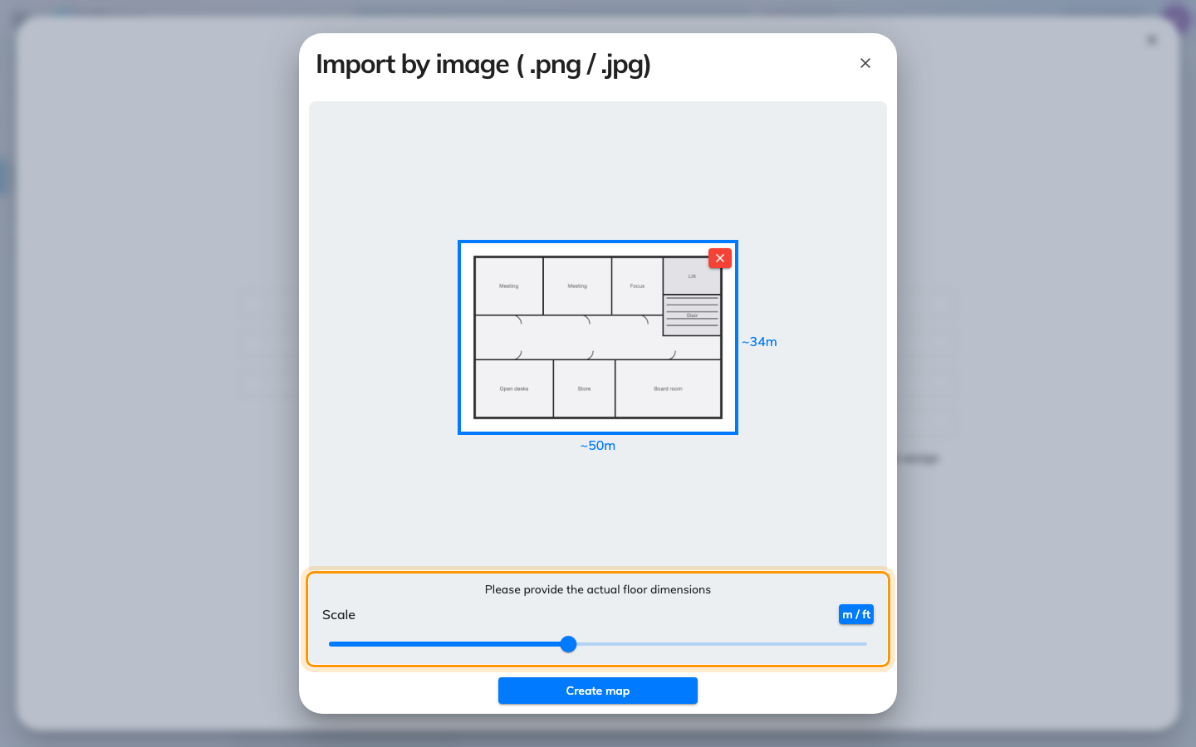
How wide the floor really is. Everything else is measured from this.
This is the most consequential click in the article. It is not the image's size;
it is how wide that floor is in the building. Every measurement afterwards —
object sizes, heights, the clearance a walking route keeps from a wall — is
derived from it, so a floor entered at half its real width produces a map that
looks perfectly normal and is wrong everywhere it matters.
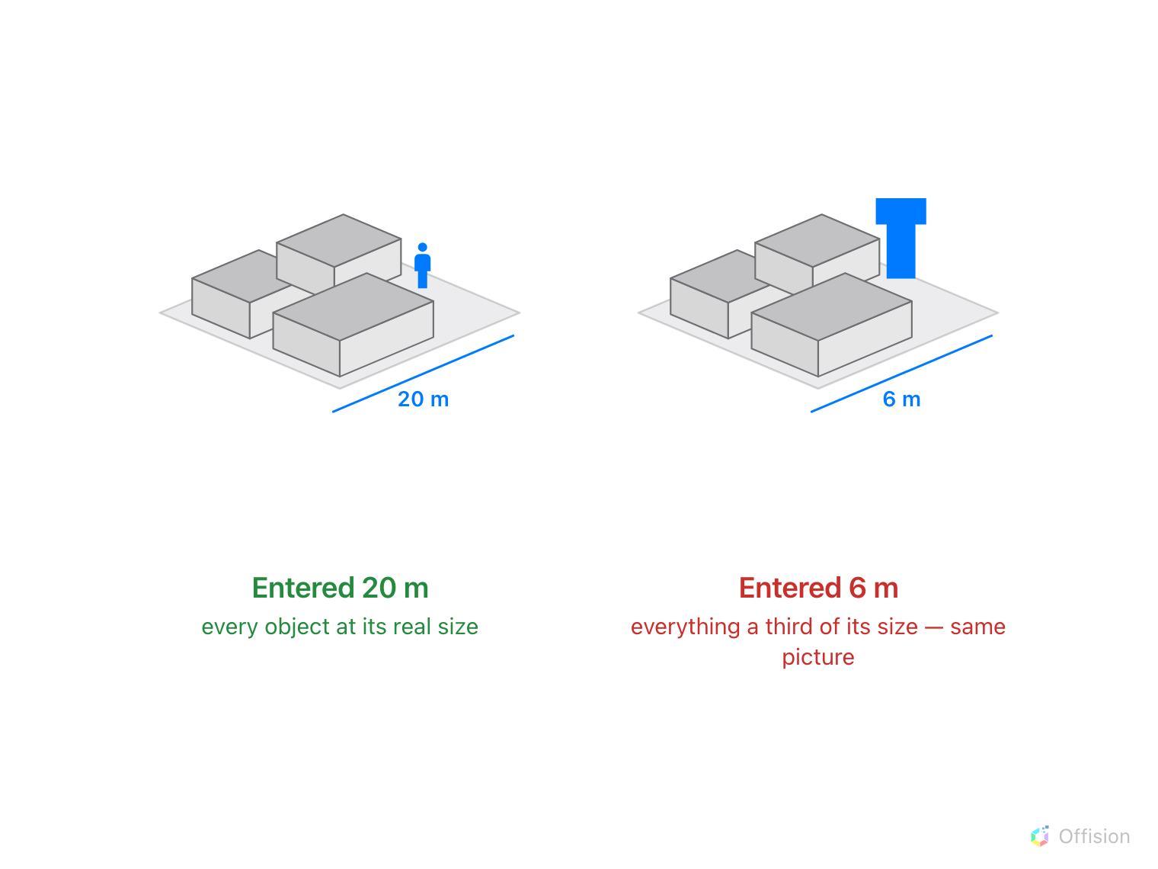
Enter the wrong width and the picture still looks right. Only something of known size gives it away.
Take the number off the plan you are tracing rather than estimating it. Then
Create map.

5. Draw, then save
You land in Design mode with your image behind the canvas, ready to trace.
That is its own article — see
Draw the rooms and furniture.
Nothing reaches the server until you save. Save keeps the editor open;
the arrow beside it offers Save & Close. Closing with unsaved work asks
first, and a session that ends badly is offered back to you next time.

6. Check it worked
Close the editor and look at the floor list. The floor should now carry a tick
instead of No floor plan, and the preview beside it should show your map in
3D — which is also the fastest way to notice that the scale is wrong, because a
floor at the wrong width looks obviously too tall or too flat once it has walls.

What this does not cover
- The rooms and desks themselves. A new map has shapes on it and nothing
linked to them — see
What an Offision map is made of for what that
link is and why it is a separate job.
- Replacing a plan later. Importing again over an existing map warns you
that it overwrites, and it means it. To change only the picture behind the
drawing, use Update floor image in the tool rail instead.
- Other floors. A map is one floor. A building with four floors is four maps
— though an .ofp export from one is a reasonable starting point for the next
if the floors are alike.
Let Offision draw it for you:
Map drawing is offered as a service — our own team builds the floor for you.
Send the plan you already have: a PDF, a CAD file (DWG or DXF), an image of the
plan, or an Offision map you started (.ofp). It comes back finished, ready for
resources to be linked to it. It is a paid service — ask for a quote when you
send the plan. It is the Contact us link on the screen above, and File →
Contact us once you are drawing.

