Create a floor map with Map 2.0
[Map family: new] Start a new Map 2.0 map from an image or PDF, or draw directly in the 3D designer. Recommended for new maps.
2026-10-03 · https://offision.com/help/en/map/create-a-map-2/
Map family: new
Where in Offision: admin app → map/floor-plan (Map)
Use Map 2.0 when creating a new map. Buildings and floors must already exist in Directory.

Start on the right floor
Open Map, choose the new-map view, then choose the building and floor. Open that floor's editor. Switching the map view can change which maps people see across the account; it is not a separate switch for each floor.
On a floor without a Map 2.0 map, choose AI drawing to read an image or PDF, or Start from empty to draw by hand. AI drawing requires available AI map quota. Check the result's scale, doors, room boundaries and assignments before relying on it.
If the floor already has a Classic map, use migration guidance for From classic.

Work in the designer
Map 2.0 edits the scene directly in 3D. A top-down camera is another view of the same map. Insert walls, rooms, doors and furniture, then select objects to adjust them. See Edit a Map 2.0 map.
Changes save as a draft. Check Saved, then follow Review and update. A floor with no published map can show its draft when the new map is enabled; do not assume a saved first draft is private.

Prepare an AI drawing
Use a clear, straight plan of one floor. For a PDF, put the intended floor on the first page. Confirm the map area, remove unrelated margins, then check the proposed Plan size in metres. A scale-bar or dimension-based estimate still needs checking against a known length; an Estimated size needs particular care. Adjust the size before continuing rather than accepting a plausible-looking floor.
AI drawing uses the account's remaining AI-map allowance, shown beside the action. No AI maps left offers Contact sales; drawing manually remains available. Do not assume a fixed allowance or that every retry is free. Stopping a reading after it starts still uses one AI map, as the Stop confirmation states.
After generation, inspect the map before choosing Use this map or opening the designer. A generated drawing does not make bookable resources: assign the existing resources. Walk through the items marked to check, inspect doors and reachable areas, and test directions after updating. If the input cannot be read, choose a clearer plan or Start from empty; do not repeatedly consume quota on the same unreadable sheet.
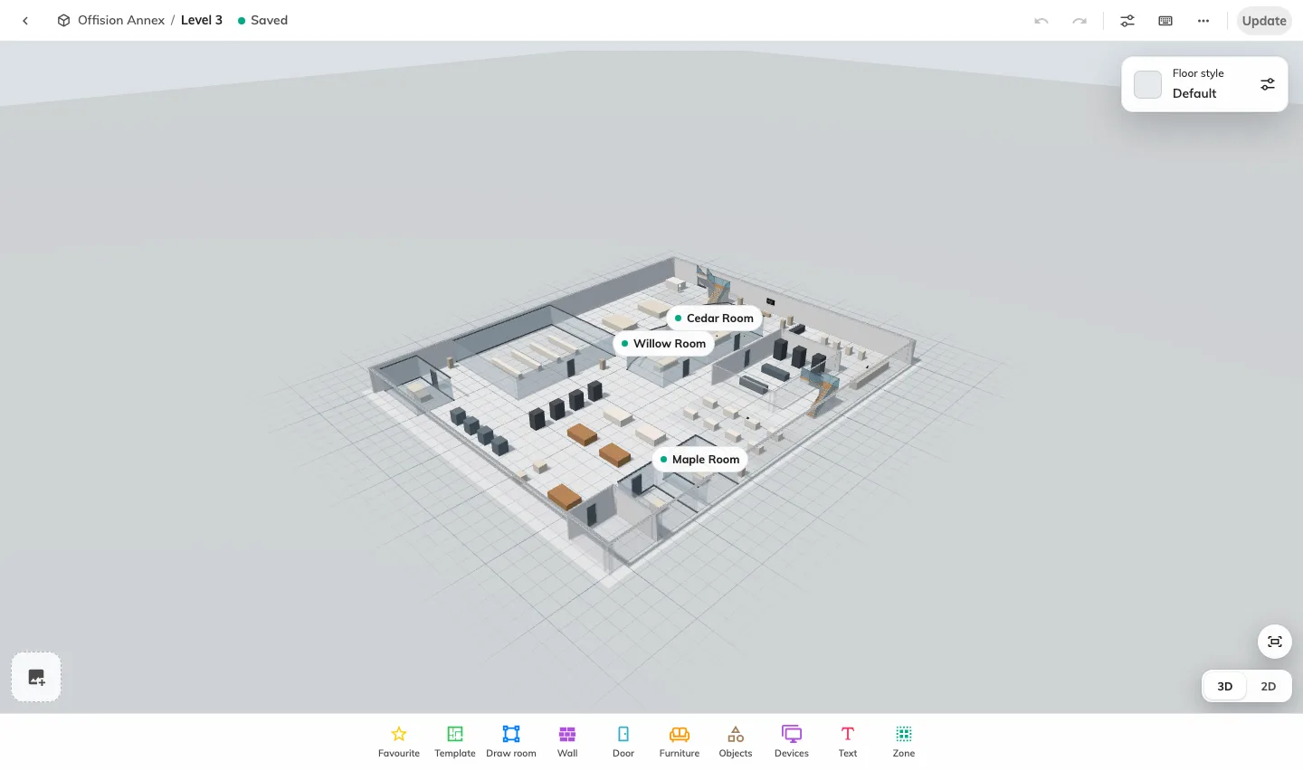
Start a new Map 2.0 map from an image or PDF, or draw directly in the 3D designer. Recommended for new maps.

