A room or desk does not appear on the map
Somebody is looking at the floor plan and the room they want is not on it. Five causes, in the order worth checking, and the one that looks like a bug and is a view filter.
2026-08-25 · https://offision.com/help/en/map/a-room-is-missing-from-the-map/
First, one question:
Is the room missing from the map, or missing everywhere? Search for it in the
resource list. If it is not there either, this is not a map problem — the room
does not exist, or the person looking is not allowed to see it.
Solution 1 — It was never assigned to an area (most common)
By far the usual answer, and it is visible without opening the editor. Open the
floor, switch to Assign, and find the resource in the list: a row that has no
place says Not yet linked to a map.
This is what a half-finished floor looks like — the rooms were assigned and the
desks were not, because the type rail was never switched to desks. Assign it and
save. See
Assign rooms and desks to the map.
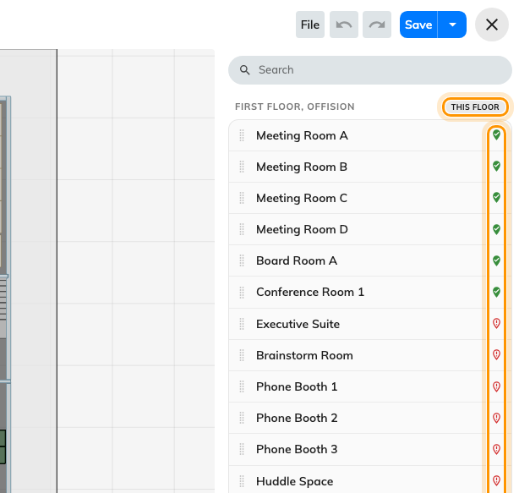
The row's marker says whether it has a place; the heading says which floor.
Where in Offision: admin app → map/floor-plan (Map)
Solution 2 — It is assigned, but on a different floor (common)
A resource sits in one place only, so assigning it on Second floor silently took
it off First. It is not missing; it is somewhere else.
The list groups resources by floor and building and marks the one you are editing
This floor, so a room that has drifted shows up under the wrong heading.
Assign it where it really is, and it moves.
The same thing explains a room that vanished from a floor nobody edited: somebody
was working on the floor above.
Solution 3 — The map was never saved (common)
Assignments are part of the map, not a separate thing that saves itself. An
afternoon of assigning that ended without Save is an afternoon that did not
happen.
Reopen the floor. If the editor offers to recover an interrupted session, take
it and save immediately — see
Work in the map editor was not saved.
Solution 4 — A view filter is hiding it, in the editor only (less common)
This one looks like a bug and is not. Two controls hide objects from you, while
you are drawing, and neither changes what anybody else sees:
- The Height filter in the layers panel narrows the drawing to a band of
heights. Pulled down to a metre, every wall disappears. Reset clears it.
- The eye beside a layer hides that layer.
If a shape is missing from the editor but present on the app's map, it is one of
these two. Nothing has been lost.
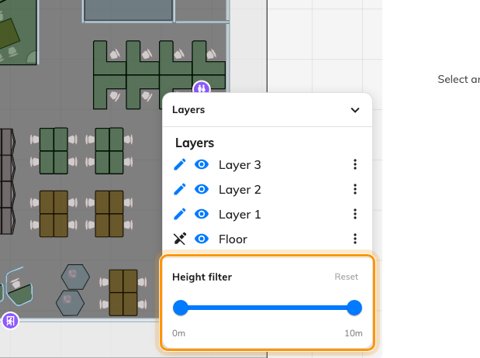
The height filter and the layer eyes hide things from you, not from anybody else.
Solution 5 — It is not a room, a desk, equipment or a parking space (rare)
Lockers, sensors, panels and signage screens all draw on the map, and none of
them is placed from Assign mode. Each is placed from its own form, so a locker
that is not showing was never given a coordinate on its own settings page.
Assign covers rooms, desks, equipment, parking spaces and facilities. Everything
else is somewhere else — see
How rooms and desks link to the map.
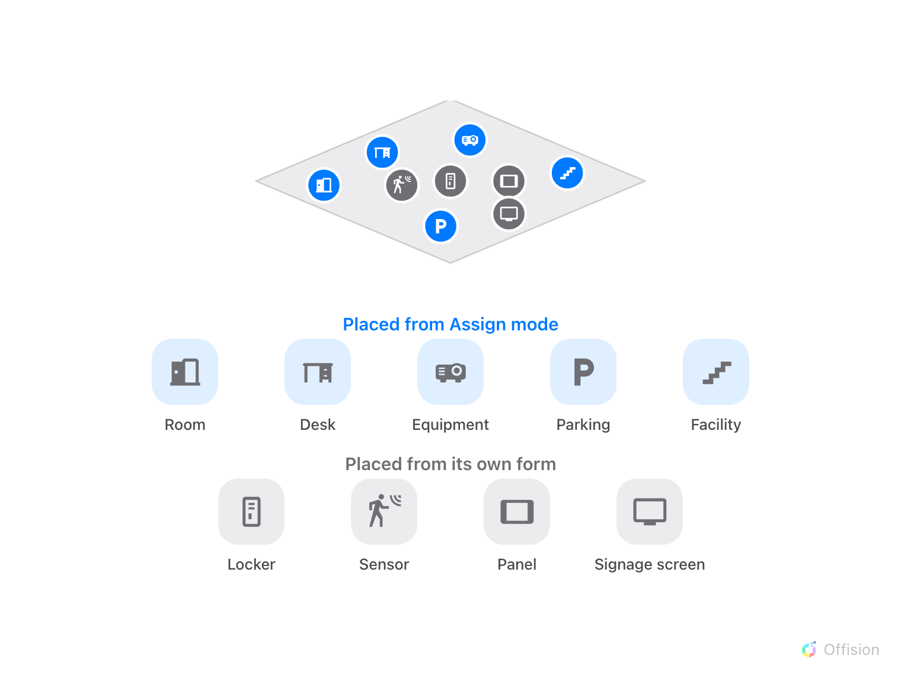
Only the blue group is placed from Assign mode.
Before you ask for help:
Have ready: the resource's exact name, which floor and building it should be on,
whether its row says Not yet linked to a map, and whether it is missing in
the editor, in the app, or both. Those four separate every cause above — in
particular, missing in the editor but present in the app is always cause 4.

