What Neat Pulse syncs into Offision
What the Neat Pulse connection pulls across — rooms, devices and which sensor readings each Neat model actually has — and what it deliberately leaves alone.
2026-08-19 · https://offision.com/help/en/integrations/what-neat-pulse-syncs/
Neat Pulse is Neat's own management cloud — every Neat bar, board and pad in the
building already reports to it. The Offision connection reads that cloud with an
API key, on a schedule you set, and turns what it finds into rooms and sensors
Offision can use. Nothing is installed on the devices, and Offision never talks
to them directly.
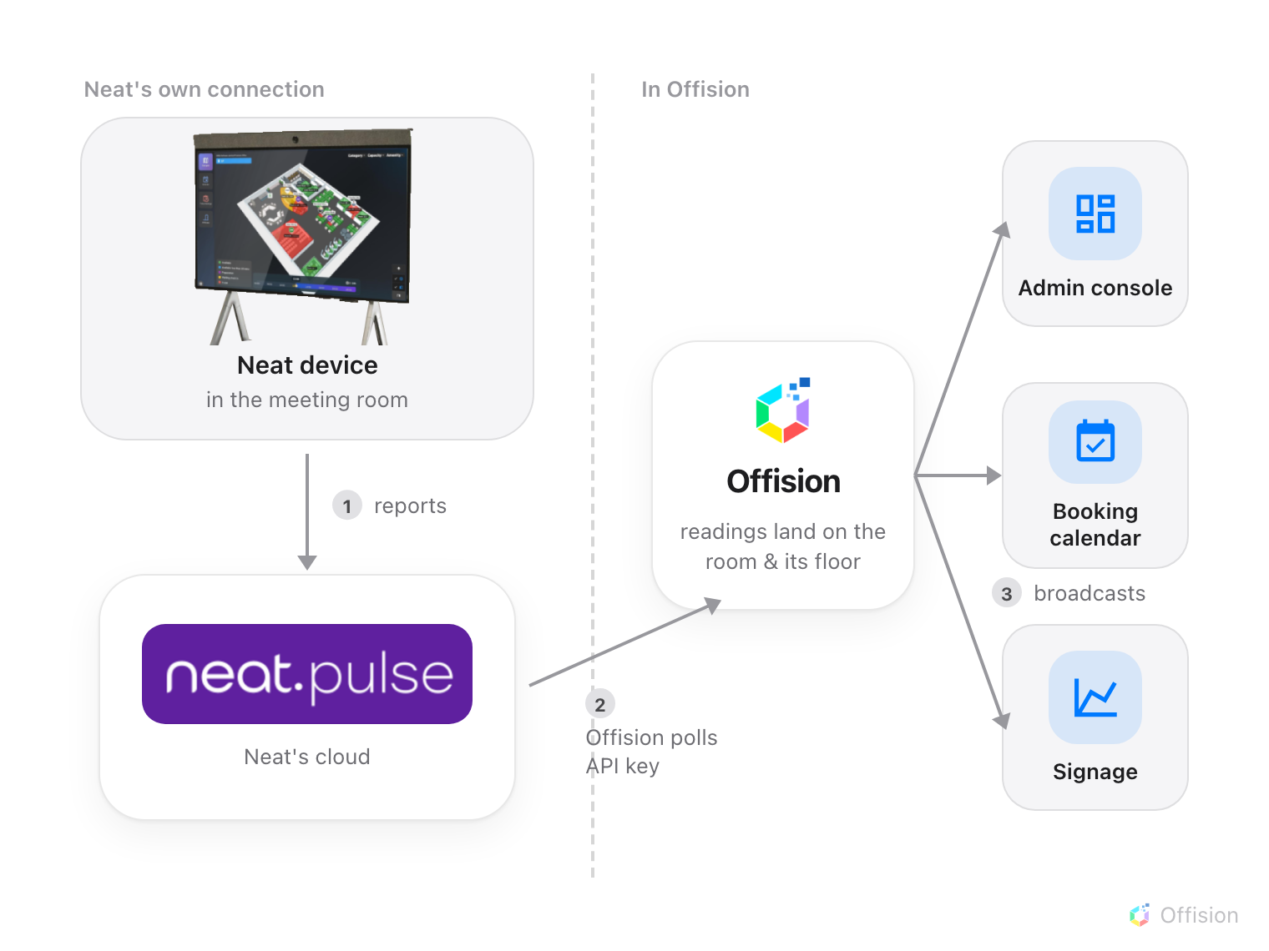
Offision polls Neat Pulse on your interval. The readings land on the room, and every surface reads them from there.

Rooms come first, devices follow
Neat's world is organised into rooms, and the sync keeps that shape: each Neat
room you check becomes an IoT space in Offision. A device only syncs when
its room does — an endpoint whose room is left unchecked is skipped, and the
sync says so.
What makes a space useful is what you link it to. In the sync dialog every room
carries a Link to choice: New space keeps it standalone, Existing
space merges it into a space you already have, and Bookable resource wires
it straight to one of your rooms — which is the option that makes the readings
appear on the booking calendar, the room's panel and its signage. Unchecking a
room later removes only what this connection created; a space that another
platform also feeds stays.

Each model brings a different sensor suite
Every synced endpoint appears as a Neat Device, and its tiles show only what
that model can measure — a tile that would always read zero is not shown at all.
Neat model | Readings
Neat Pad | Temperature, humidity, CO2, TVOC
Neat Bar, Neat Board | Temperature, humidity, CO2, TVOC, light level, people count, occupancy
Neat Bar Pro, Neat Frame, Neat Board 50, Neat Board Pro | Temperature, humidity, VOC index, light level, people count, occupancy
Neat Bar Gen 2 | Light level, people count, occupancy
Neat Center | People count, occupancy

Two of those rows are easy to misread. The newer models report a VOC index
rather than absolute CO2 and TVOC values — a different number with a different
scale, not a worse one. And occupancy is derived: Neat reports how many
people its camera sees, and Offision treats the room as occupied whenever that
count is above zero.

How fresh the numbers are
The connection polls on the Poll interval you set when connecting — every
few minutes is typical. Every reading in Offision is at most one poll old, which
is the right freshness for room health and occupancy, and the reason a reading
never changes the second something happens in the room.

What this does not sync
A Neat room is not a calendar. The connection moves no bookings, no meetings
and no people — rooms and calendars come from
Microsoft 365 or Google Workspace, and
Neat Pulse only adds sensing to rooms you already have. Control is deliberately
thin too: Offision can reboot a Neat device and ask it to resync, and nothing
else — the device's own configuration stays in Neat Pulse.

