Open your gates with an Offision visitor badge
Your turnstile scans an Offision visitor badge, asks Offision whether it is good right now, and records the arrival. Three API calls, one credential, and a verdict you can act on rather than a state you have to interpret.
2026-08-18 · https://offision.com/help/en/integrations/verify-visitor-badges-with-your-own-system/
This is how a building's own access control — a turnstile, a gate, a lobby reader, another
visitor management system — works with Offision visitor management.
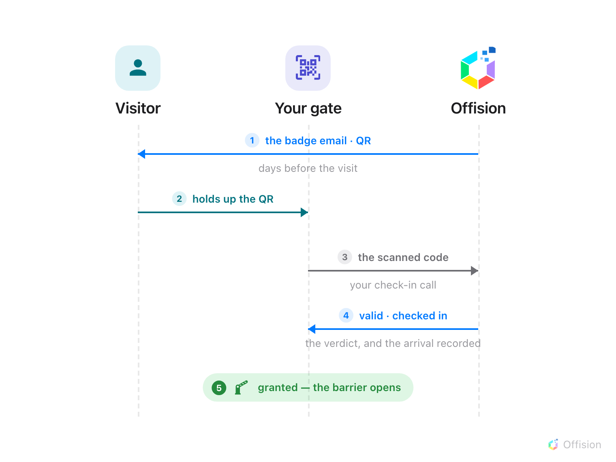
The badge reaches the visitor by email days before anyone arrives. At the barrier one call both asks the question and records the answer — your gate opens on the verdict it gets back.
Before you start:
Nothing here is configured on the reader from Offision — Offision never reaches into your network.
Every call travels the other way, which means you need a developer on the access control side.
- An Offision account that can open API authentication
- An access control system whose readers can call an HTTPS API when a code is scanned, and act on the answer
- The fixed outbound IP addresses that system will call from
- A test visit already booked in Offision, so there is a real badge to scan
- An hour on the Offision side, plus whatever your access control vendor's own work takes

1. Create the API credential
Where in Offision: admin app → marketplace/external-authentication-setting (API authentication)
Connect your own systems walks the credential itself — naming it,
its IP restriction, where the client id and secret appear, and exchanging them for a token. Name
this one after the system that will use it: you will be reading that name in an audit trail later,
and Lobby turnstiles is easier to place than API key 3.
A gate needs exactly one API scope:
Scope | Needed for
visitor.readwrite | Checking a scanned code, and recording arrivals and departures

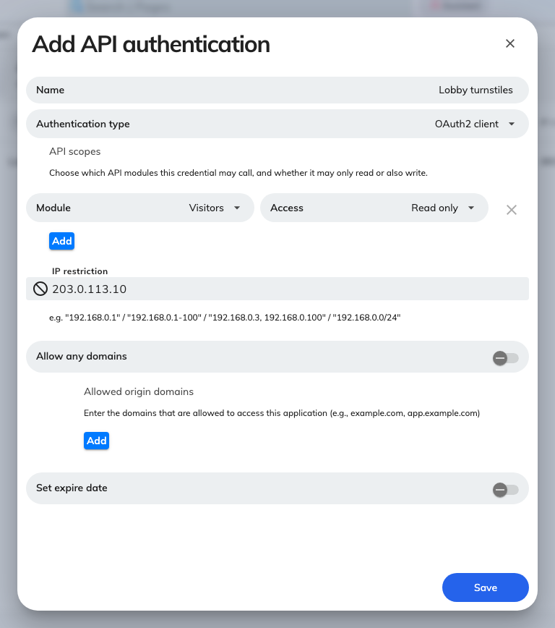
A new credential, with its API scopes and IP restriction.
The client id and client secret are not in this form — Offision generates them, and they
appear in the detail panel once the credential is saved.
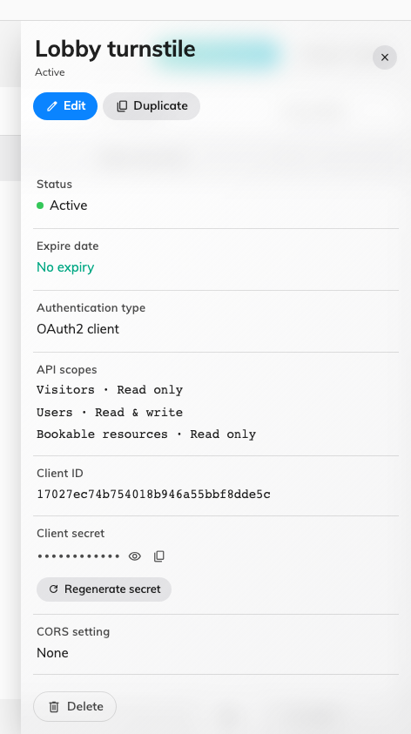
Client id and secret, with the action that mints a new secret.
Read-only is not enough, even for checking a code:
All three gate calls are POST, including the one that only asks a question — a badge code is a
live credential and does not belong in a URL, where every proxy on the way logs it. Access level
follows the HTTP method, so a read-only credential is refused. It costs nothing in practice: a gate
that checks people in needs write access anyway.

2. Check a scanned code
Send whatever the scanner read to
the verify call,
along with the building the gate stands in. You do not have to work out which kind of code you are
holding — the badge uid inside the QR, the six-character Visitor code printed on the badge, a
code your own system issued, or an eight-digit long term badge code all resolve the same way.
The answer is a verdict — valid, expired, cancelled, wrongLocation and the rest — rather
than a state to interpret, and alongside it comes isGranted, which is the field your barrier
actually acts on. Every verdict is listed in
What the visitor badge API answers.
A refused scan is still a 200:
An expired, cancelled or unknown pass comes back as an ordinary successful response with
isGranted false. A reader written as if the call succeeded, open the barrier admits every one
of them. HTTP status still means what it means — 400 malformed, 401 bad token, 403 missing scope —
but the verdict is in the body.

3. Record the arrival
The check above changes nothing. Skip this step and every badge sits at Await forever: reception
never sees the visitor arrive, the host is never told, and the visit reports stay empty.
The check-in call
takes the same code and answers the same way, and records the arrival when the verdict is valid.
So a gate that both admits and records makes one call, not two — the separate check in step 2
is for a reader that only validates, such as an exit-side scanner or a lobby display.
The check-out call
is its mirror, for gates that read people out as well as in.
Both are safe to call on every scan, and both return action alongside the verdict, saying what
was actually recorded — a second scan while the visitor is still inside deliberately writes
nothing. See What the visitor badge API answers for the
verdicts, the actions, and how check-out and re-entry differ.
Note:
A check-in recorded this way does not open an Offision-managed door — Offision releases one
only for a check-in made at an Offision panel. Here your system opens the barrier, which is the
point of the integration.

4. Check it worked
Test all four of these, because they fail independently:
- A good badge. Scan a real one during its period. You should get valid, isGranted true and
the visitor's name, and the barrier should open.
- The write-back. Look at that badge in Offision afterwards. It should have moved to
Visiting, and the host should have been notified.
- The same badge again. Scan it a second time. It must still admit, come back as
alreadyCheckedIn, and leave the check-in time exactly as it was.
- A bad badge. Deliberately scan a cancelled badge, and one for tomorrow. Both must be refused.
The last one is the test people skip. A reader that has only ever been tried with a valid badge is
a reader that admits everyone.

When it goes wrong
Nine symptoms and their usual causes, from a gate that admits every badge to one that records
nobody's arrival, are in
The gate admits a badge it should refuse.
A meeting room door is a different problem:
Nothing is scanned at a meeting room door — the door has to know in advance who booked the room.
That runs the other way round to everything above, and has an article of its own:
Open a meeting room door for the people who booked it.

