Sync rooms from Microsoft 365
Bring room mailboxes into Offision — a few by hand, or every room in the directory automatically — and set the booking agent account that lets everyone book them.
2026-08-30 · https://offision.com/help/en/integrations/sync-rooms-from-microsoft-365/
A room mailbox in Microsoft 365 becomes a bookable resource in Offision, and from then
on the two calendars stay in step in both directions.
There are two ways to get them in — one room at a time, or the whole directory at once
— and which are available depends on how you connected.
Before you start:
The rooms must already exist as room mailboxes in Microsoft 365. Offision links to
them; it does not create them — for a room Offision owns outright, see
Add a room. Desks and equipment are
added by address rather than picked from a list, because Microsoft only lists room
mailboxes.

What to have ready
- The Microsoft 365 integration already connected
- The room mailboxes created in Microsoft 365
- A Microsoft 365 account to act as the booking agent, if anybody who books these
rooms is not a Microsoft 365 account in this directory — ideally a new one created
for this, not a real person's

1. Open connected resources
Where in Offision: admin app → marketplace/apps (Integrations)
Open the Microsoft 365 tile, then on the integration card choose the
Connected resources row. Everything in this article is on that screen.
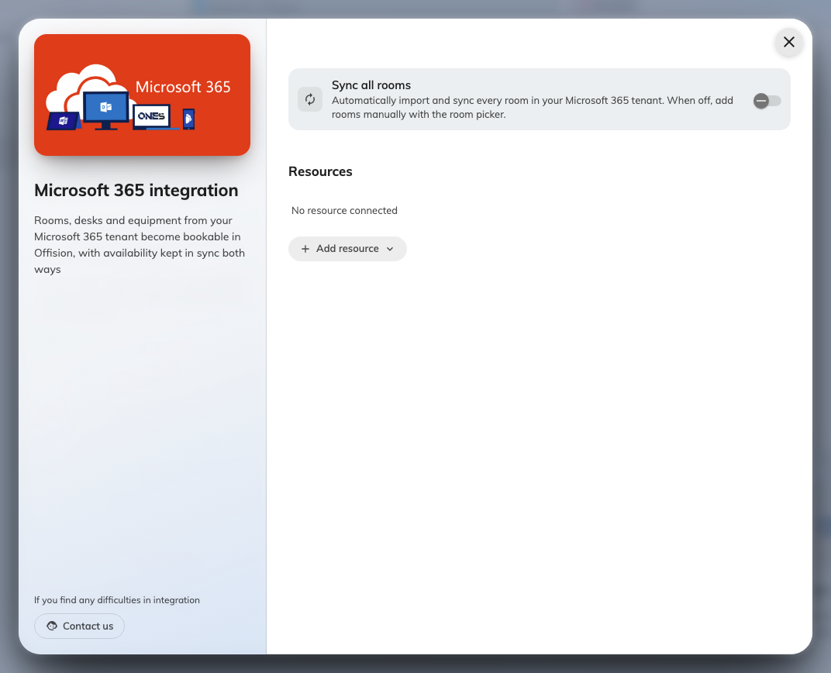
Connected resources, where rooms are added and the room sweep is turned on.

2. Add rooms one at a time
Choose Add resource, then Room, and search. Search runs when you ask it to,
not as you type — each search goes to Microsoft, so search-as-you-type would be slow
and rate-limited rather than helpful.
Rooms already connected are shown as Connected and cannot be added twice.
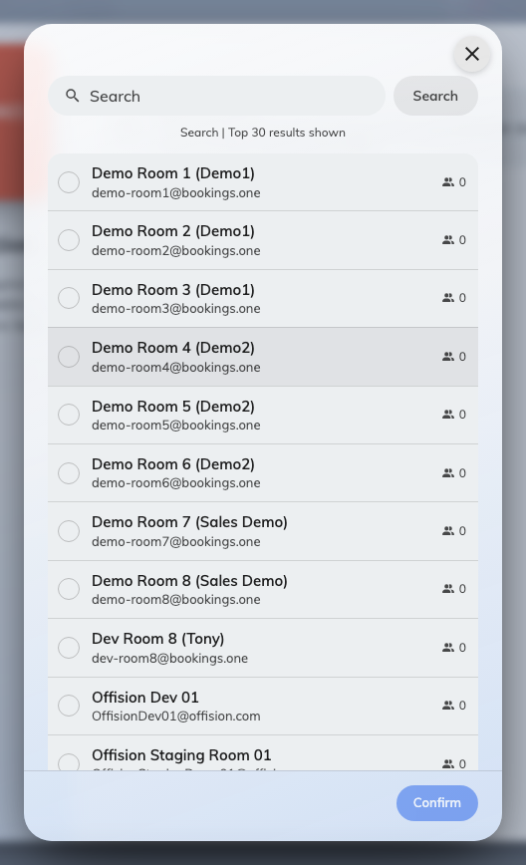
The room picker, listing rooms from the directory with their capacity.
If a room does not appear, it is usually one Microsoft has not published to its
directory yet — a mailbox created recently takes a while to show up there, and that
normally settles within a day. Offision lists what Microsoft gives it, so waiting is
the first answer.
If it still does not appear, use Room not listed? Enter email address manually and
type the mailbox address. That also covers the other case: a mailbox that is not a room
mailbox — a shared mailbox or a distribution list — which Offision can link but
Microsoft will not list.
Desks and equipment always use the address field, for the same reason.

3. Or sync every room automatically
On an application-family connection there is a Sync all rooms switch. Turned on,
every room in your Microsoft 365 directory is imported and kept up to date, and the
Add button becomes Resync.
Turning it on shows a preview first — every room it would import, with capacities and
a count — so you can see exactly what is about to arrive before confirming.
Note:
Sync all rooms is a mirror. A room deleted in Microsoft 365 is removed from Offision
too, along with its bookings. That is the point of it, but it is worth knowing before
you turn it on for a directory you did not tidy first.
If there is no Sync all rooms switch, your connection is a delegated one and
cannot enumerate the directory. Rooms come one at a time, and that is expected — see
Which Microsoft 365 connection to choose.

4. Set the booking agent account
Whether you need this at all depends on who books these rooms. Microsoft 365 does not
let an account outside your organisation book a resource, and any Offision user who is
not a Microsoft 365 account in this directory is exactly that. The
Booking agent account is the Microsoft 365 account those bookings are made on
behalf of.
- Everyone who books is a Microsoft 365 account in this directory — you do not
need one. Each person books as themselves.
- Anyone else books too — Offision-only accounts, or people from another connected
directory — you do. Without it they silently cannot book these rooms, which is the
complaint "only some people can book the room".
Open the Booking agent account row on the integration card and sign in with the
account. Use a new Microsoft 365 account created for this purpose — bookings will be
made in its name, and it must outlive whoever set the integration up.
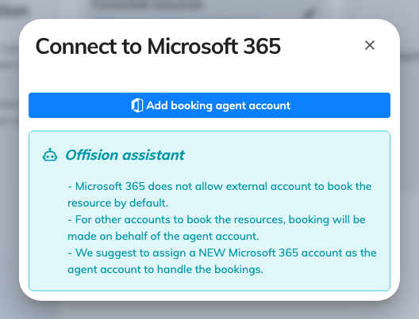
The booking agent account, which bookings are made on behalf of.
Until one is set, the card shows No account with a warning, and only the accounts
already connected can book these rooms.

5. Check it worked both ways
For one synced room:
- Book it in Offision and confirm it appears in Outlook
- Book it from Outlook and confirm it appears in Offision
- Have someone who is not a Microsoft 365 account book it, to prove the booking
agent account is doing its job
- If the room has a panel, check the booking shows there — see Put a Microsoft
365 or Google room on a booking
panel

When it goes wrong
What you see | Usual cause
A room is not in the picker | Microsoft has usually not published it yet — wait, then add it by address. It may also not be a room mailbox
Adding a room fails | The connection cannot open that mailbox's calendar — on a delegated connection, that means the delegated account has no access to it
That room is already connected | The mailbox is linked already, possibly on another integration
Only some people can book a synced room | No booking agent account is set, and the people who cannot book are not accounts in this directory
No Sync all rooms switch | A delegated connection, which cannot enumerate the directory
Every synced room disappeared at once | A room sweep ran against a directory it could not read. Check the connection before turning the sweep back on
Bookings stopped reaching Outlook for one room | The mailbox was renamed, or its calendar permission changed after it was linked
Bookings stopped reaching Outlook for every room | The connection's sign-in has lapsed. Look for the Action required card on the console's home page — see Bookings stopped syncing with the calendar

