Connect rooms from Google Workspace
Subscribe the delegated account to your resource calendars, add each one by address, and set the booking agent account that lets everyone book them.
2026-08-17 · https://offision.com/help/en/integrations/sync-rooms-from-google-workspace/
A resource calendar in Google Workspace becomes a bookable resource in Offision, and
from then on the two calendars stay in step in both directions.
Rooms arrive one calendar address at a time. There is no room browser and no sweep that
imports the whole directory — Offision reads the delegated account's own calendar list,
so the work is mostly done on the Google side before you ever open Offision.
Before you start:
The rooms must already exist as resource calendars in Google Workspace. Offision links
to them; it does not create them. And the delegated account must be subscribed to
each one, or Offision cannot see it to add it.

What to have ready
- The Google Workspace integration already connected
- Your resource calendars created in Google Workspace
- A Google account to be the delegated account, subscribed to those calendars
- A second Google account to act as the booking agent, if anybody who books these
rooms is not a Google account in this directory — ideally a new one created for
this, not a real person's

1. Prepare the calendars in Google
Do this first. Every failure later in this article traces back to a step skipped here.
In Google Calendar, signed in as the account that will be the delegated account:
- Open Settings, then Add calendar → Browse resources, and subscribe to
every resource you intend to connect.
- Open each resource and set its Time zone. A resource with the wrong time zone
produces bookings an hour or several out, and it is not obvious from the Offision
side which end is wrong.
- On each resource, set Auto-accept invitations to
Automatically add all invitations to this calendar. Without this, Offision's
bookings sit as unanswered invitations and the room looks free when it is not.

2. Add the delegated account
Where in Offision: admin app → marketplace/apps (Integrations)
Open the Google Workspace tile, then on the integration card choose the
Connected resources row. Everything else in this article is on that screen.
If no delegated account is connected yet, the screen offers Add delegated account.
Choose it, sign in as the account you subscribed the calendars to, and allow the
access Google asks about.
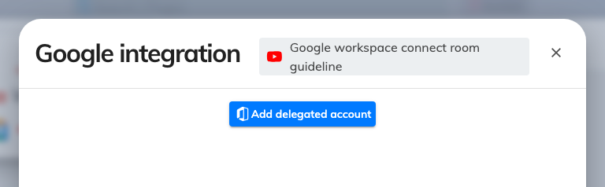
Connected resources, where the delegated account is set and rooms are added.
Once connected, the account is shown as the Managed account, with Renew beside
it. Renew when its access lapses — a password change or a revoked grant in Google both
end it, and the symptom is that syncing stops rather than that anything reports an
error.

3. Add each room by address
Choose Add Google Workspace resource, then Room, Desk or Equipment, and
type the resource calendar's email address.
The address is the one Google gives the resource calendar, not a person's mailbox and
not the room's display name. If Offision refuses to add it, the delegated account is
almost always not subscribed to that calendar — go back to step 1 rather than retyping
the address.
Note:
Every room arrives with a capacity of 10, whatever Google says it seats. Set the real
capacity on the resource afterwards, or booking rules that depend on capacity will
quietly work off the wrong number.

4. Set the booking agent account
Whether you need this at all depends on who books these rooms. Google Workspace does
not let an account outside your organisation book a resource, and any Offision user who
is not a Google account in this directory is exactly that. The booking agent account
is the Google account those bookings are made on behalf of.
- Everyone who books is a Google account in this directory — you do not need one.
Each person books as themselves.
- Anyone else books too — Offision-only accounts, or people from another connected
directory — you do. Without it they silently cannot book these rooms, which is the
complaint "only some people can book the room".
Open the Booking agent account row on the integration card and sign in with the
account. Use a new Google Workspace account created for this purpose — bookings will be
made in its name, and it must outlive whoever set the integration up.
Until one is set, the card shows No account with a warning, and only the accounts
already connected can book these rooms.
Note:
The Booking agent account row only appears on connections that reach user accounts.
On a resource-only connection there is no row, and no way to set one — every booking
then has to come from an account that is itself a Google account.

5. Check it worked both ways
For one connected room:
- Book it in Offision and confirm it appears in Google Calendar
- Book it from Google Calendar and confirm it appears in Offision
- Have someone who is not a Google account book it, to prove the booking agent
account is doing its job
- If the room has a panel, check the booking shows there — see Put a Microsoft
365 or Google room on a booking
panel

When it goes wrong
What you see | Usual cause
Adding a room by address fails | The delegated account is not subscribed to that resource calendar
No Add delegated account button, and no rooms can be added | The connection has no delegated account yet, or its access lapsed — use Renew
Every room says it seats 10 | Expected — the capacity is a placeholder. Set the real one on each resource
Only some people can book a connected room | No booking agent account is set, and the people who cannot book are not accounts in this directory
Bookings appear in Google but the room still looks free | Auto-accept invitations is not set on that resource calendar
Bookings are out by a whole number of hours | The resource calendar's time zone is wrong in Google
Bookings stopped reaching Google for every room at once | The delegated account's access ended. Renew it
Bookings stopped for one room only | That calendar was renamed or unsubscribed, or its sharing changed
I cannot find a room picker | There is not one. Google rooms are added by address, one at a time

