Sync people from Microsoft 365
Let your Microsoft 365 directory create and remove Offision accounts by itself, for everyone or just for the groups you choose. About five minutes to set up.
2026-08-16 · https://offision.com/help/en/integrations/sync-people-from-microsoft-365/
With user synchronization on, your Microsoft 365 directory is the source of truth for
who exists in Offision. New starters appear without anyone adding them, and leavers
disappear without anyone remembering to.
Before you start:
Your Microsoft 365 integration must be in a mode that can read the directory —
application mode, or either Complete mode. On the other modes there is no
Synchronize users row on the integration card; you get Connected users
instead, which lists people who have signed in rather than syncing them. See
Which Microsoft 365 connection to choose.

What to have ready
- The Microsoft 365 integration already connected
- A decision about scope: everyone, or only certain Microsoft 365 groups
- The Offision user groups new people should land in

1. Open user synchronization
Where in Offision: admin app → marketplace/apps (Integrations)
Open the Microsoft 365 tile, then on the integration card choose the
Synchronize users row. If synchronization has never been on, the screen is an
empty state with a single Turn on user synchronization button.
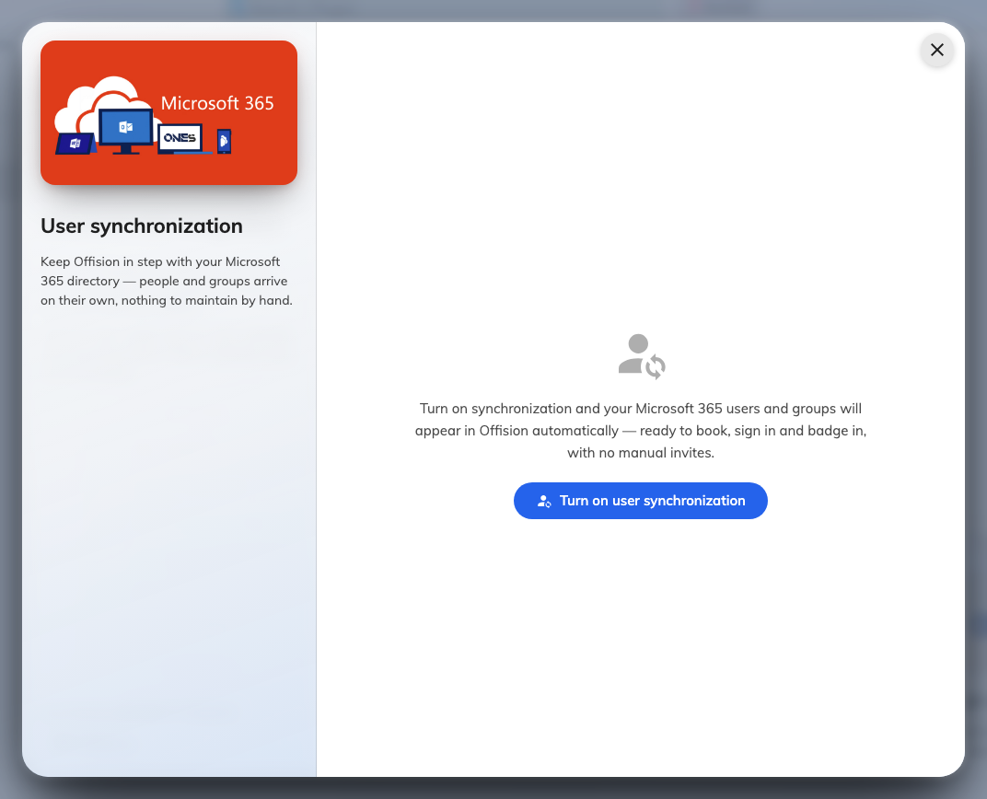
Turning user synchronization on for the first time.

2. Choose what to sync
Choice | What arrives
Sync all users | Every person in the directory, no groups
Sync all user and user groups | Every person, and the group structure with them
Sync specified user group's users | Only the members of the Microsoft 365 groups you pick

Pick Sync specified user group's users when Offision is for part of the
organisation rather than all of it. It is much easier to widen the scope later than
to remove several thousand accounts that should never have arrived.

3. Check the preview before saving
As you change the settings, Offision counts what they would actually bring in and
shows it as Will sync N users and M groups, with a row of faces. This is a real
dry run against your directory, calculated from the unsaved settings in front of you.
Read it. A count far larger or far smaller than you expected means the scope is wrong,
and this is the last moment it costs nothing to fix.

4. Set where new people land
Default native user group decides which Offision user groups a newly synced person
joins. Everything that keys off user groups — which rooms someone may book, what they
can see — follows from this, so a new starter with no group may be able to sign in and
book nothing.
Synchronize card number options sits here too, and is the one field on this page
worth ignoring: leave it on No synchronize. Card numbers do not arrive with a
Microsoft 365 sync, so issue them in Offision instead — see
Issue an access card to someone.
Save, and the first sync runs.

5. Check it worked
Open the Synchronized users page in the same screen and confirm the people you
expected are there, in the groups you expected. Re-sync runs it again on demand
rather than waiting for the schedule.
Then check the other direction: someone who is not in scope should not be listed.

Sync is a mirror, not an import
This is the part worth understanding before you turn it on.
Note:
While synchronization is on, Microsoft 365 decides who exists. Someone removed from
the directory — or moved out of a synced group — is removed from Offision on the next
run, along with what belonged to them. That is the feature working correctly.
Turning synchronization off does not delete anyone. The people already synced stay
in Offision; they simply stop updating from Microsoft 365. Offision says so when you
turn it off, and the warning is worth reading rather than clicking past.
People added directly in Offision are unaffected either way — see
Add people to Offision.

When it goes wrong
What you see | Usual cause
No Synchronize users row on the card | The integration is in a mode that cannot read the directory
The preview will not load | The directory permissions were granted but consent was not, or Microsoft has not applied them yet
Far fewer people than expected | The scope is set to specific groups, and they are smaller than assumed — or nested groups are not what you thought
People arrive but can book nothing | No default user group is set, so they land with no permissions
Someone came back after being deleted | They are still in a synced group in Microsoft 365; remove them there, not here
Everyone disappeared at once | The scope changed to a group that is empty or unreachable. Fix the scope, then re-sync

