Let people sign in with Microsoft 365
Put a Microsoft button on the sign-in page so people use their work account instead of an Offision password. Two minutes, once the integration is connected.
2026-08-16 · https://offision.com/help/en/integrations/sign-in-with-microsoft-365/
When single sign-on is on, the Offision sign-in page carries a Microsoft button, and
people use the work account they are already signed into. No second password, and
nothing to reset when they change the first one.
Before you start:
Not every connection can sign people in. Resource only mode and
Resource calendar mode reach room calendars and nothing else, so they carry no
sign-in permission at all — the setting is absent rather than switched off. See
Which Microsoft 365 connection to choose.

What to have ready
- The Microsoft 365 integration connected, in a mode that signs people in
- A decision on what the button should say
- For your own Entra ID app: the
redirect URIs already added to the app registration

1. Find the setting
It is not called single sign-on on the integration card. Open the Microsoft 365 tile,
and on the integration card choose the Login button name row — that is the
sign-in settings.
Where in Offision: admin app → marketplace/apps (Integrations)
When sign-in is off, that row shows a red User login is disabled instead of a
button name. That is the fastest way to check whether this is on, and the first thing
to look at when someone reports the Microsoft button missing.

2. Turn on user login
Switch User login on.
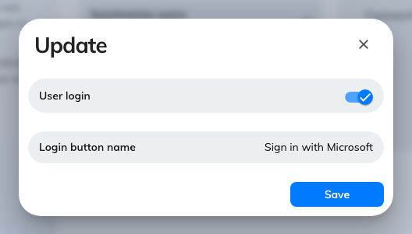
Sign-in settings: the user login switch and the button name people read.

3. Name the button
Login button name is the text on the sign-in page. It is the one string in this
whole integration that ordinary staff will read, so write it for them rather than for
the IT team — Sign in with Microsoft or the name of your organisation, not
M365 SSO Provider.
If you connect more than one Microsoft 365 organisation, this is also the only thing
that tells people which button is theirs. Name them distinctly.

4. Decide where new arrivals land
The default user groups set here apply to people who arrive through this integration.
Someone who signs in successfully but lands in no group can sign in and book nothing,
which reads to them as a broken account rather than a permissions setting.
Where people come from your directory rather than from first sign-in, set this
alongside Sync people from Microsoft 365 and
keep the two consistent.

5. Check it worked
Sign out, or open a private window, and load the Offision sign-in page. The button
should be there with the name you gave it. Sign in with a Microsoft 365 account and
confirm you land in Offision with the right permissions.
Test with an ordinary account, not an administrator — an administrator has permissions
of their own, and will not reveal a missing default user group.

Where the sign-in credentials come from
Worth knowing when sign-in behaves differently from the calendar side.
- On Offision's own application and delegate modes, sign-in runs through a shared
Offision registration. There is nothing to configure and nothing to expire.
- On your own Entra ID app,
sign-in uses your registration. You can reuse the integration's credentials or give
sign-in a separate client of its own, and ADFS is available as an alternative to
OAuth. This is also why the redirect URIs matter: without them Microsoft has nowhere
to send people back to.

When it goes wrong
What you see | Usual cause
No Microsoft button on the sign-in page | User login is off, or this connection's mode has no sign-in
The Login button name row shows user login disabled | Exactly that — turn user login on
Sign-in returns to the login page with no error | Redirect URIs missing from your own app registration
Sign-in works but the account cannot do anything | No default user group, so the account arrived with no permissions
Sign-in works for some people, not others | They are not in Offision yet — see Sync people from Microsoft 365
Two Microsoft buttons and nobody knows which | Two connected organisations with the same button name

