Name card settings
Every field in the name card's Marketplace dialog — the company line, the eleven switches deciding what staff may change, and the two share channels — with what each one does and when to change it.
2026-08-26 · https://offision.com/help/en/integrations/name-card-settings-reference/
The Name card tile in Integrations › Marketplace opens one dialog,
and everything the company decides about staff name cards is in it.
Where in Offision: admin app → marketplace/apps (Integrations)

Turning it on and off
Setting | What it does | When to change it
Turn on name card | Gives every member of staff the ability to publish a card. Publishes none of them | Once, when the company adopts the feature
Disable feature | Takes every published card offline at once. The links stop resolving and each person's own settings are kept | Withdrawing the feature, or pausing it while the company line is wrong

The settings below appear only while the feature is on; with it off, the dialog
shows the description and the button alone.

Company info
One line for the whole company, printed on every card.
Setting | What it does | When to change it
Company address | The office address printed on every card, shown as its Office row and linked to a map | The company moves, or the cards should carry the head office rather than a site
Company website | The address the card's Website row points at | A rebrand, or a landing page meant for people who scan a card

Both start empty, and an empty field simply does not appear on the card.
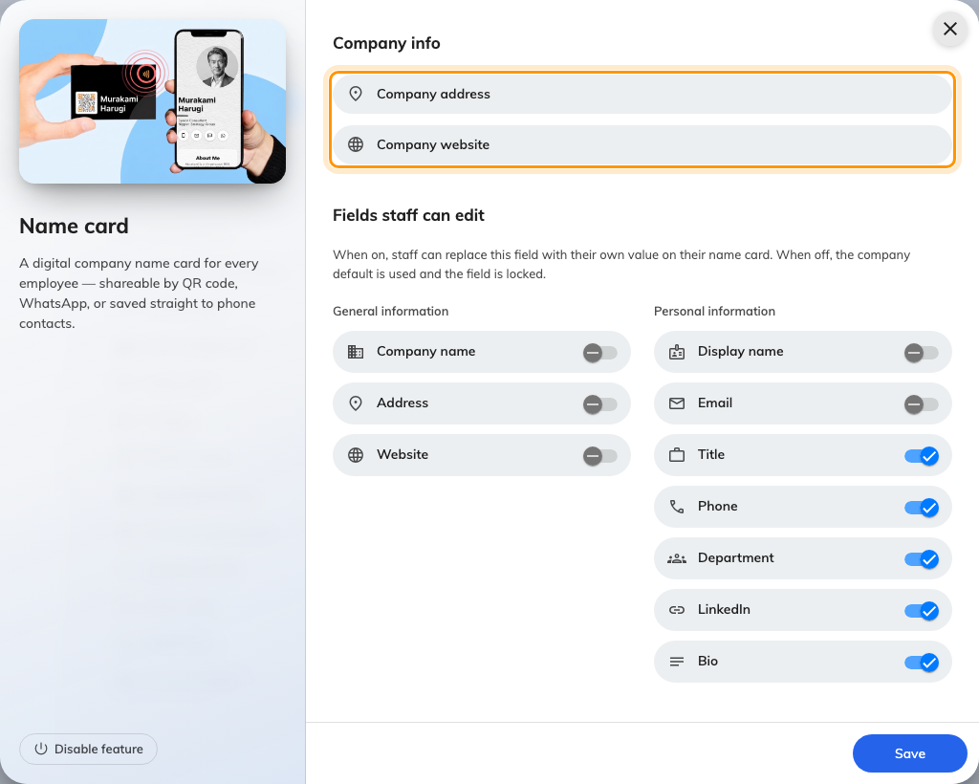
Company info holds the company address and website.

Fields staff can edit
Each switch decides one field. On, a person may replace it on their own card;
off, the company's value is used and the field shows as Locked on their form.

General information
Setting | What it does | When to change it
Company name | Lets a person print a different company name from the account's | Off by default. Turn it on for a group trading under more than one name
Address | Lets a person replace the company address with their own office | Staff sit in several offices and the card should say which
Website | Lets a person point the website row somewhere else | A team with its own site or portfolio

Personal information
Setting | What it does | When to change it
Display name | Lets a person set the name on the card | Off by default. On where people use a preferred or romanised name
Email | Lets a person publish an address other than their sign-in one | A shared or role address is what customers should reach
Title | Lets a person write their own job title | On by default; off where titles are governed by HR
Phone | Lets a person set the number on the card | On by default — and required for a WhatsApp QR, which is built from it
Department | Lets a person write their own department | On by default; off where the directory is the source of truth
LinkedIn | Lets a person add a LinkedIn profile | On by default; off where personal profiles are not for customers
Bio | Lets a person write a short bio | On by default; off where cards should stay uniform

Share channels
Which targets the QR toggle on a staff card offers. Contact, which saves the
person to the scanner's phone, is always there and is not a setting.
Setting | What it does | When to change it
WhatsApp | Offers a QR that opens a WhatsApp chat with the person. On by default | Off where WhatsApp is not how the company talks to customers
LINE | Offers a QR that adds the person on LINE. Off by default | On in markets where LINE is the norm

A channel being on is only half of it — the tab is hidden for anyone who has not
entered the detail it addresses: a phone number for WhatsApp, a LINE id for LINE.

What this does not control
- The company's address of record. Company address here is printed on
cards and read by nothing else. Each site's address is on its building, under
Directory › Locations.
- Whether anybody's card is public. Each person turns on Publish my name
card for themselves.
- The user record. A field a person overrides changes their card only, never
their directory entry.
- Emails and printed badges. Those carry the building's address and the
account name, and are set on their own pages.

