Which Google Workspace connection to choose
Offision connects to Google Workspace two ways, and the second one lets you pick a mode. Read this once before you connect, because the choice sets what people can do afterwards.
2026-09-02 · https://offision.com/help/en/integrations/google-workspace-connection-modes/
Offision talks to Google Workspace through one connection, and that connection is made
one of two ways. Both sync calendars. What separates them is whose application
registration is used, and how much choice you get over what Offision may reach.
Make this choice before you connect. Both ways end at the same Google sign-in screen,
but only one of them lets you decide what that sign-in covers.
One connection — or several: a second Google Workspace organisation, or Microsoft 365
alongside, each gets a card of its own. See
Connect more than one directory.

The two ways
 | Quick connect | Your own OAuth app
Whose app registration | Offision's | yours, in Google Cloud
What you type in | your Customer ID | Customer ID, Client ID, Client secret
Who approves it | any one Google account, by signing in | the same, against your own app
Mode | fixed | you choose one of three
Stores a client secret | no | yes, yours
Setup time | about five minutes | half an hour, across two people

Quick connect is right for most organisations. Register your own app when your
security policy will not accept Offision's, or when you want a mode narrower than the
default — see
Connect Google Workspace with your own OAuth app.
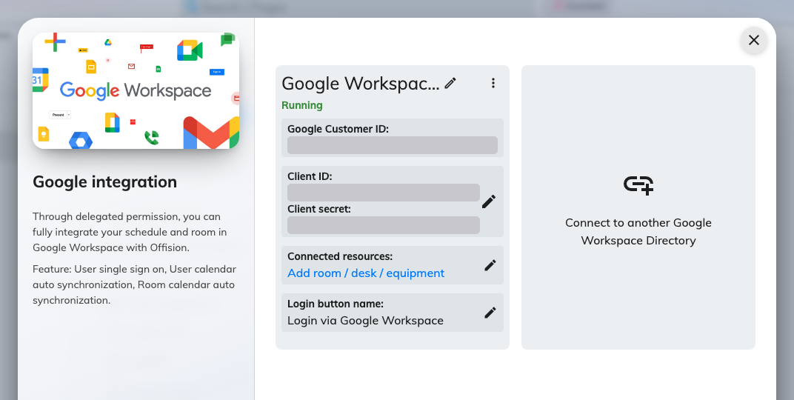
A connected Google Workspace integration, with everything it manages on one card.

Everything runs as one delegated account
This is the single most useful thing to understand about the Google integration, and
it explains most of what follows.
Offision does not act as an application against your Google Workspace organisation. It
acts as one Google account you sign in with — the delegated account — and it can
reach exactly what that account can reach, no more.
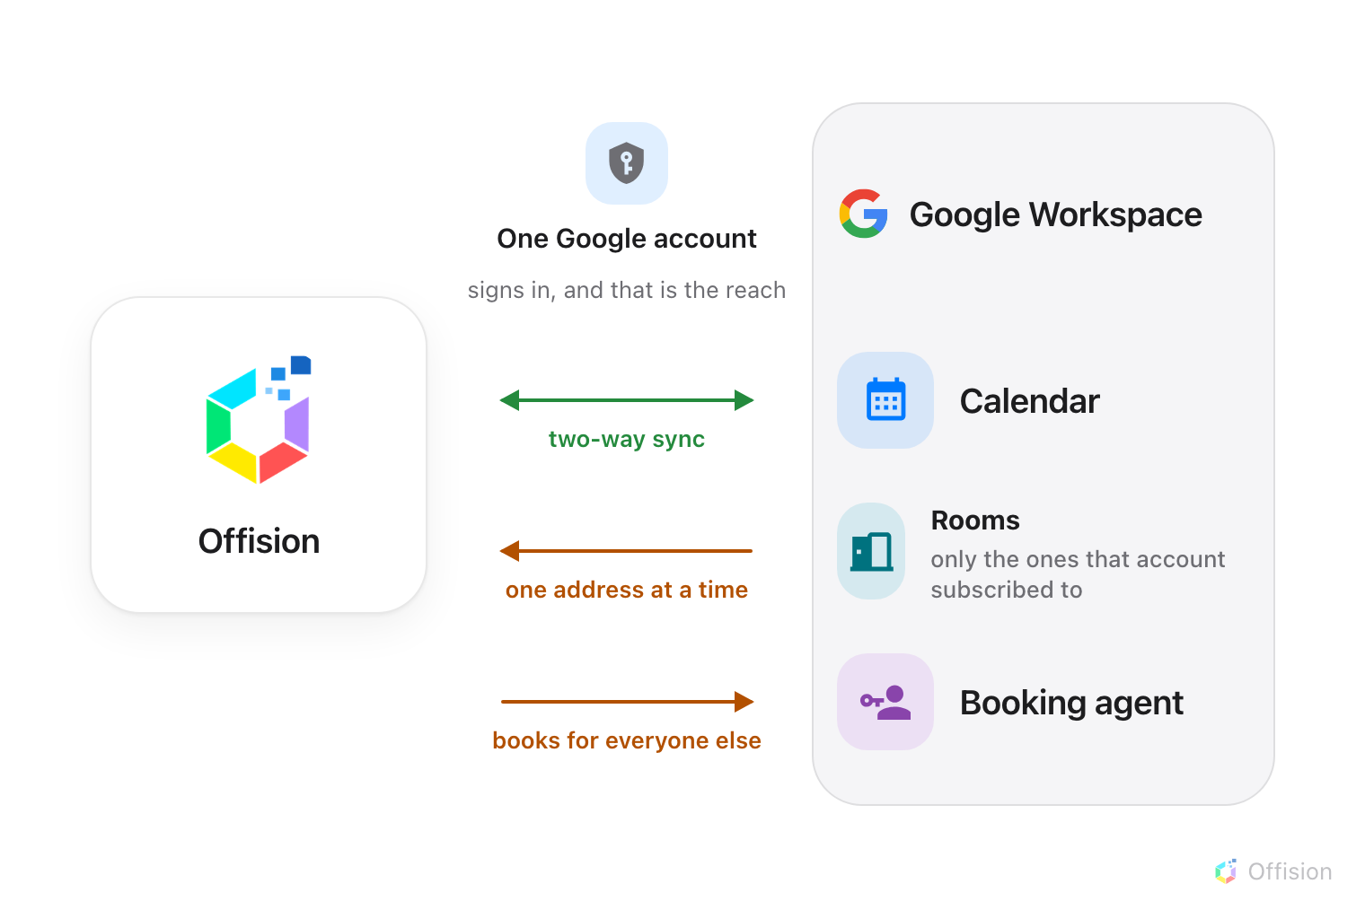
One delegated account in the middle. Offision sees what it sees — which is why rooms arrive one at a time.
Three consequences, all of which surprise someone who connected Microsoft 365 first:
- Rooms are added one calendar address at a time. There is no room browser and no
sweep that imports every room in the directory. Offision reads the delegated
account's own calendar list, so a room only becomes addable once that account has
subscribed to it in Google Calendar. See
Connect rooms from Google Workspace.
- People and user groups do not sync. Add people the ordinary ways — invite them,
import them, or let them arrive on first sign-in. Google is a calendar and sign-in
integration, not a directory one.
- Someone has to book on everyone else's behalf. Google refuses bookings from
accounts outside your organisation, and every Offision-only account is exactly that.
That is what the booking agent account is for, below.

The three modes
Only the custom setup offers a choice. Quick connect uses a fixed mode equivalent to
Standard.
Mode | Room calendars | User calendars | Single sign-on
Complete mode | yes | yes | yes
Standard mode | yes | yes | yes
Resource calendar mode | yes | no | no

Resource calendar mode is the narrow one, and it is narrow on purpose: Offision
reaches room calendars and never touches anybody's personal calendar. Sign-in is not
merely switched off in this mode, it is unavailable — the setting is absent. Choose it
when reaching staff calendars would not survive a security review.
Note:
Complete mode's card lists user synchronisation, but Offision has no screen for the
service-account credentials that would need. Until it does, Complete mode and Standard
mode behave identically. Pick either.

The booking agent account
Google Workspace does not let an account outside your organisation book a resource. So
when someone books who is an Offision account rather than a Google one, the booking has
to be made on behalf of a Google account — the booking agent account.
Without one, only the accounts you have connected can book your Google rooms, and
everyone else silently cannot. Set one up as part of
Connect rooms from Google Workspace, and use a
new account created for the purpose rather than a real person's.

What Google will not do
Worth knowing before you plan around it, because Microsoft 365 does all three:
- Offision cannot send email through your Google Workspace organisation
- Equipment and desks are added by address, never enumerated
- Contacts do not sync

Where to start
Where in Offision: admin app → marketplace/apps (Integrations)
Once connected, the things worth setting up next are
rooms,
sign-in and
Google Meet links.

