Embed Offision in your company portal
Put the user app inside a page on your own intranet or portal: where to copy the address, the iframe to drop into your page, the embedding choice that lets your site hold it, and how to confirm it worked.
2026-09-01 · https://offision.com/help/en/integrations/embed-offision-in-your-company-portal/
Before you start:
You can edit the portal page itself, and you are the account owner — the
embedding screen is open to the owner only. Your portal must be served over
https, unless it sits on your own network.

1. Copy the user portal address
Open System URLs, under Marketplace. The first row, User portal URL,
is the address to embed. Copy it.
Where in Offision: admin app → marketplace/integration-links (System URLs)
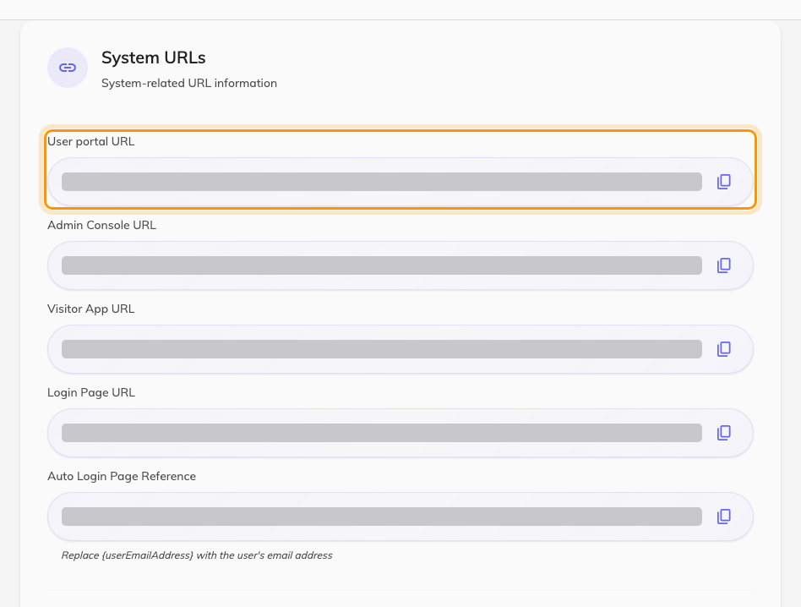
System URLs. The first row is the address to embed.

2. Put it in your page
Add an iframe to the portal page, with that address as its source. Give it real
height — the app fills whatever box it is given, and a short frame makes it look
broken:
<iframe
src="USER-PORTAL-URL-FROM-STEP-1"
title="Offision"
style="width: 100%; height: 900px; border: 0;"
allow="clipboard-write; camera"
></iframe>
camera is only needed where people scan a QR code to check in from the
embedded app; drop it otherwise.

3. Let your site hold it
Until this step the frame comes up empty on most tenants. Open Security
setting, under System config, set User app embedding to Listed
websites, and add your portal's address to Allowed websites.
Where in Offision: admin app → system-account/security-settings (Security setting)
Type the origin of the portal page — scheme and host, no path. What the list
accepts, and how to cover several portal addresses with one entry, is in
choose which websites may embed Offision.
Save. The change applies to the next page load.

4. Check it worked
Open the portal page in a private window, as somebody who is not you:
- The app appears in the frame rather than an empty box.
- Signing in works, and a reload still shows them signed in.
- They can open a room and make a booking.
An empty frame means the address in Allowed websites does not match the page
holding it — work through
the embedded page refuses to display.
A frame that keeps asking for a sign-in is a different problem, in
people are asked to sign in again.
The visitor app is a separate switch:
Visitor app embedding on the same screen covers a lobby or registration page
built into your own site. It has its own choice and its own list; setting one
does nothing to the other.

